**VAPOR SYSTEM PROJECT**

**Business Application**



**Name:** Decho Dechev

**University:** University of World and National Economy

**Faculty Name:** Applied Informatics and Statistics

**Specialty:** Business Informatics and Communications

**Year of Study:** (2025)

**Date: 23.04.2025**

Contents

1. Project description 1

1.1. Project objectives 1

1.2. Project scope 1

2. Business goals 2

3. Stakeholders (User roles) 2

4. Process Models То-be 3

4.1. Description for each process 3

4.2. Use cases diagram 4

4.2.1 Login (User & Password) 4

4.2.2 Login (Google Authentication) 5

4.2.3 Registration Process 6

4.2.4 Game Discovery Process 7

4.2.5 Cart & Checkout Process 7

4.2.6 Points Discount Process 8

4.2.7 Library Access and Ownership Display Process 9

4.2.8 Community Participation Process 10

5. Functional specification and requirements 11

5.1 Functionality requirements 11

5.2 User interface 14

5.2.1 Navigation Bar 14

5.2.2 Store Page 17

5.2.3 App Details Page 26

5.2.4 Cart Page 39

5.2.5 Wishlist Page 50

5.2.6 Wallet Page 52

5.2.7 Account Details Page 55

5.2.8 Purchase History Page 57

5.2.9 Change Username Page 58

5.2.10 Change Email Page 60

5.2.11 Change Password Page 65

5.2.12 Google Account Linking & Unlinking Functionality 72

5.2.13 User Profile Page 75

5.2.14 Edit Profile Page 77

5.2.15 Library Page 81

5.2.16 About Page 84

5.2.17 Admin Panel Page 85

5.2.18 Community Page 91

5.2.19 Create Post Page 103

5.2.20 Registration Page 106

5.2.21 Login Page 110

5.2.22 Footer 120

5.2.23 Privacy Policy Page 120

5.2.24 Terms of Service Page 122

5.2.25 Refund Policy Page 124

5.2.26 Support Page 126

5.3 Data Flow Diagrams 128

5.3.1 Full Overview DFD 128

5.3.2 Register Process DFD 130

5.3.3 Login Process DFD 131

5.3.4 Email Verification Process DFD 132

5.3.5 Forgotten Password Process DFD 133

5.3.6 Game Search Process DFD 135

5.3.7 Add to Cart Process DFD 136

5.3.8 Checkout Process DFD 137

5.3.9 Library Update Process DFD 138

5.3.10 Community Post Process DFD 139

5.3.11 Profile Update Process DFD 140

5.3.12 Admin Management Process DFD 141

6. Data model - sources and data models 142

6.1 Overview of the Database 142

6.2 Table-by-Table Explanation 145

6.2.1 Roles Table 145

6.2.2 Publishers Table 145

6.2.3 AppPublishers Table 145

6.2.4 Developers Table 146

6.2.5 AppDevelopers Table 146

6.2.6 Genres Table 146

6.2.7 AppGenres Table 146

6.2.8 AppImages Table 147

6.2.9 AppVideos Table 147

6.2.10 AppLibrary Table 147

6.2.11 AppTypes Table 147

6.2.12 CartItems Table 147

6.2.13 log_21180128 Table 148

6.2.14 PostLikes Table 148

6.2.15 PostComments Table 148

6.2.16 Posts Table 148

6.2.17 Users Table 148

6.2.18 Apps Table 149

6.2.19 Wishlist Table 149

6.2.20 PurchaseHistory Table 149

6.2.21 PaymentTokens Table 150

6.2.22 PasswordResetTokens Table 150

6.2.23 Notifications Table 151

6.2.24 EmailVerifications Table 151

6.2.25 EmailChangeTokens Table 152

6.2.26 AppReviews Table 152

7. Implementations technologies and decisions 153

7.1 Technologies Used 153

7.2 Key Design Decisions 153

8 Testing 154

1. Project description

The Vapor application is a full-stack web system designed to the functionality of digital game distribution platforms like [Steam](https://store.steampowered.com). It includes features for browsing, purchasing and managing games, community engagement and much more. It is more than just e-commerce, it is a platform, where users can share their opinion about these products that the application is providing.

* 1. Project objectives
* Enable users to securely register/login. (including Google login)
* Allow users to browse, search and filter games with detailed multimedia previews.
* Implement a wallet and Stripe integration for purchases.
* Support ownership tracking and visualizing it in a digital library for each user.
* Enable users to earn and redeem points for discounts.
* Facilitate a social “Community” section for user posts related to owned games.
* Include secure email verification, password reset to protect users and maintain data integrity.
* Allow users to save favorite games to a wishlist with priority management and review their purchase history.
* Support community engagement through editable post comments and game reviews.
* Notify users about activity on their posts, improving interactivity and user retention.
  1. Project scope
* Full-stack web app using ASP.NET Core backend and React as a frontend.
* JWT authentication and refresh token system, which increases the user experience, by prolonging the user activity on the application, if they are interacting with it.
* Game catalog with search, filter, media previews and sorting as well.
* Additional game content for some game applications. (DLCs, Music..)
* Cart and wallet payment system with Stripe fallback. Adding funds to the wallet via Stripe and also having the option to pay the remaining amount via stripe.
* User profile with editable info and public url with his library of game applications displayed.
* Points system for discount logic, 1 points equals 1€, 100 points = 10% discount, 250 points = 25% discount and lastly 500 points = 50% discount. Points will only be earned by products that are bought without redeeming points for the current transaction in order to reach higher profit margin.
* Community module for user posts and interactions like liking the post and commenting beneath it.
* Email/token verification for secure account flow.
* Wishlist and purchase history features.
* Editable comments and game reviews.
* Notification system.
* Informative email notifications for actions such as invoice generation on purchase, password changes, and account updates.

1. Business goals

The system provides a low-cost prototype of a digital game platform/e-commerce with key business goals:

* Increase digital sales through user incentives. (point discount system)
* Improve user retention with community interaction and profiles.
* Enhance customer experience with modern responsive user interface.
* Reduce friction in the checkout process via wallet and Stripe integration.
* Lay groundwork for future scalability (achievements, badges etc.).
* Boost engagement and return visits through wishlist and notifications.
* Strengthen account security and trust through email verification and recovery options.

1. Stakeholders (User roles)

The stakeholder groups of the applications are the following:

* Users – browse, purchase, “play” games, manage profiles and participate in community.
* Administrators – manage app data (CRUD operations) and oversee community.
* Guests – limited browsing access without any interaction in order to increase their incentive for registration.

The system covers user needs such as:

* Secure registration and login via email verification (including Google authentication).
* Fast and intuitive game discovery through search, filters, and previews.
* Flexible payment options (Stripe and wallet system).
* Trackable ownership and purchase history.
* Personal profile editing and public sharing.
* Expressing opinions via posts, comments, and reviews.
* Wishlist system.
* Reviews and editable comments.
* Notifications.

1. Process Models То-be

The application follows a modular business process post-deployment.

* 1. Description for each process
* Registration/Login – Users can sign up using email and password or via Google login. Authentication is handled through JWT tokens for secure and stateless session management.
* Game Discovery – Users browse, search or filter available games by specific criteria.
* Cart and Checkout – Users can add applications to a cart and proceed to checkout. Payments can be completed either using their wallet balance or via Stripe for card payments.
* Points for Discounts – Users earn points from purchases. These can be optionally redeemed for discounts if the user has collected enough. The discount tiers depend on the number of points available.
* Library access – After purchasing an app, it is added to the user’s library. Related content such as DLCs or music is also displayed, even if not owned, and shown in a distinct visual style based on ownership status.
* Community Participation – Users who own a game can create posts in the Community section, write reviews, or share gameplay experiences (including optional images). Other users can comment on posts regardless of ownership. Guests can view posts but cannot interact with them.
* Profile Management – Users can update their display name, profile picture, username, and email address, unless the account is linked to Google (via OAuth), in which case the email and username remain fixed. If a user with a matching @gmail.com address logs in via Google OAuth, the system automatically links the account. In such cases, an option to unlink the Google account is available. Each user also has a shareable public profile page showing their owned games and basic information. Profiles of other users can be freely viewed.
  1. Use cases diagram
     1. Login (User & Password)

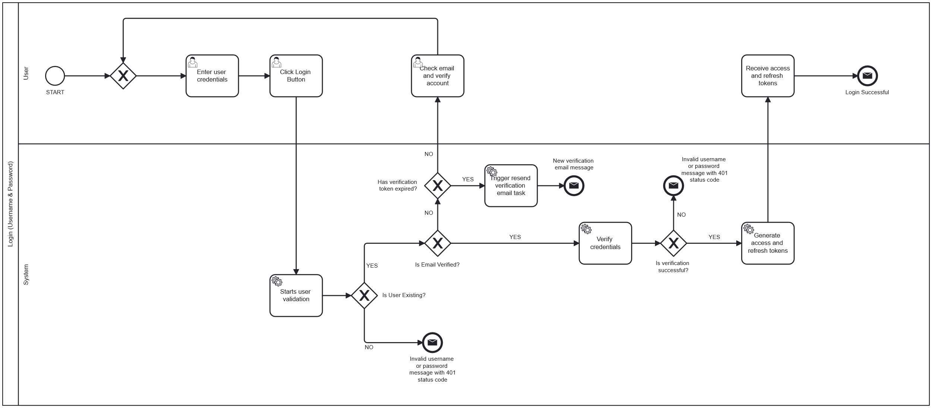On **Figure 1**, is shown, the user authentication process using existing credentials. The flow begins when the user submits their username and password. The system then verifies whether the user exists and checks if their email address has been verified. If the email is not verified and the token has expired, a new verification email is sent. If the credentials are valid and verification is successful, the system generates access and refresh tokens and completes the login process. Any invalid input results in a descriptive error message. The process ends successfully when the user receives valid access and refresh tokens.

Figure 1. Login (Username & Password) Diagram

* + 1. Login (Google Authentication)

**Figure 2** illustrates the login process using Google OAuth within the application. After the user successfully authenticates with Google, the system checks whether an account with the corresponding email already exists.

* If the user does not exist, a new account is automatically created.
* If the user does exist, the login continues using the existing account.

In both scenarios, the system generates and returns access and refresh tokens to complete the authentication flow.

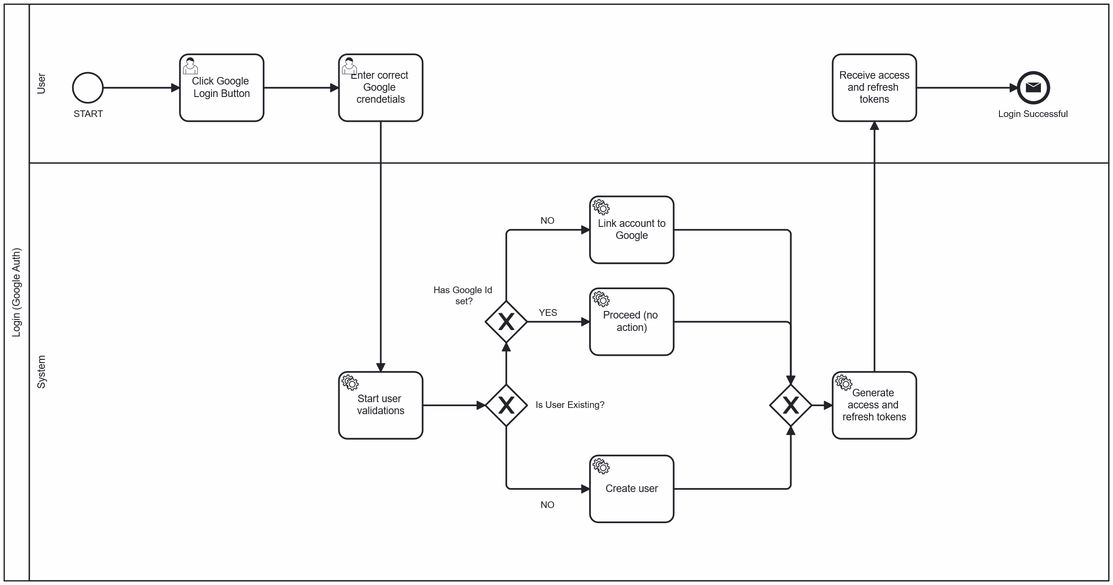Additionally, if a user has already registered with a @gmail.com email using the Figure 1 approach, and later logs in via Google OAuth, the system will automatically link the existing account to Google, enabling seamless OAuth login in the future. Users logged in via Google OAuth have their emails verified by default.

Figure 2. Login (Google Authentication) Diagram

* + 1. Registration Process

**Figure 3** outlines the user registration process. After the user submits their credentials, the system performs the following checks:

* Verifies that the username and email are not already in use.
* Validates the format and structure of the username, email, and password.
* If all validations pass, a new user is created and saved in the database.
* An email verification token is generated and sent to the user’s email address.
* If any check fails, a corresponding error message is returned to the user.

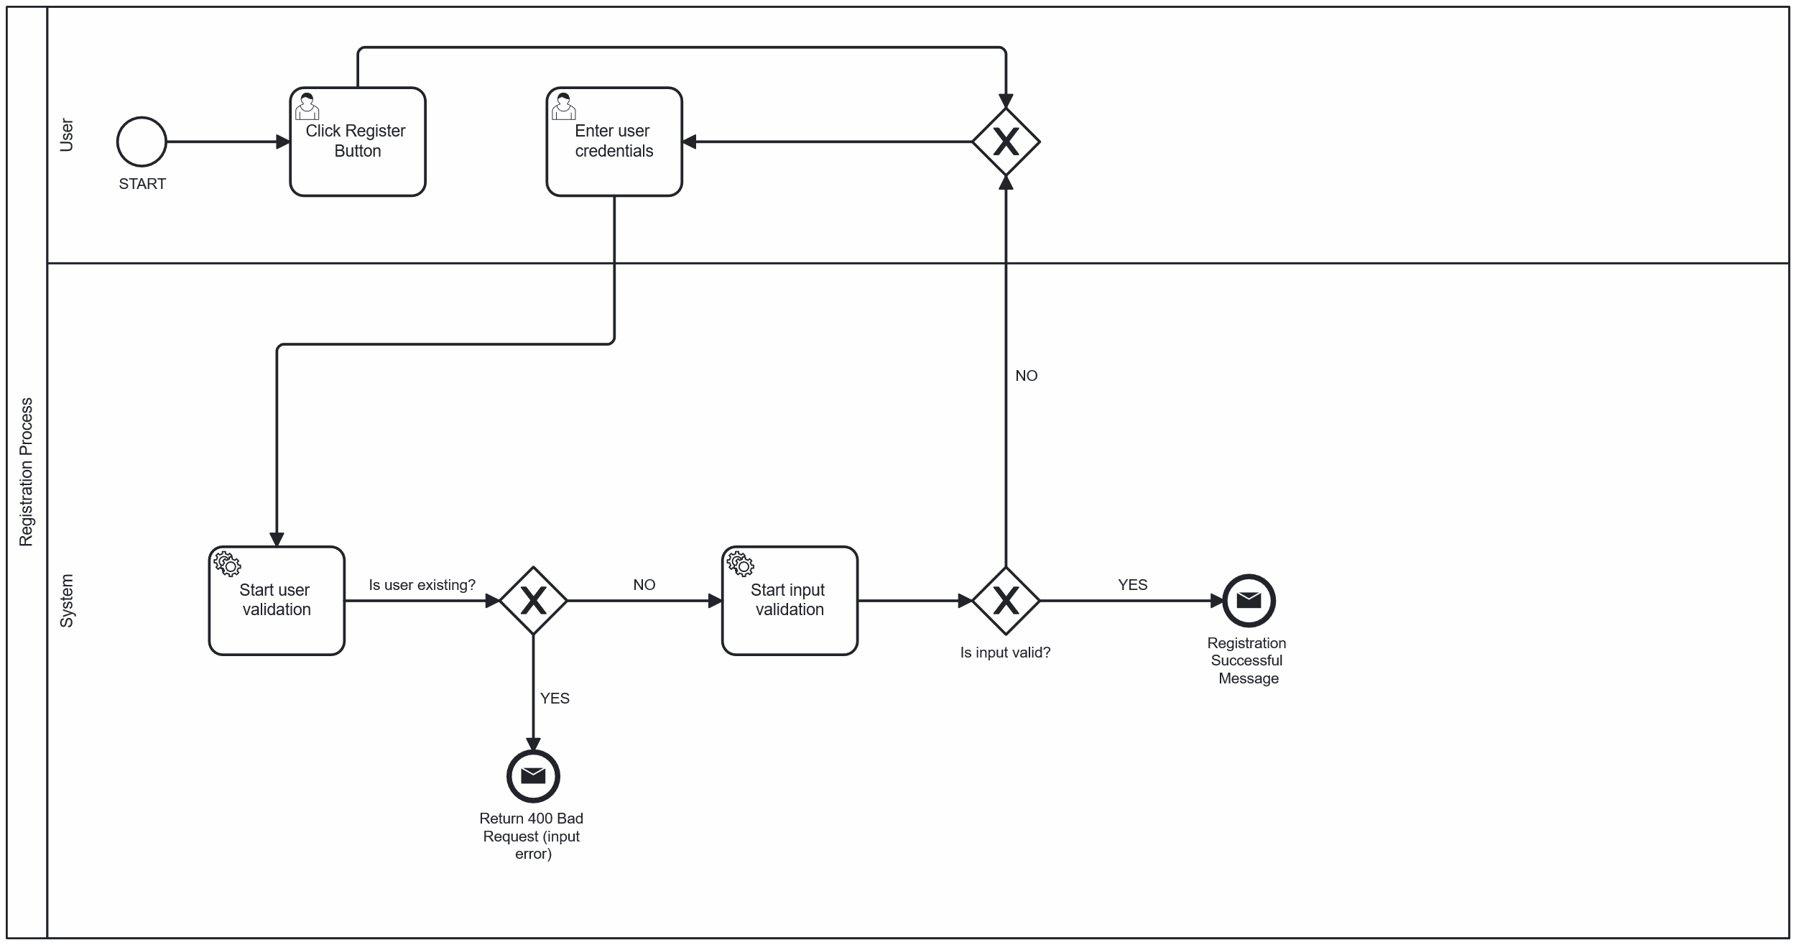The user must verify their email before being able to log in successfully.  
If the account was created by mistake or without consent, the email owner can use the verification token to delete the account directly from the verification page.

Figure 3. Registration Process Diagram

* + 1. Game Discovery Process

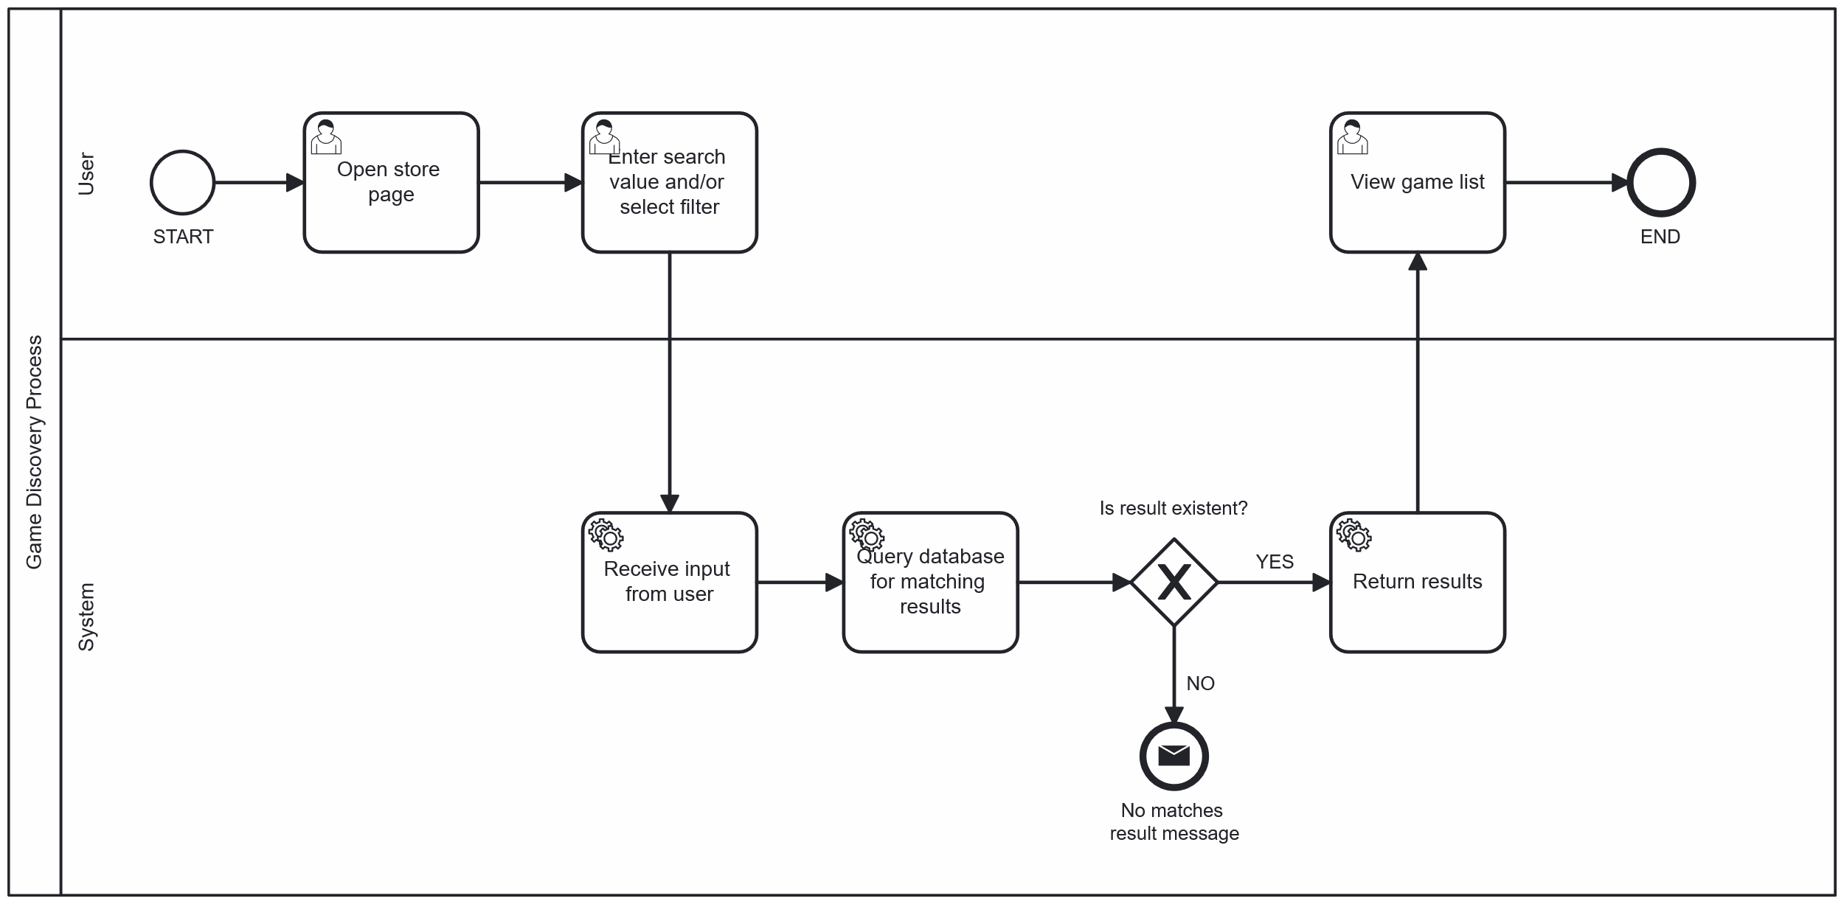**Figure 4** illustrates the game discovery process through the store page’s search functionality. After opening the store, the user can enter a search query and apply filters. The system receives this input, queries the database, and either returns a list of matching games or displays a message indicating that no results were found.

Figure 4. Game Discovery Process Diagram

* + 1. Cart & Checkout Process

**Figure 5** presents the checkout flow in the application, focusing on the wallet and Stripe payment logic. Once the user adds items to the cart (that they do not already own), the system performs validation to ensure item ownership. To maintain diagram readability, some logical steps (like ownership checks) are excluded visually but are explained here for completeness.

At checkout, the system validates the cart and checks if a discount was selected. Then, it evaluates the user's wallet balance:

* If the wallet contains sufficient funds, the purchase amount is deducted directly.
* If the wallet has insufficient funds, the system automatically initiates a Stripe payment for the remaining amount.
* If the transaction completes successfully via Stripe or wallet, the apps are added to the user’s library, and a confirmation email is sent.
* If the user did not use a discount, discount points equivalent to the purchase amount are added to their account.
* If a partial Stripe payment was made, the wallet is emptied (set to 0) after the transaction.
* To enhance security, a unique Stripe payment token is generated per session. It is validated against expiration time and the user before applying any wallet updates, preventing unauthorized or repeated transactions.

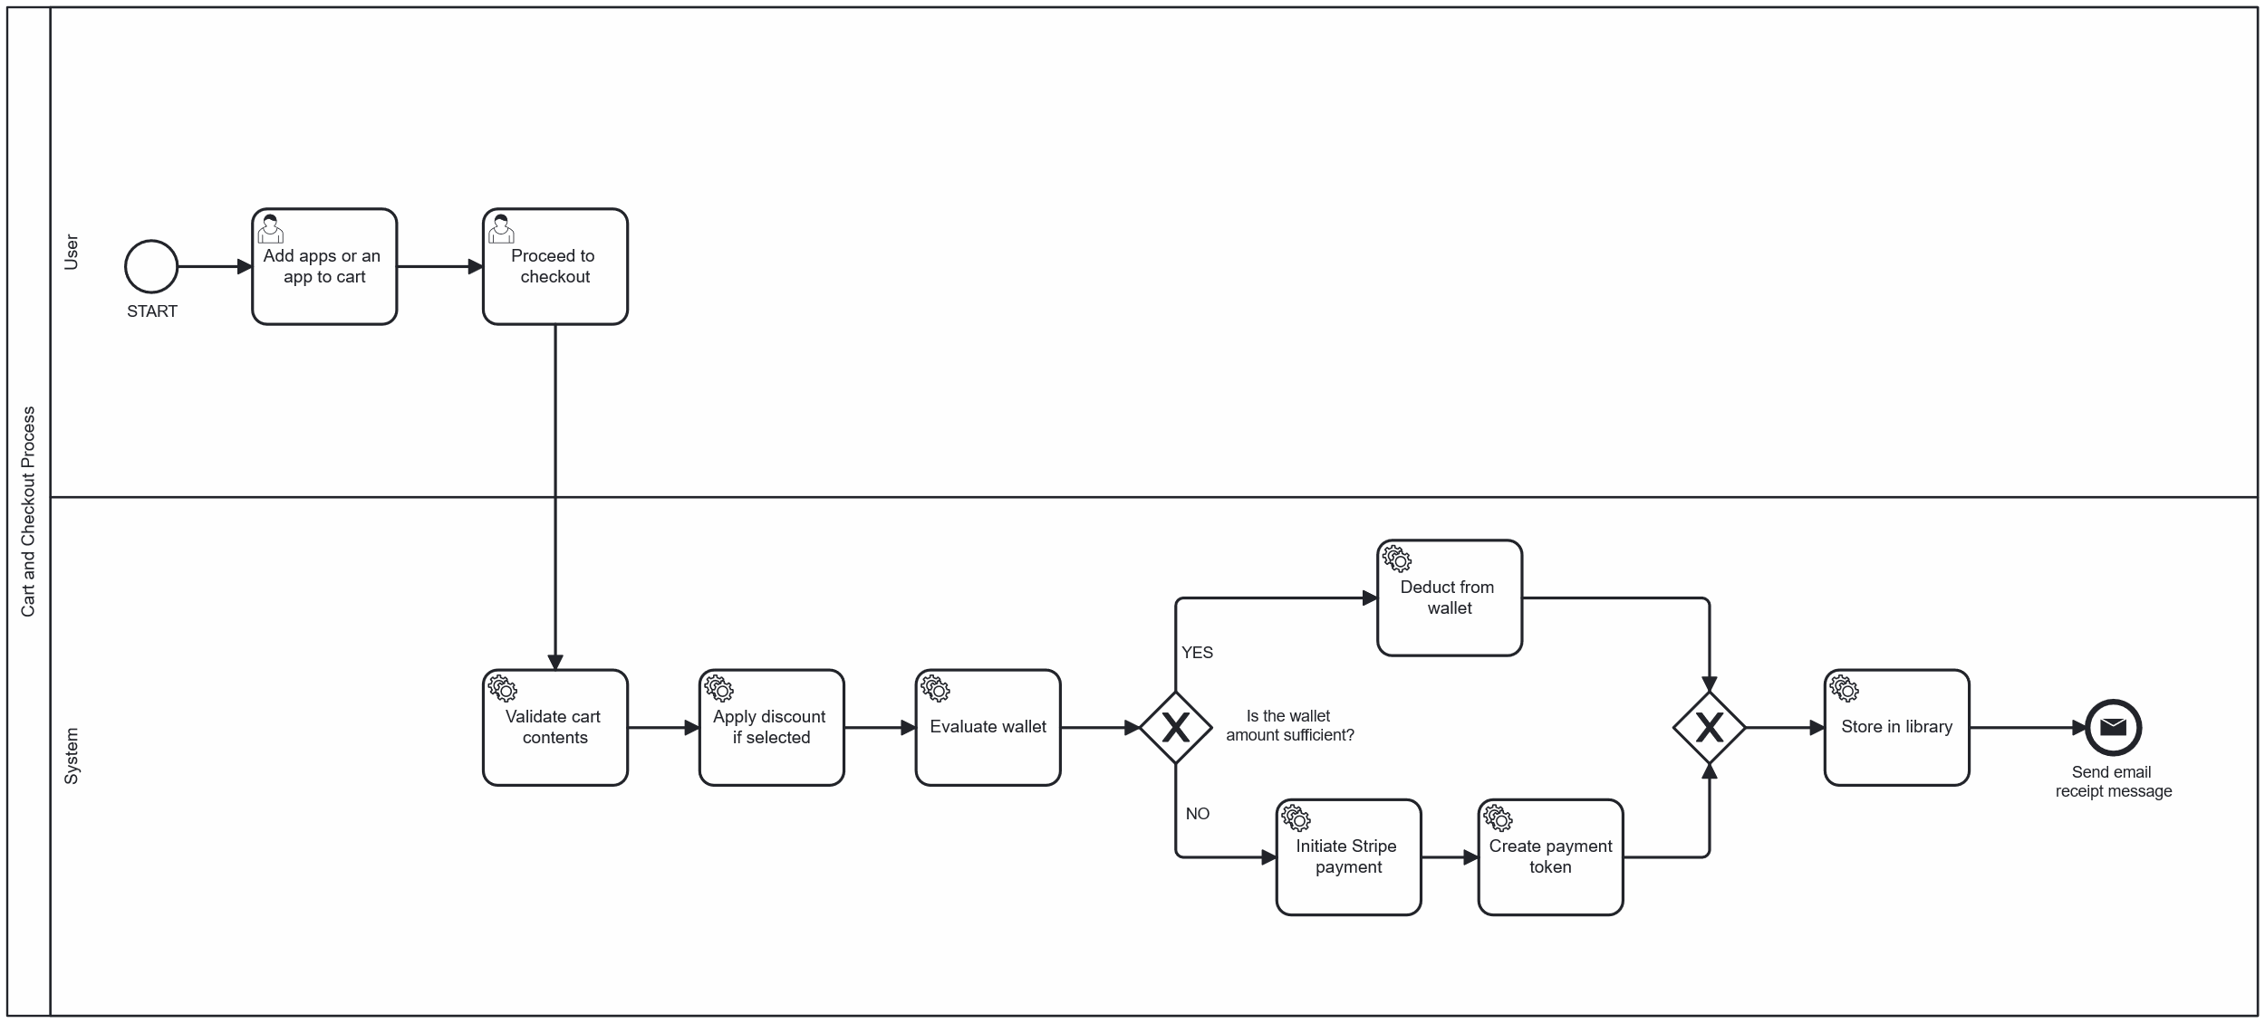

Figure 5. Cart & Checkout Diagram

* + 1. Points Discount Process

**Figure 6** describes the logic behind applying discount points during the checkout process. If the user has a sufficient number of points, the system displays the available discount tiers (e.g., 10%, 25%, 50%). Once a tier is selected, the final price is recalculated. If the user's wallet balance covers the discounted amount, the purchase is completed using the wallet. Otherwise, the system initiates Stripe payment for the remaining balance. Upon successful payment, the purchased item is stored in the user's library and an invoice is sent to the email address of the user.

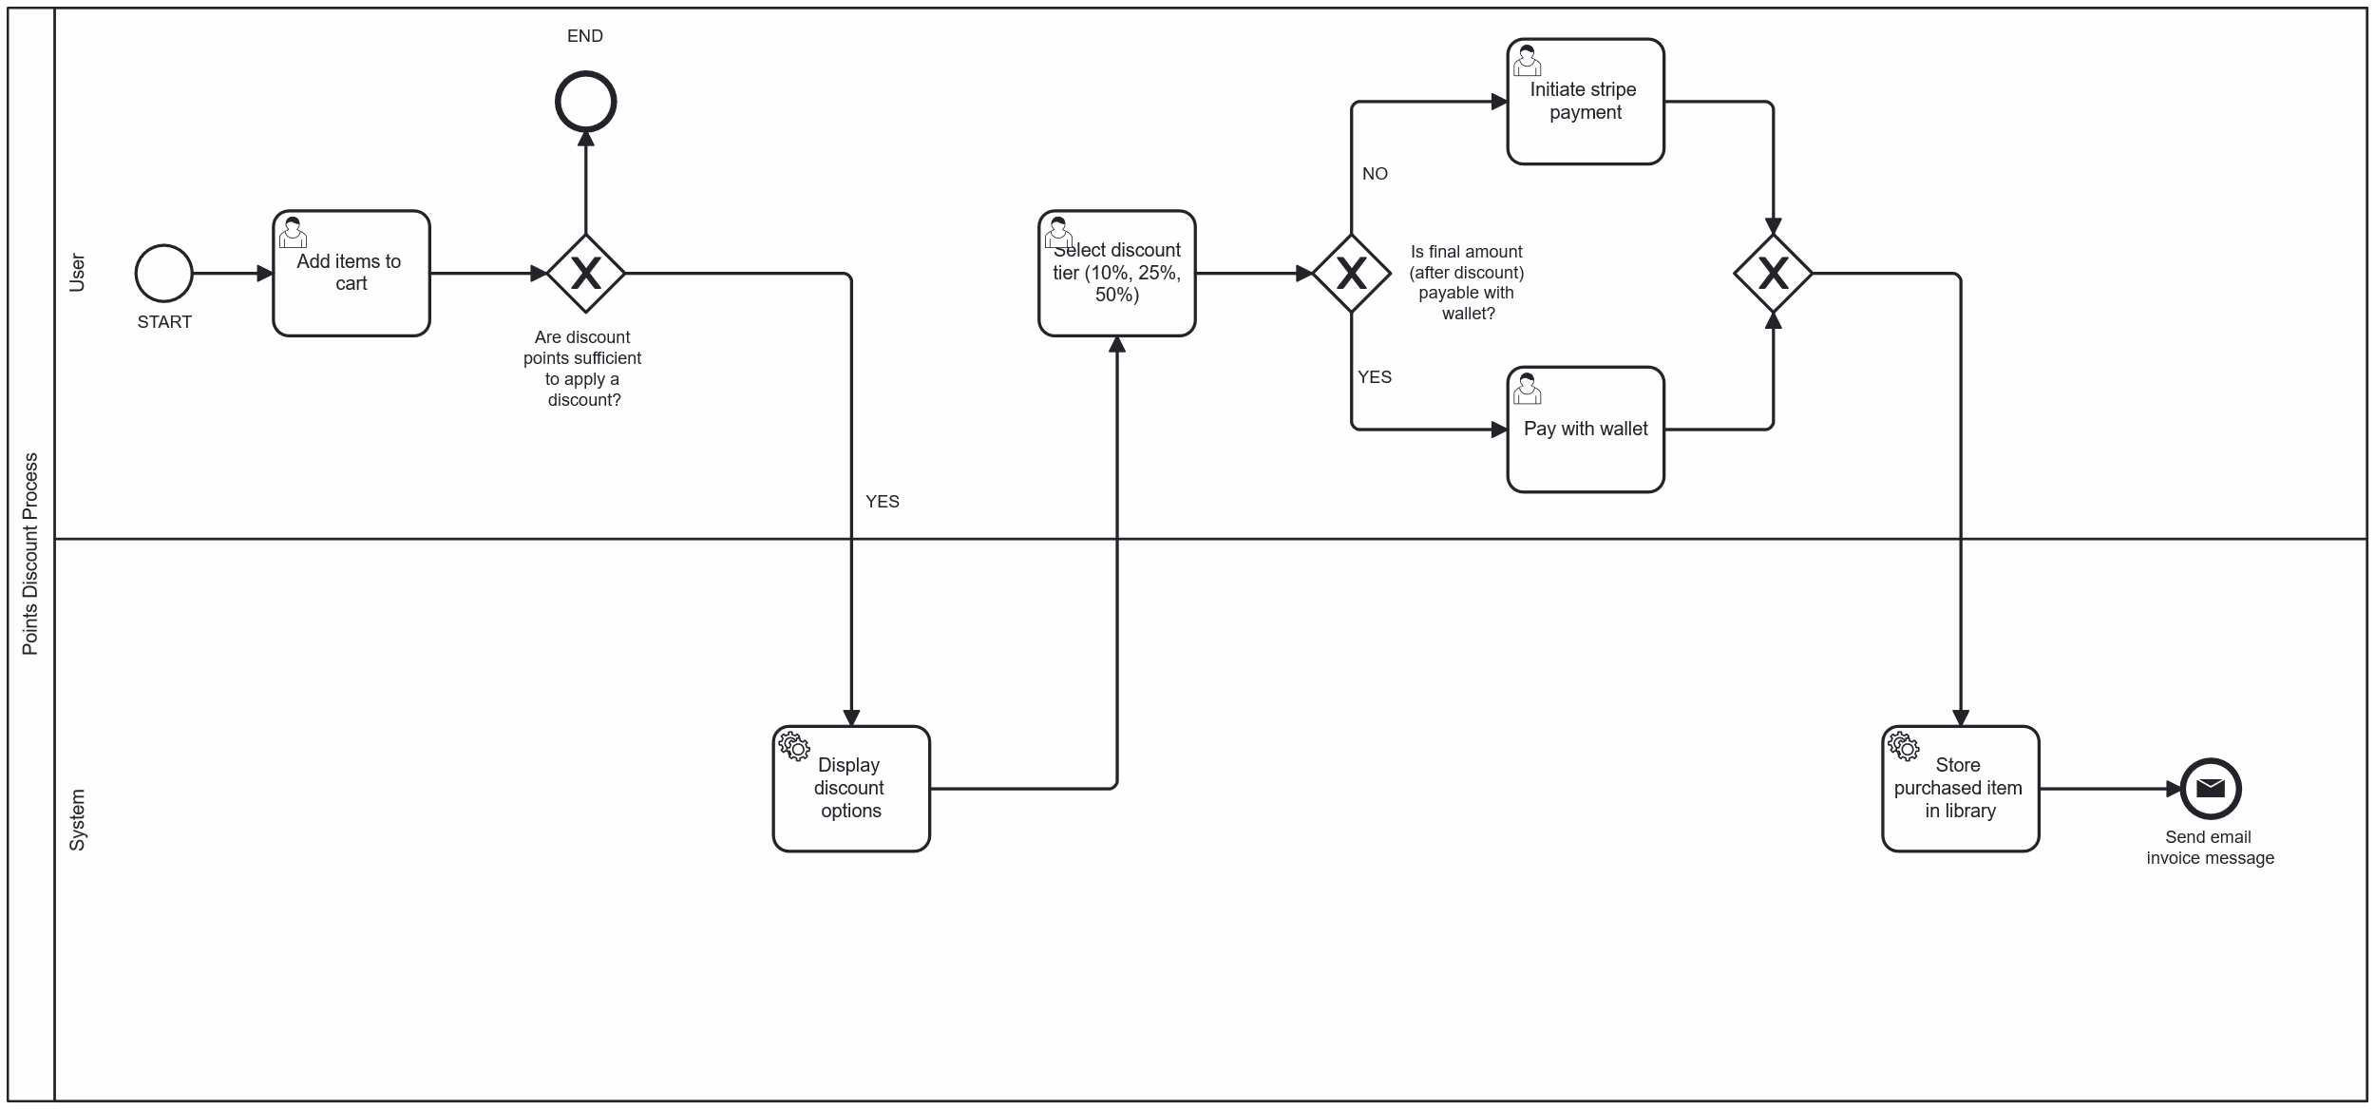

Figure 6. Points Discount Process Diagram

* + 1. Library Access and Ownership Display Process

**Figure 7** shows the process of loading and displaying the user's game library. Once the library page is accessed, the system retrieves the list of owned applications and fetches related content, such as DLCs or soundtracks. For each related item, the system checks ownership status and marks it accordingly:

* If the content is **owned**, it is displayed normally with a colored outline.
* If the content is **not owned**, it is grayed out and labeled with a red ❌ **Not Owned** tag.

This approach enables users to clearly distinguish between owned and unowned related content while still browsing the full set of available items.

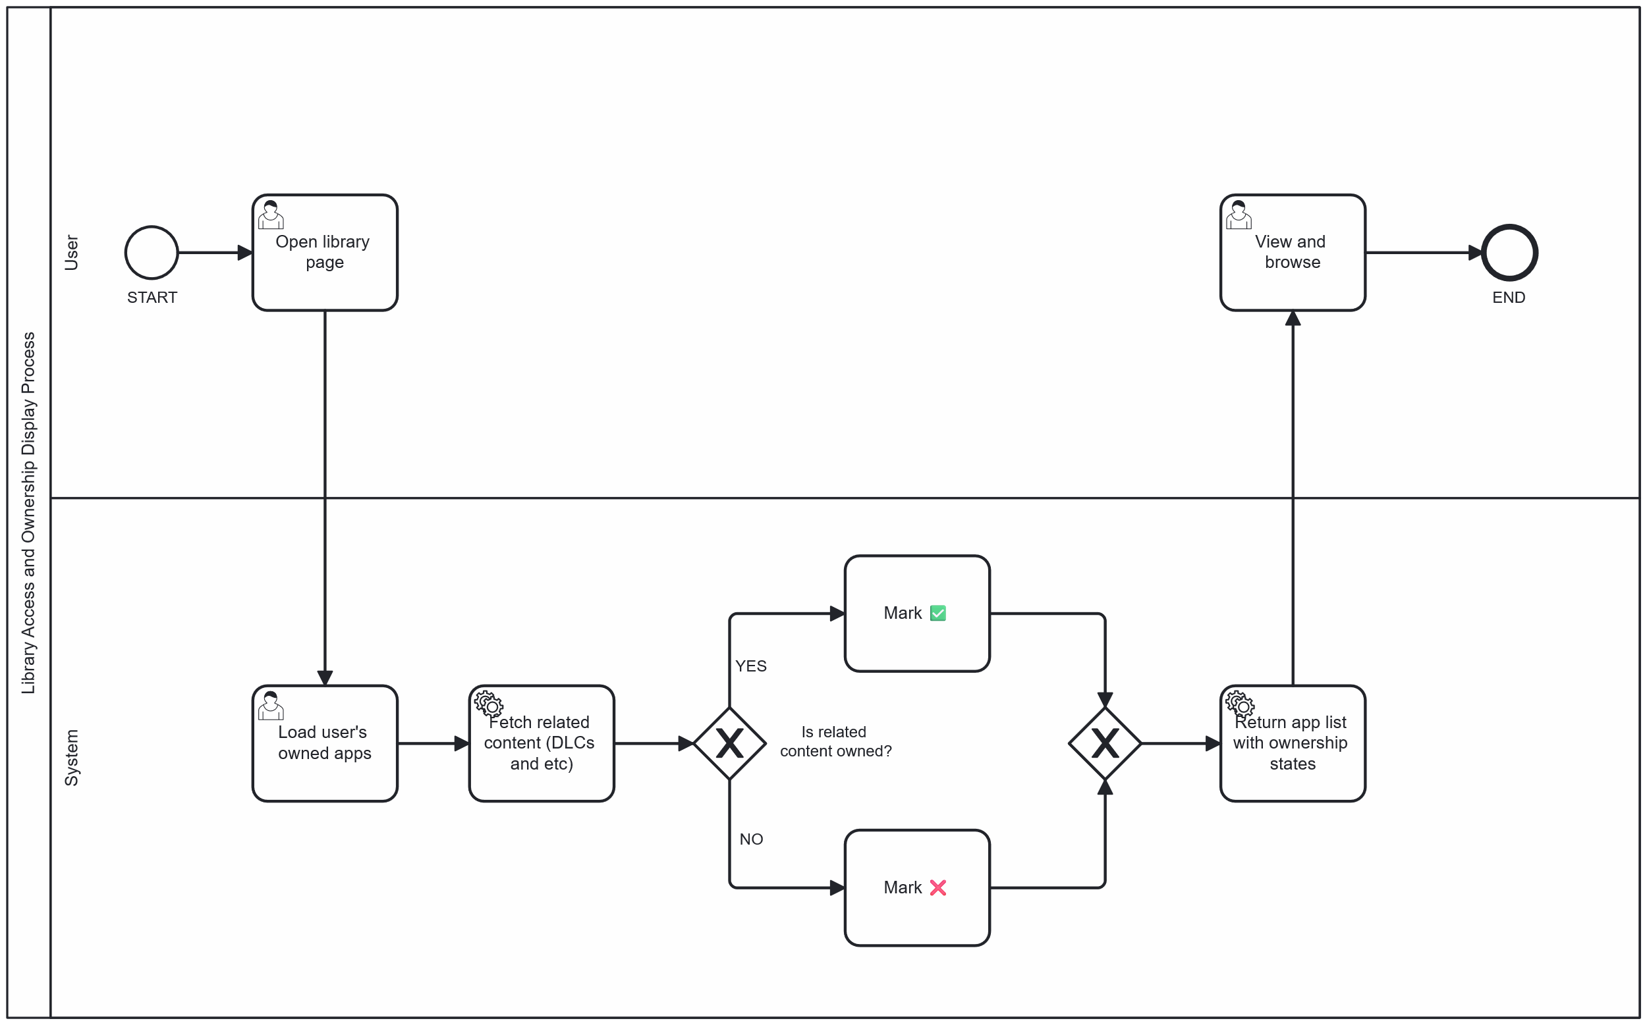

Figure 7. Library Access and Ownership Display Diagram

* + 1. Community Participation Process

**Figure 8** depicts the interaction flow within the Community section of the application. Upon opening the community page, the system loads all available posts and comments.

* If the user is not logged in, they are restricted to viewing content only. Any attempt to comment or like will redirect them to the login screen.
* Logged-in users may like and comment on existing posts.
* Users who own at least one game (including free titles) are additionally allowed to create new posts in the community section.
* When a user likes or comments on a post, a notification is automatically sent to the original post owner to inform them of the interaction.

This flow ensures that meaningful participation in the community is gated by game ownership, while still allowing guests to browse discussions.

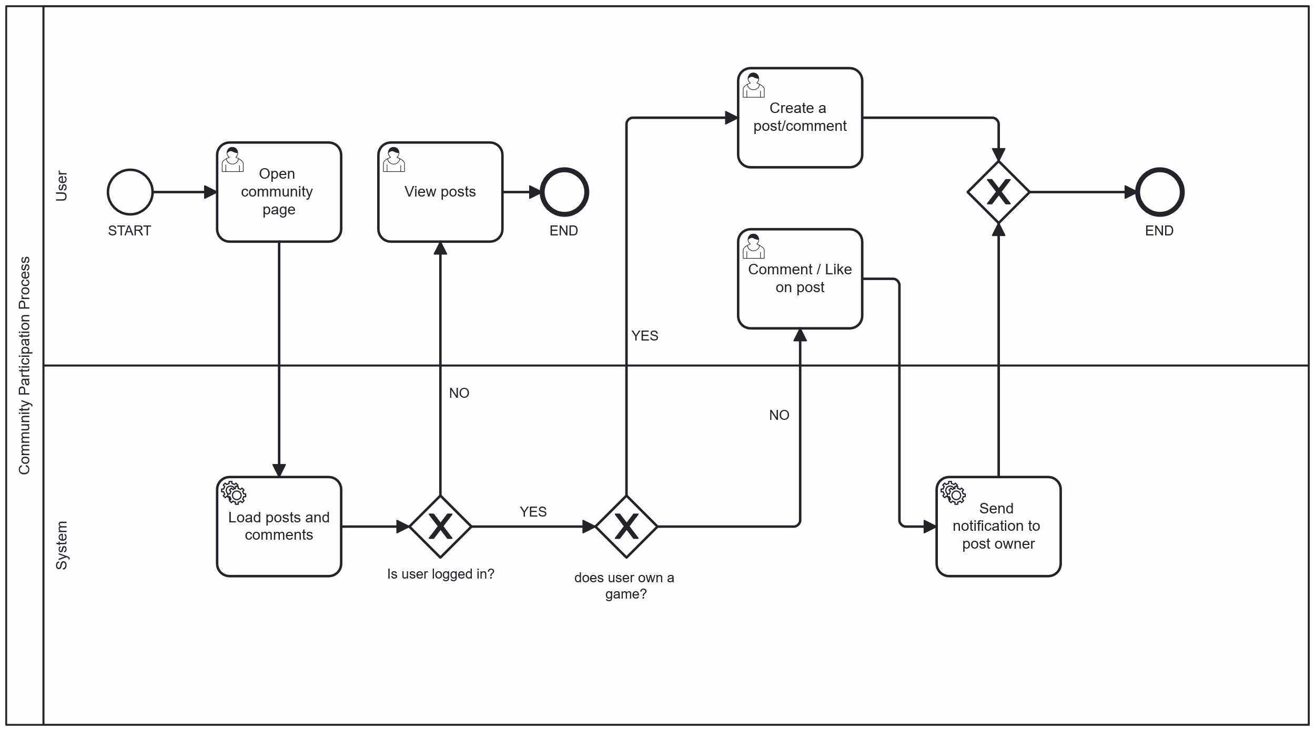

Figure 8. Community Participation Diagram

1. Functional specification and requirements
   1. Functionality requirements

* Authentication & Authorization
  + Users can register with email and password.
  + Users must verify their email before logging in.
  + Expired verification links can be re-sent via a secondary request.
  + A new verification link can only be requested after the previous token has expired.
  + Users can log in using credentials or Google Sign-In.
  + Users receive access and refresh tokens (JWT).
  + Role-based access (e.g., user versus admin).
  + Guests can browse, but not interact with community or perform purchases.
  + If a user initially registers with a @gmail.com and later logs in using Google OAuth, the system automatically links the Google account to the existing profile.
  + Email tokens are deleted after successful verification or if the account is deleted via the verification email.
* Store & Game Discovery
  + Users can browse all published games.
  + Users can search games by name or filter by genre and type (free/paid).
  + Related content (DLCs, music, demos) is always displayed beneath the base game, with visual distinction based on ownership.
  + Sorting option by price.
* Cart & Checkout
  + Users and guests can add games to cart.
  + Users can apply points for tiered discounts (10%, 25%, 50%), if eligible.
  + If the wallet balance is sufficient, the payment is completed using wallet funds.
  + If the wallet balance is insufficient, the remaining amount is paid via Stripe.
  + Checkout uses temporary payment tokens for secure Stripe integration.
  + Existing payment tokens are cleared when a new session is created or the current session is cancelled.
  + An email invoice is sent after successful payment.
* Points & Wallet System
  + Users earn points from purchases that do not use discount tiers (If a discount is applied, points are not awarded).
  + Users can apply points to reduce price at checkout.
  + Users can view their current wallet balance and total points.
  + Discount tiers are available only if the user has sufficient points.
  + Users can top up wallet via Stripe payments.
* Library & Ownership
  + Users can view all owned apps.
  + Related content such as DLCs and music is always displayed, but visually marked based on ownership status.
* Community Module
  + All users (including guests) can view posts.
  + Logged-in users can comment.
  + Only users who own a game can create a post for it.
  + Community posts may include text and image.
  + Guests attempting to interact are redirected to the login page.
  + Any post interaction (like, comment or soft-delete comment by post owner) triggers a notification to the post owner.
  + Post owners can soft-delete comments under their posts.
  + Post owners can delete their own post.
  + Users can soft-delete their own comments.
  + All users can edit their comments, and edited comments are visibly marked after submission.
* Profile Management
  + Users can view public profiles of others via (/profile/:username).
  + Users can edit their display name and profile picture (with cropping functionality).
  + Usernames can be changed, and the user is notified via email when this occurs.
  + Users can change their password and receive an email notification upon doing so.
  + Forgotten passwords can be reset using a time-limited token, which is deleted after use.
  + Accounts not linked with Google can change their email address.
  + Google-linked accounts cannot change their email unless unlinked.
  + Profile displays all owned games.
* Purchase History
  + Users can view a detailed list of all purchases, including app name, purchase date, payment method, and price.
  + The history also displays wallet changes (in/out) and resulting wallet balances.
  + Stripe top-ups and free purchases are also tracked for transparency.
* Admin Capabilities
  + Admins can manage specific tables.
  + Admin panel allows export of user data in multiple formats (JSON, XLSX).
  1. User interface
     1. Navigation Bar

**Figure 9** presents the application’s navigation bar, a fixed UI element positioned at the top of every page. It grants quick access to major sections of the platform and provides real-time user status and account insights.

* Logo & App Name:
  + Positioned on the far left.
  + The Vapor logo is clickable and redirects users to the Store, which acts as the home page.
* Primary Navigation Links
  + Store – Directs users to browse all available games and media.
  + Library – Opens the user’s personal collection of owned applications.
  + Community – Leads to the Community section where users can view posts, comment and interact.
  + About – Provides information about the Vapor application, including how it operates and special features, such as points system.
* User Profile Section
  + Appears on the far right.
  + Displays the display name and wallet balance.
  + If not logged in, a Login button is shown instead (See **Figure 10**).
  + The profile picture adapts dynamically, defaulting to a preset image upon registration unless updated by the user.
* Notification System
  + The notification bell icon appears next to the profile only when the user is logged in.
  + Notifications are shown for:
    - Comments on the user’s post (See **Figure 11**).
    - Likes on the user’s post.
    - Deletion of the user's comment by a post owner (See **Figure 12**).
  + Users can:
    - View a count of unread notifications.
    - Clear individual or all notifications with a single click.
    - See a fallback “No notifications yet” message when empty (See **Figure 13**).
  + Each notification acts as a hyperlink, redirecting the user to the relevant post based on the postId. The page automatically scrolls to the selected post and briefly highlights it for better visibility and user focus. (See **Figure 14**)
* Design Characteristics
  + Dark theme that complements the platform’s visual identity.
  + Modern, minimalist layout prioritizing readability.
  + Active section links are highlighted for visual clarity (e.g., the “Store” link is highlighted when on Store page).
  + Clean alignment and spacing ensure a polished appearance.
* UX/UI Principles Followed:
  + Consistency: Uniform design across pages.
  + Minimalism: Only essential navigation elements are displayed.
  + Immediate feedback: Immediate visual updates (e.g., link highlighting).
  + Accessibility: High-contrast colors improve legibility.

The navigation bar provides seamless access to key areas of the application, displaying essential user information such as wallet balance and username. It also features a responsive notification system for real-time interaction updates. The overall design is dark-themed, modern, and consistent - carefully crafted to enhance usability and deliver optimal user experience.



Figure 9. Navigation Bar (Logged In)



Figure 10. Navigation Bar (Logged Out)

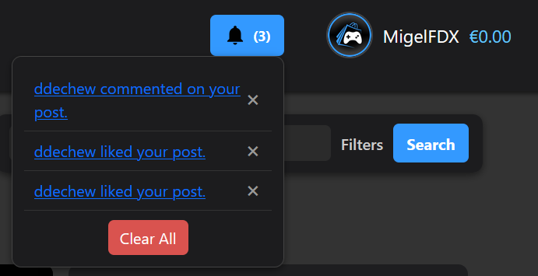

Figure 11. Notification System (Like and Comment Notification Types)

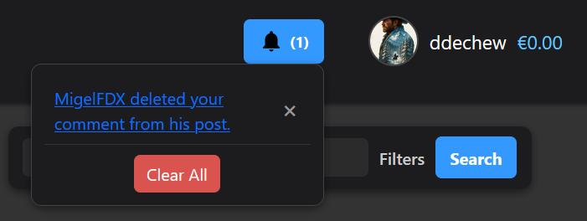

Figure 12. Notification System (Soft-Deleted Comment Notification Type)

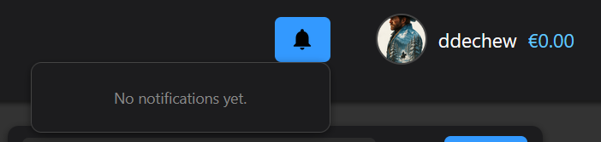

Figure 13. Notification System (Fallback)

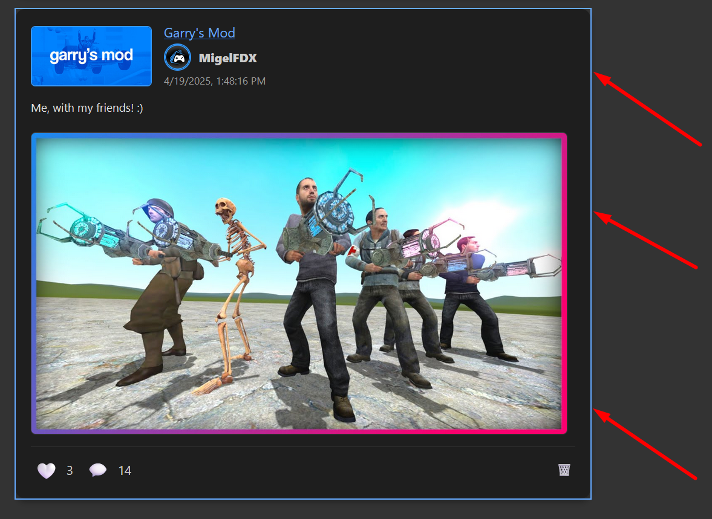

Figure 14. Notification-Triggered Post Scroll and Highlight in Community

* + 1. Store Page

The Store page component (**Figure 15**) serves as the primary hub for discovering and browsing games. It features a user-friendly, intuitive interface that allows users to search, filter, and explore the available catalog of applications. The layout is divided into clearly defined sections, each offering specific functionality - such as search, genre filtering, sorting, and pagination - to enhance the user experience. By default, games are displayed in descending order based on their purchase count, meaning the most popular titles appear first on the initial page.

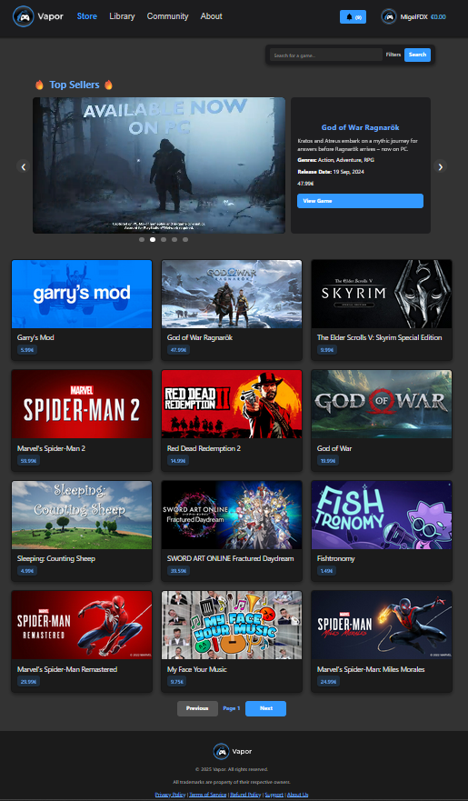

Figure 15. Store Page

**Main Components**

The components that I have included in the store page are several and I split them like this on purpose so the code on the page has better readability and less lines of code.

* + - 1. Search Bar

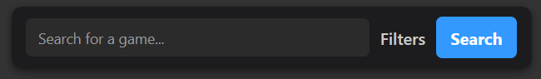The search bar component (**Figure 16**), positioned at the top of the page below the navigation bar, enables users to search games by name, filter results by genre, and sort entries by price in ascending or descending order (**Figure 17**). Additionally, users can refine the results to display only free titles. A “Clear Filters” button is provided for quickly resetting all applied filters (**Figure 18**).

Figure 16. Search Bar Component

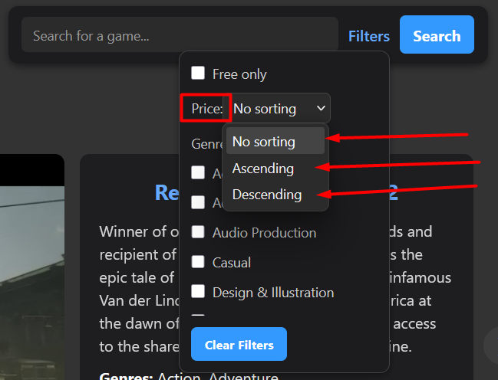

Figure 17. Search Bar Component's Price List Dropdown Menu

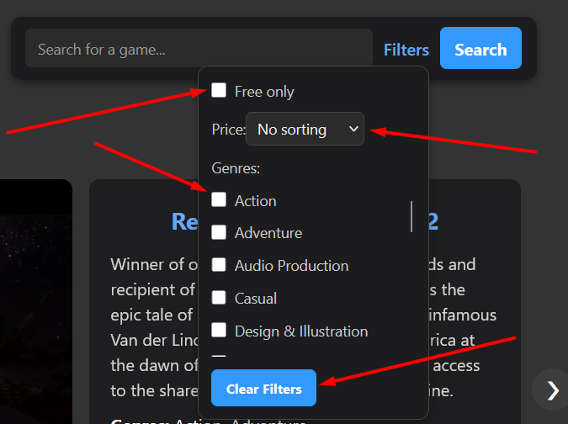

Figure 18. Search Bar Component's Filter Menu

An important feature of the filtering system is its ability to combine multiple filter options simultaneously, allowing users to tailor the results to their specific preferences. This flexibility enhances usability and enables more precise discovery. For example, as illustrated in **Figure 19**, a user interested in both Action and Adventure games but constrained by budget may choose to sort games by ascending price while simultaneously selecting both genres. The system will then return games that match all specified criteria, ensuring efficient and personalized browsing experience.

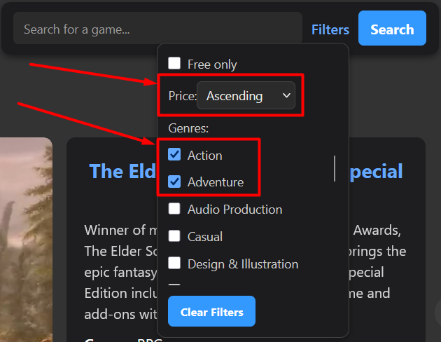

Figure 19. Search Bar Component Filtered

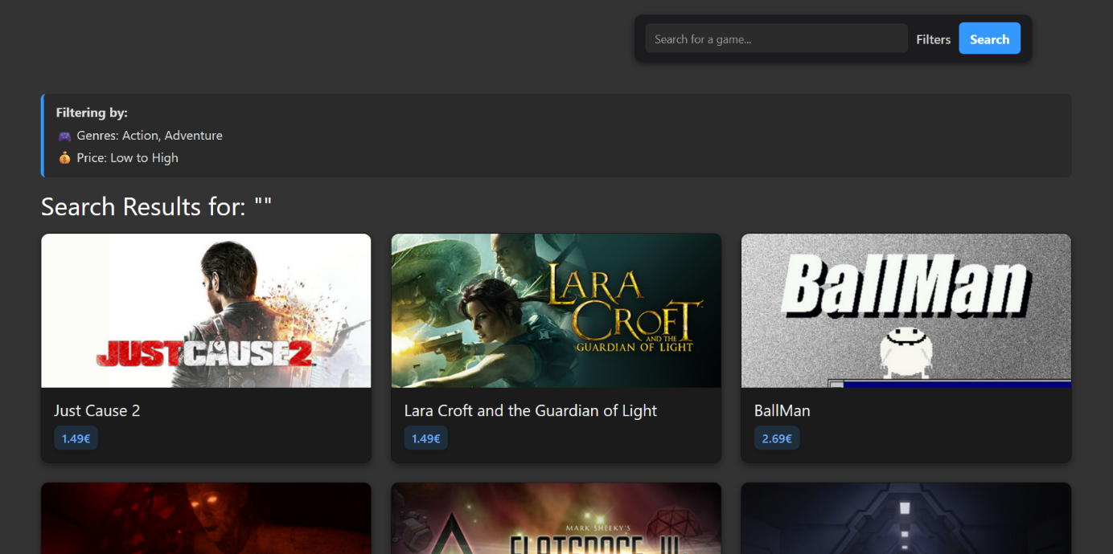After the user activates the search functionality by clicking the Search button, the application redirects to a results page displaying all applications that match the selected filtering criteria. As shown in **Figure 20**, even if no text is entered into the search bar, the system still executes the filter query based on the chosen parameters - in this case, the genres Action and Adventure. This ensures that users receive meaningful results tailored to their selections, with the option to browse and select a game directly from the results page.

Figure 20. Search Bar Page Filter By Price and Genre

When the filters shown in **Figure 21** are applied, the system retrieves only the applications that meet all selected criteria simultaneously. In this specific case, it filters for free applications that also belong to the selected Action and Adventure genres. Price sorting is not applicable in this scenario, as all results have a price of zero and thus no sorting by price is performed.

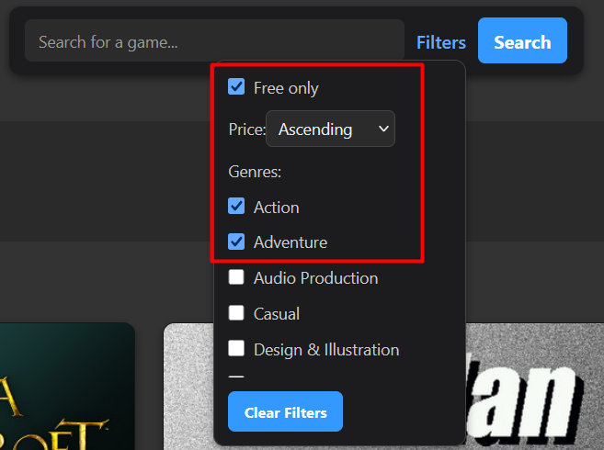

Figure 21. Search Bar Filtration by All Criteria

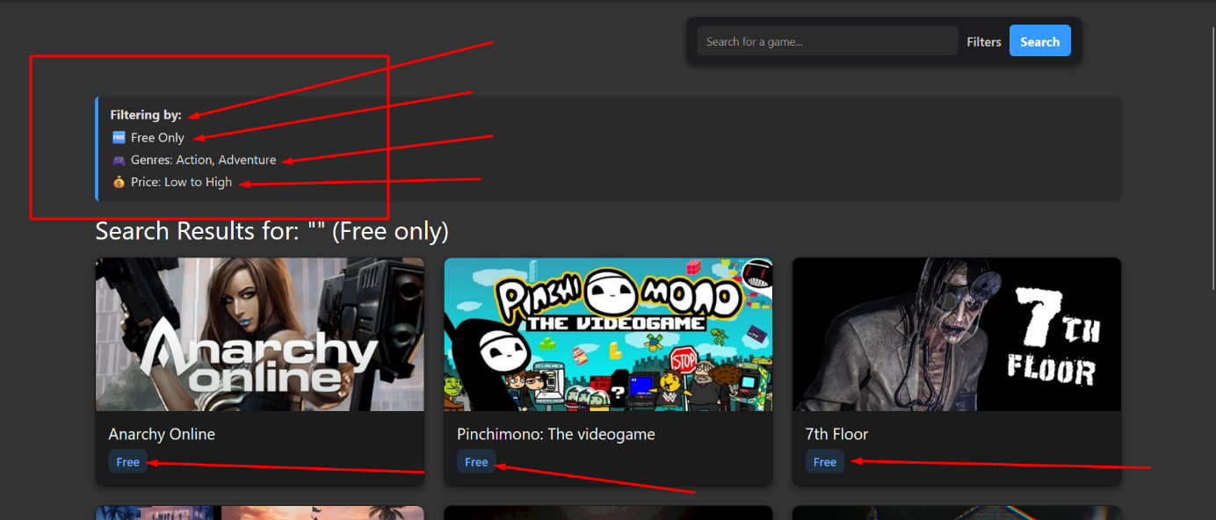**Figure 22** shows the resulting page after applying the filters. The filtering summary is displayed at the top (e.g., Free Only, Genres: Action & Adventure, Price: Low to High), followed by a dynamically generated list of matching applications. Each result clearly indicates its price and basic metadata, allowing users to evaluate their options immediately without navigating away from the page.

Figure 22. Search Bar Filtration by All Criteria Result Page

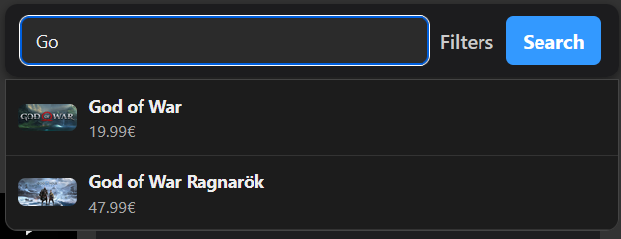Lastly, as the user types in the search bar, dynamic suggestions appear based on the entered input, as shown in **Figure 23** and **Figure 24**. Each suggestion corresponds to a matching application from the catalog. Clicking on a suggestion navigates directly to the respective App Details page. The same redirection also occurs when a result is selected from the search result page.

Figure 23. Search Bar Suggestion Pop-up #1

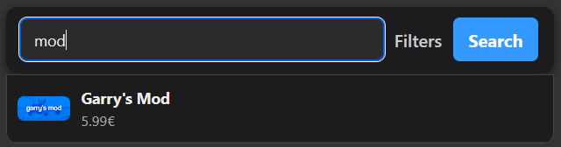

Figure 24. Search Bar Suggestion Pop-up #2

* + - 1. Top Sellers Carousel

The Top Sellers component (**Figure 25**) showcases the most popular applications based on total purchase count, allowing users to quickly identify trending titles. This section enhances user engagement by promoting high-performing games and encouraging exploration without the need for manual search.

**Features:**

* + - * **Dynamic Carousel:** Implemented using the react-slick library.
      * **Autoplay Functionality:** Automatically scrolls through items every 4 seconds with smooth transitions.
      * **Manual Navigation:** Users can manually cycle through games using ❮ / ❯ arrow controls.
      * **Pagination Indicators:** Clickable dots enable users to jump to specific slides.
      * **Dynamic Game Details:** Title, Short Description, Genres, Release Date and Price
      * **Embedded Videos:**
* If the trailer is a YouTube URL, it is rendered through an embedded iframe.
* If the trailer is a direct MP4 file, it is rendered using the native <video> element.
* **"View Game" Button**: Redirects users to the corresponding App Details page.

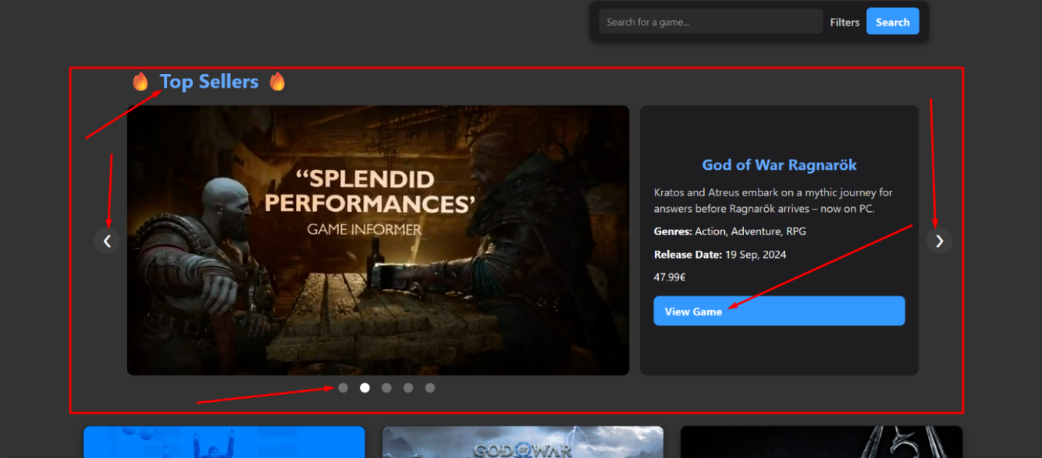This section delivers a polished, premium experience - reminiscent of industry-standard platforms such as [**Steam**](https://store.steampowered.com/) and [**Epic Games Store**](https://store.epicgames.com/en-US/) - making it a central visual anchor on the store page.

Figure 25. Top 5 Sellers Carousel View Component

* + - 1. App Cards (Game Cards)

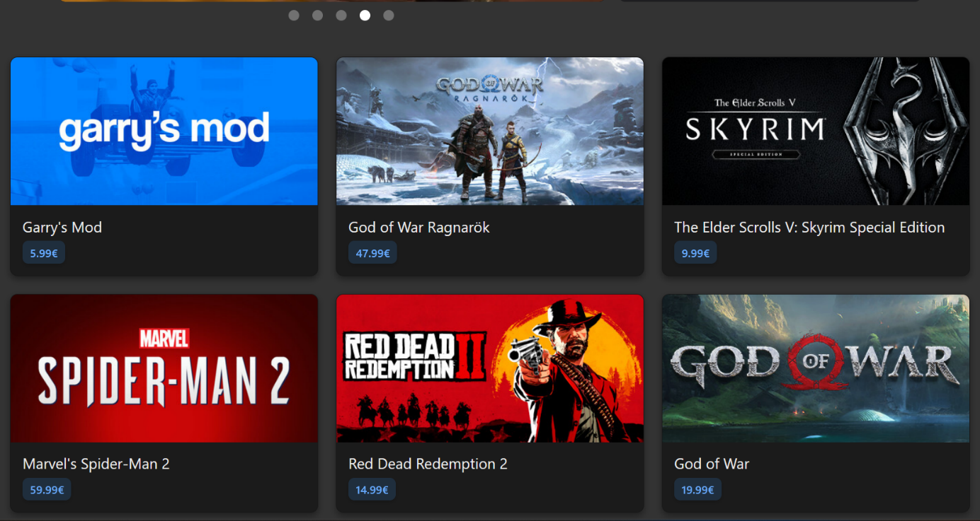The application cards, shown in **Figure 26**, present a paginated, interactive grid layout that displays available games in the store. This interface allows users to explore titles efficiently, with each card showing the game's name and its price (either marked as **"Free"** or listed in **EUR**). The cards are fully clickable, redirecting users to the corresponding App Details page.

Figure 26. App Cards

**Features:**

* **Default Display**: Each card initially shows the game's header image (cover art).
* **Hover Behavior**: When hovering over a card (see **Figure 27**):
  + If the game has a trailer:
    - **YouTube links** are embedded and played muted.
    - **MP4 files** play inline, silently.
* **Pagination**:
  + Implemented at the bottom of the page for seamless navigation.
  + Supports server-side pagination, displaying **12 games per page** to ensure optimal performance.
  + The "Previous" and "Next" buttons scroll the user back to the top of the application grid upon navigation.On each card we can see the name of the application itself as well as the price displayed clearly (either “Free” or price in €)
  + 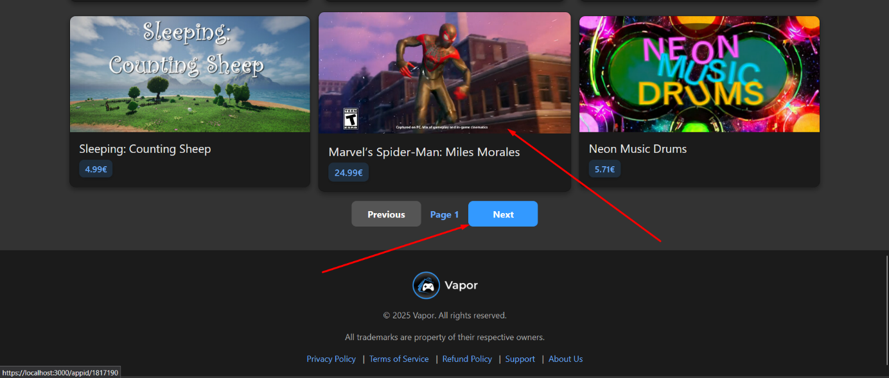Pagination maintains consistent order, ensuring the same cards appear in the same position when returning to a previous page.

Figure 27. App Card Hovered

* + 1. App Details Page

The App Details Page (**Figure 28**) provides users with a comprehensive overview of a selected application. It displays core information such as title, genre, pricing, developer, publisher, and media content including trailers and screenshots. Users can view related applications (e.g., DLCs, music), check their ownership status, and perform key actions such as adding the app to their cart or wishlist. If the app is free, users may add it directly to their library. The page also features a review section where eligible users can submit, edit, or view reviews. Dynamic UI behavior adapts based on the user’s ownership, login status, and whether the app requires a base game. Visual indicators and feedback ensure clarity throughout the purchasing and interaction process.

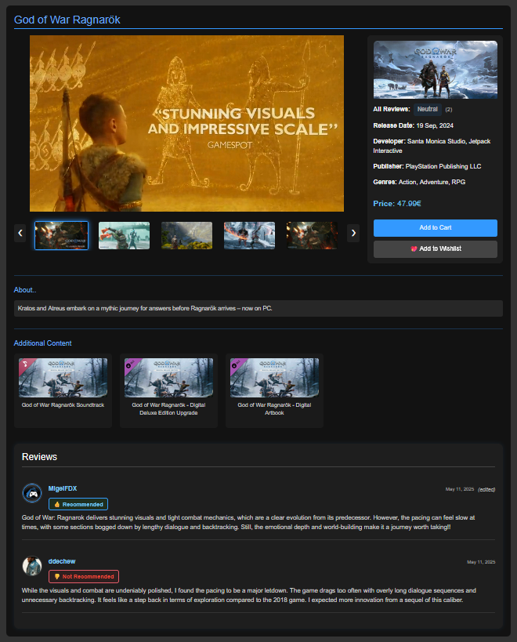

Figure 28. App Details Page (Base App)

* **Main Components**

The App Details Page is composed of several key components that work together to deliver a rich and interactive experience. These include a media carousel, detailed game information, related content, user review functionality, and purchase-related actions. Below is a breakdown of each component and its respective functionality.

* + - 1. Media Section

The media section (**Figure 29**) features a dynamic carousel displaying available trailers and screenshots for the selected application. If a trailer is provided, it is displayed first—either as an embedded YouTube video or an inline MP4 video. When the video ends, or if no video is available, the carousel begins autoplaying through the remaining screenshots in a continuous loop, similar to the behavior in the Top Sellers section.

Manual navigation is also supported via arrow buttons on either side of the main media panel, allowing users to move forward or backward at their own pace. Additionally, a row of clickable thumbnails is provided beneath the main viewer. Clicking on any thumbnail updates the main media display to show the corresponding image or video.

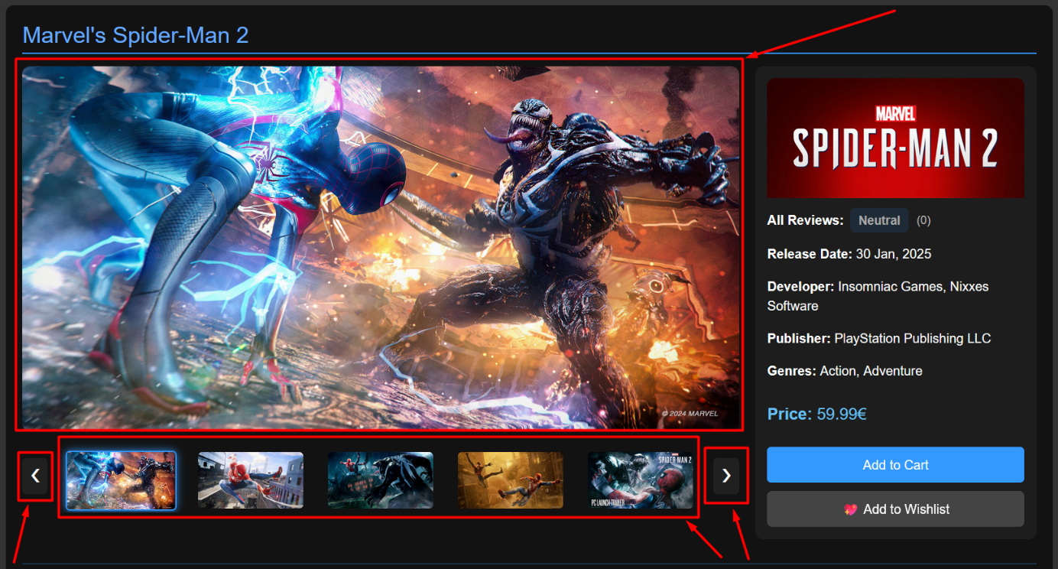This component enhances the user experience by providing a rich, interactive preview of the application’s content before making a purchase decision.

Figure 29. App Details Media Section and Basic Information

* + - 1. Basic Information for the Application

To the right of the media section (**Figure 30),** a structured panel displays essential information about the application. This includes the release date, developer(s), publisher(s), genre(s), and pricing details. The price is clearly shown - either labeled as “Free” or indicated in euros if the game is paid. This concise overview allows users to quickly assess the game's basic attributes before making further decisions, such as adding it to their cart or wishlist.

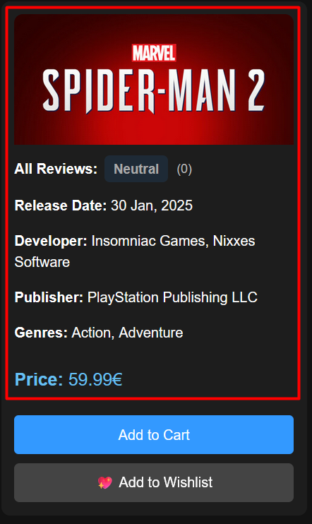

Figure 30. Application Information Section

* + - 1. Purchase & Wishlist Section

The **Purchase & Wishlist Section** (see **Figures 31–33**) allows users to either acquire an application or save it for future consideration. The functionality adapts dynamically based on the user’s ownership status and the app’s pricing.

* **If the app is already owned**, the button displays “In Library” and becomes inactive. Clicking it redirects the user to their Library page (**Figure 31**).
* **If the app is free and not owned**, the button shows “Add to Library.” Upon clicking, the app is immediately added to the user's library without passing through the cart (**Figure 32**).
* **If the app is paid and not owned**, the button displays “Add to Cart.” After clicking, a modal prompts the user to either proceed to checkout or continue shopping. The app is marked as "In Cart" and stored in the database (**Figure 34**).
* If the app is already in the cart, the button changes to **“In Cart”** and links directly to the cart page.

Additionally, all users (logged in) can use the **wishlist feature**:

* If the app is not already in the wishlist and not owned, a **“💖 Add to Wishlist”** button is available beneath the main purchase button.
* Once added, the button updates to **“In Wishlist”** and links to the user’s wishlist page.
* Users cannot wishlist apps they already own.

This system offers flexibility and intuitive UX by distinguishing between ownership, purchase intent, and interest tracking - streamlining the interaction for both free and paid apps.

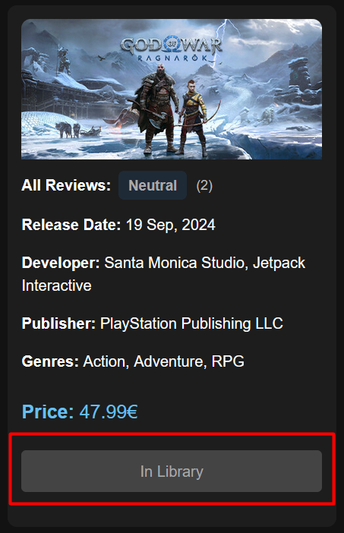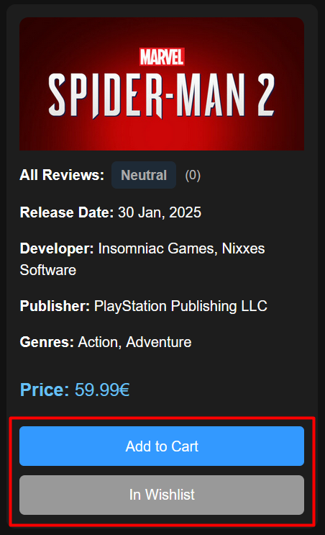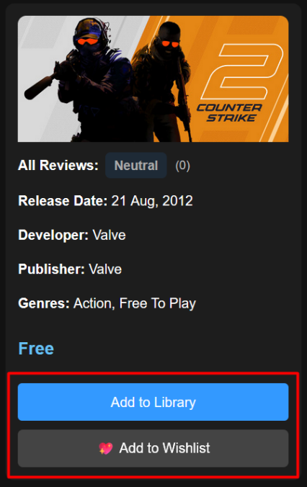

Figure 31. Owned App

Figure 32. Not Owned (Free App)

Figure 33. Not Owned (In Wishlist)

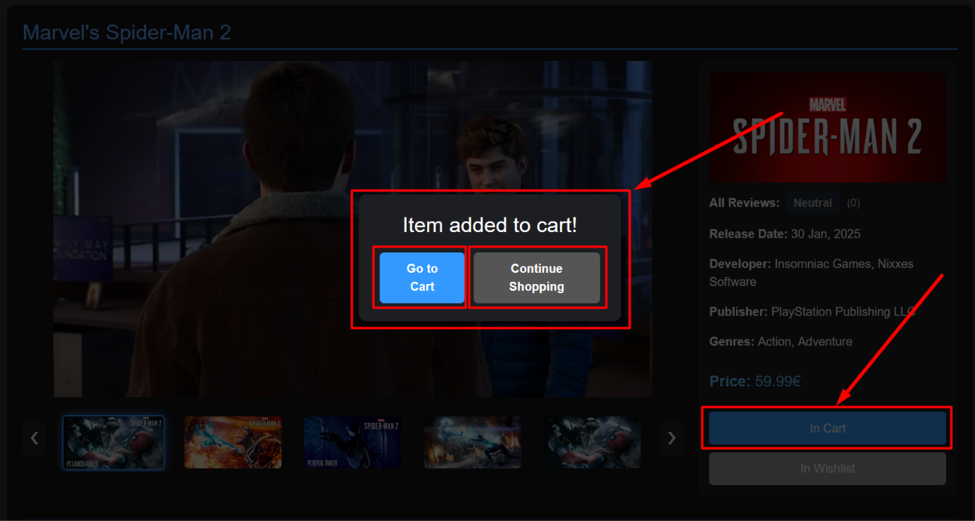

Figure 34. App Details Modal and In Cart Button

* + - 1. Game Description

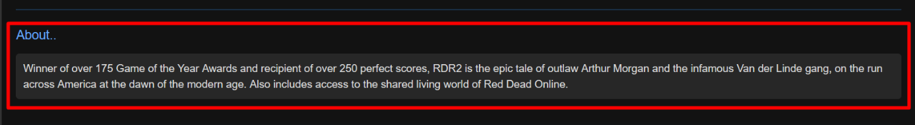The **description section** (See **Figure 35**), located directly beneath the media area, provides users with a detailed overview of the selected application. It outlines the narrative, key features, or promotional highlights provided by the developers or publishers. This section helps users better understand the nature of the game before making a purchase or adding it to their wishlist.

Figure 35. App Details - Game Description

* + - 1. Related Applications Section

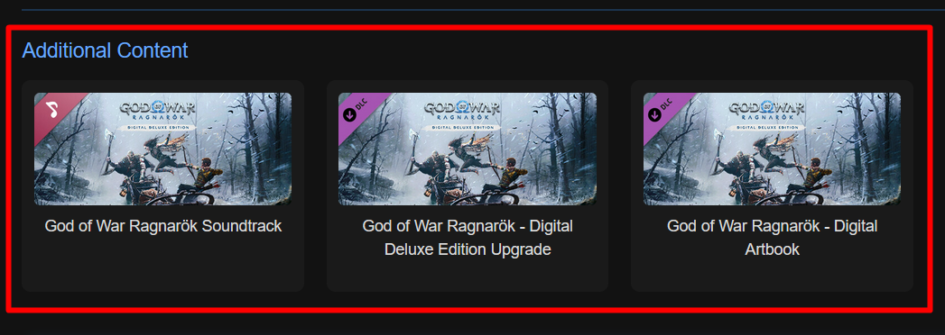This section (**Figure 36**), positioned directly below the game description, displays all related content associated with the selected base application. Related applications may include DLCs, soundtracks, digital upgrades or artbooks. These items are shown regardless of ownership status; however, purchasing or claiming them requires prior ownership of the base game. Related content may be free or paid, and each item is presented using a streamlined card layout similar to the main App Details Page, but with minor adjustments - such as ownership restrictions, grayed-out visuals, or disabled interaction - depending on whether the user owns the base game. This ensures consistency in design while clearly conveying access conditions.

Figure 36. App Details Related Applications Section

* + - 1. ***Reviews Section***

The reviews section (**Figure 37**) allows users who own the game to leave feedback based on their experience. The goal is to help inform potential buyers with community-sourced opinions and contribute to the game's overall public rating. This section supports writing, editing, and summarizing reviews and is conditionally rendered based on ownership and review status.

**Review Eligibility & Access:**

* Only users who own the game and haven’t reviewed it yet can submit a review.
* Once a review is submitted, the submission form is hidden and a confirmation is shown to the user (See **Figure 37**).
* Users can only write one review per application, but they may edit it afterward.

**Review Content & Editing:**

* Reviews consist of:
  + A recommendation badge (“Recommended” or “Not Recommended”)
  + A text field describing the user’s thoughts.
* Users can edit their reviews later and changes are saved upon confirmation.
* If a review is edited a label (edited) is shown next to the date.

Summary & Display States

* All reviews are listed below the game description, including:
  + Profile picture (or a default avatar if missing),
  + Display name with a link to their public profile (if available),
  + Review date and status (recommended or not),
  + The review body itself.

Three key states exist for this section:

* Reviews section with submitted reviews shown. Users can view others’ reviews and optionally edit their own (**Figure 37**).
* Review form is shown when a user owns the app but hasn’t submitted a review yet (**Figure 38**).
* No reviews exist for the app; users are prompted to leave the first one (**Figure 39**).

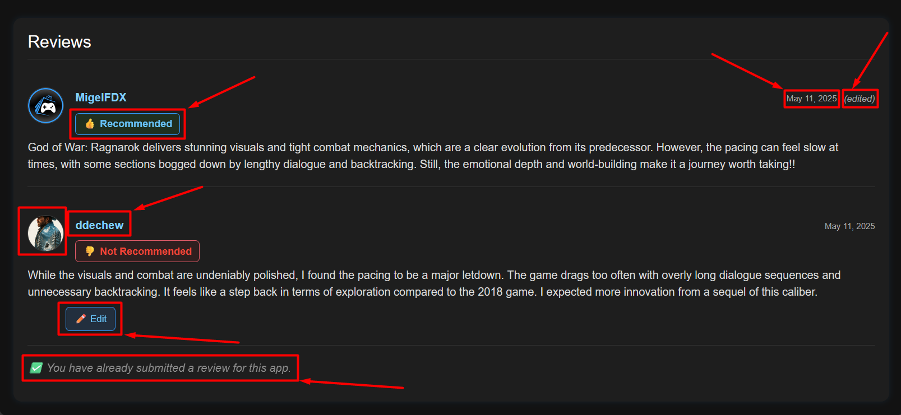

Figure 37. App Reviews Section (Reviewed)

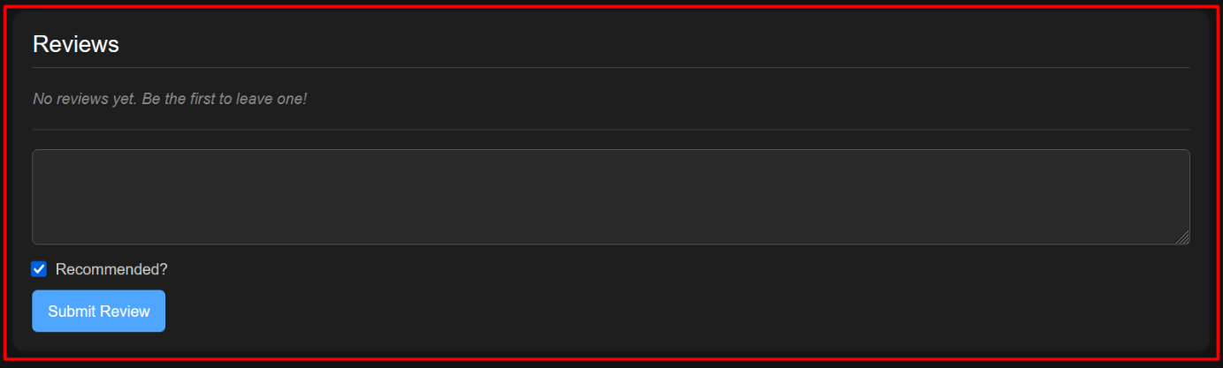

Figure 38. App Review Section (Owns App, Not Reviewed, No Reviews)

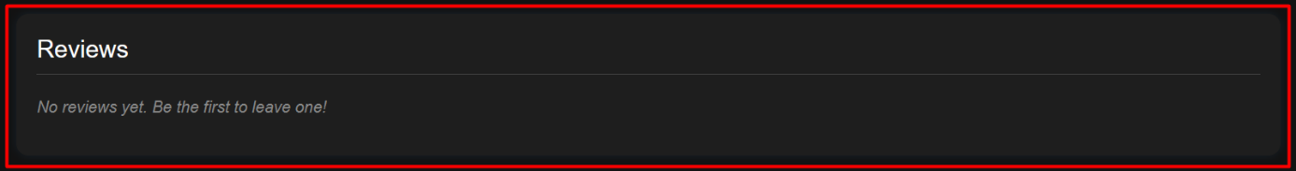

Figure 39. App Review Section (Not Owned, No Reviews)

**Figure 40** demonstrates the editing interface for an existing review. If the logged-in user has already submitted a review, an “Edit” button appears. Upon clicking it:

* The existing review text is populated into a text area.
* A checkbox allows toggling the recommendation status.
* Save and Cancel buttons become available for confirmation.

This inline editing form enhances the user experience by allowing real-time updates without redirecting to a separate page.

The Save button remains disabled until a change is detected, ensuring that unnecessary update requests are avoided. Once changes are saved, the UI is refreshed and the review summary is recalculated if necessary.

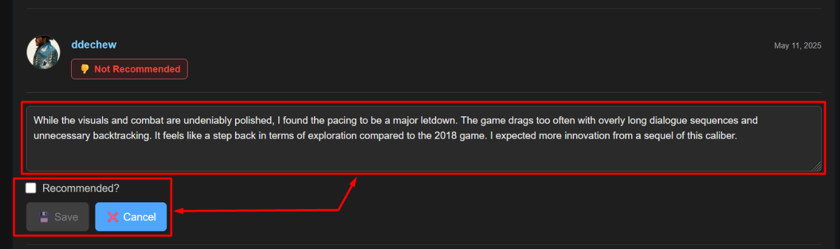

Figure 40. App Review Section (Edit Mode)

The review summary feature (**Figures 41–43**) provides users with a quick visual indication of the overall sentiment for a given application. This summary is dynamically calculated based on user-submitted reviews, and it is displayed on the right-hand panel of the App Details page alongside other game information like release date, developer, publisher, genres, and price.

The summary logic follows these rules:

* **"Mostly Positive"** is shown if the number of *Recommended* reviews is greater than the number of *Not Recommended* ones.
* **"Mostly Negative"** is shown if *Not Recommended* reviews exceed the *Recommended* ones.
* **"Neutral"** is shown when the counts are equal or when no reviews exist.

This sentiment badge is displayed alongside the total number of reviews in parentheses.

**Examples:**

* **Figure 41:** Shows a Neutral summary with two total reviews, one recommended and one not recommended.
* **Figure 42:** Displays Mostly Positive, reflecting a majority of recommended reviews.
* **Figure 43:** Displays Mostly Negative when the majority of users did not recommend the app.

If no user reviews exist yet, the summary defaults to **Neutral** by design.

This feedback is useful for users who want to quickly assess whether an app is well-received or poorly rated before reading full reviews or making a purchase.

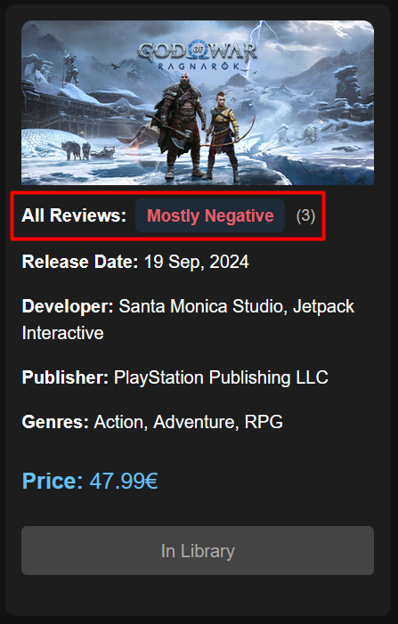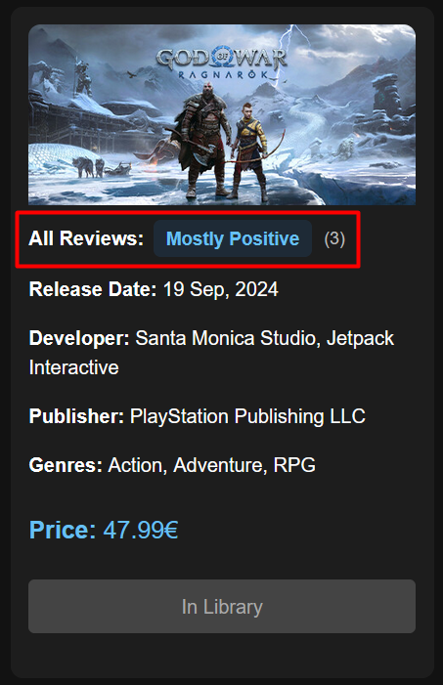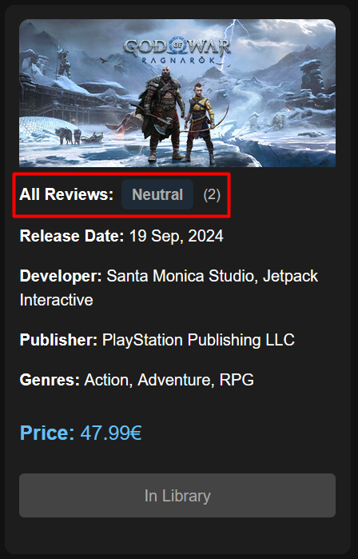

Figure 41. Review Summary (Neutral)

Figure 42. Review Summary (Positive)

Figure 43. Review Summary (Negative)

* + - 1. App Details - Related Application View

This section is used to visualize content related to the currently viewed base application - such as DLCs, soundtracks, or digital upgrades. These additional applications are always tied to a primary base game and are clearly marked visually and functionally.

As seen in **Figure 44**, if the user navigates to a related application's detail page and does not own the base game, a banner is displayed beneath the media section prompting them to visit the main application’s page. In this case, the Add to Cart or Add to Library buttons are also disabled (grayed out), ensuring the content cannot be purchased or claimed independently. These restrictions are enforced both on the frontend and backend.

Additionally, in **Figure 45**, the cover image of a related app features a pink ribbon or label in the upper-left corner. This visual indicator denotes whether the app is a DLC, music pack, or other related content, making it easier for users to distinguish it from standalone games.

These mechanisms collectively ensure that related apps are contextually linked and only accessible when the necessary ownership conditions are met.

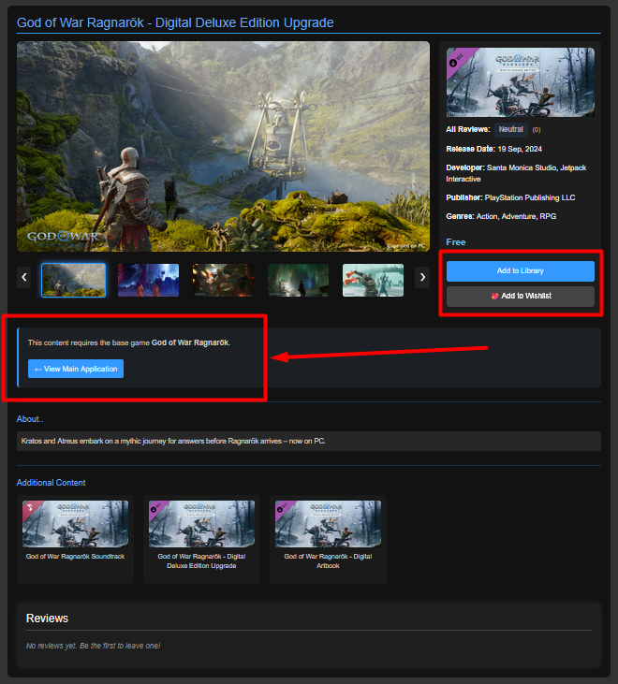

Figure 44. App Details Page (Related App)

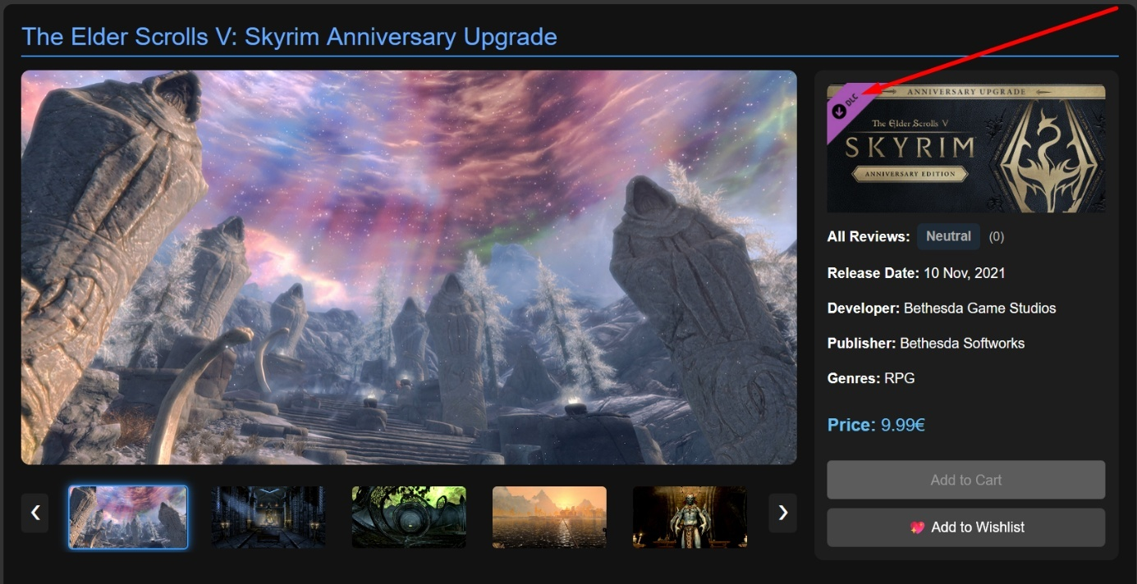

Figure 45. App Details Page (Related App, not owned)

* + 1. Cart Page

The Cart Page allows users to review applications selected for purchase before finalizing the transaction. Each item is listed with its name and price, and a total amount is dynamically calculated at the bottom of the cart. Users have the option to remove individual items or clear the cart entirely.

The page adapts based on the wallet balance of the logged-in user. In **Figure 46**, we see a scenario where the user (MimasXD) has a sufficient balance (€50.00) to cover the total cost of the selected application (€47.99). As a result, a “Pay with Wallet” button is presented, enabling direct payment without the need for external processors like Stripe.

Additionally, the interface shows the number of earned points, which implies the user has previously made purchases. These points can later be used for discounts, but in this scenario, they are not applied yet.

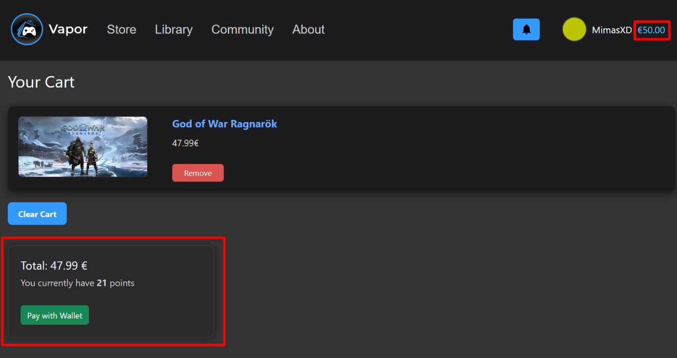

Figure 46. Cart Page (Sufficient Wallet Amount)

By clicking on the “Pay with Wallet” button, the application is successfully purchased, and the corresponding amount is deducted from the user’s wallet. As shown in **Figure 47**, the wallet now reflects a remaining balance of €2.01. Additionally, a confirmation email receipt is automatically sent to the user, summarizing the order details including the purchased title and total amount - this is illustrated in **Figure 48**. Naturally, once the payment is complete, the cart is cleared, and the purchased application is added to the user’s Library — which will be discussed in a later section.

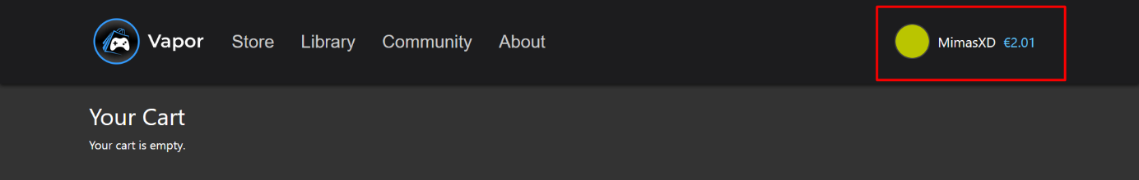

Figure 47. Cart Page (After Payment)

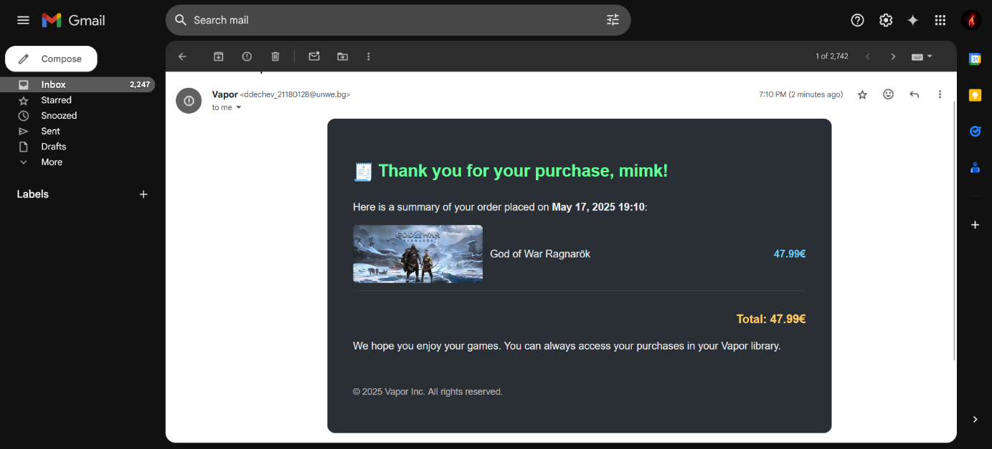

Figure 48. Email Invoice (No discount applied)

Now, let us consider a different scenario, as shown in **Figure 49**.

As previously explained, users cannot purchase related content such as DLCs or music packs unless they own the corresponding base game. However, the system has been designed to allow for a bundled purchase - if the base application is added to the cart, its related content (e.g., DLCs) can also be included. This enables users to effectively create their own bundles in a single transaction. If the base application is later removed from the cart, all related content will be removed automatically as well, preventing users from bypassing ownership requirements.

When proceeding to checkout with insufficient funds, users are given two payment options:

1. **Add Funds** - This option initiates a Stripe session and automatically calculates the **exact missing amount** needed to complete the purchase. In this example, the system calculates the shortfall as **€17.97**, which when added to the user’s existing balance of **€2.01**, allows for an exact total of **€19.98**, leaving the wallet at **€0** after the transaction.
2. **View Wallet** - This method redirects users to the wallet management page, where they can select from predefined top-up amounts: €5, €10, €25, €50, or €100. In this case, the closest applicable option would be **€25**, which would result in a wallet balance of **€27.01**, and leave **€7.03** remaining after the purchase.

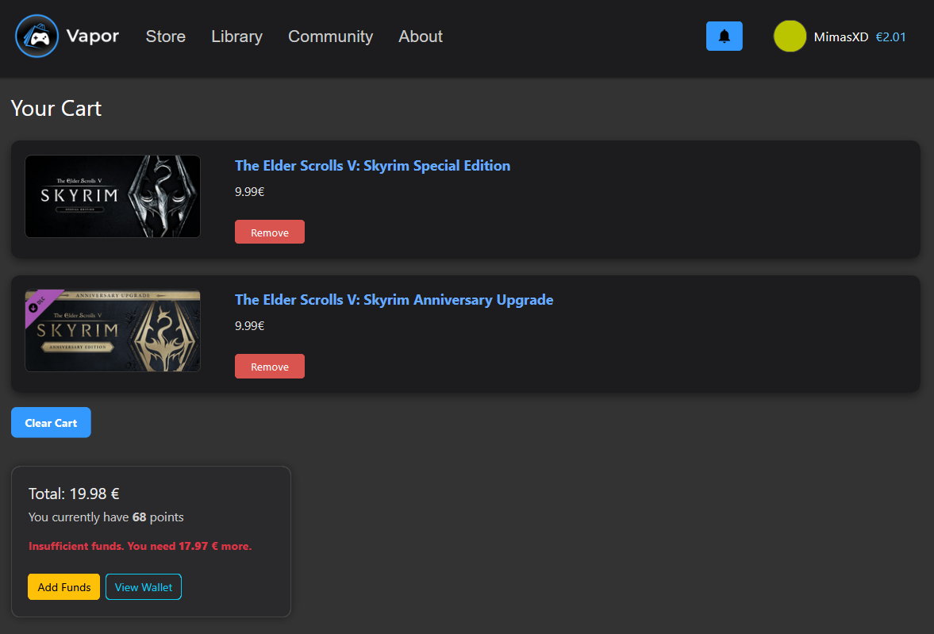This flexible dual approach allows users to choose whether they want to pay only the precise amount needed or maintain a wallet buffer for future purchases.

Figure 49. Cart Page (Insufficient Wallet Amount)

Next, we examine the integrated point system, which was developed to encourage continued user engagement and reward purchases. The system operates on a simple rule: **1 point is awarded for every €1 spent**. This means that users earn points equivalent to the integer portion of their total transaction amount - for instance, a purchase totaling €19.98 will earn **19 points**.

As shown in **Figure 50**, the current cart total is **€44.97**, and the user has **68 points** prior to this transaction. Upon successful purchase, **44 additional points** will be granted (the decimal portion is disregarded), bringing the user’s total to **112 points**. This surpasses the minimum threshold required to unlock a discount during their next purchase.

To facilitate this demonstration and trigger the discount eligibility logic, an additional game was intentionally added to increase the total value above **€32**, allowing us to reach the minimum discount tier.

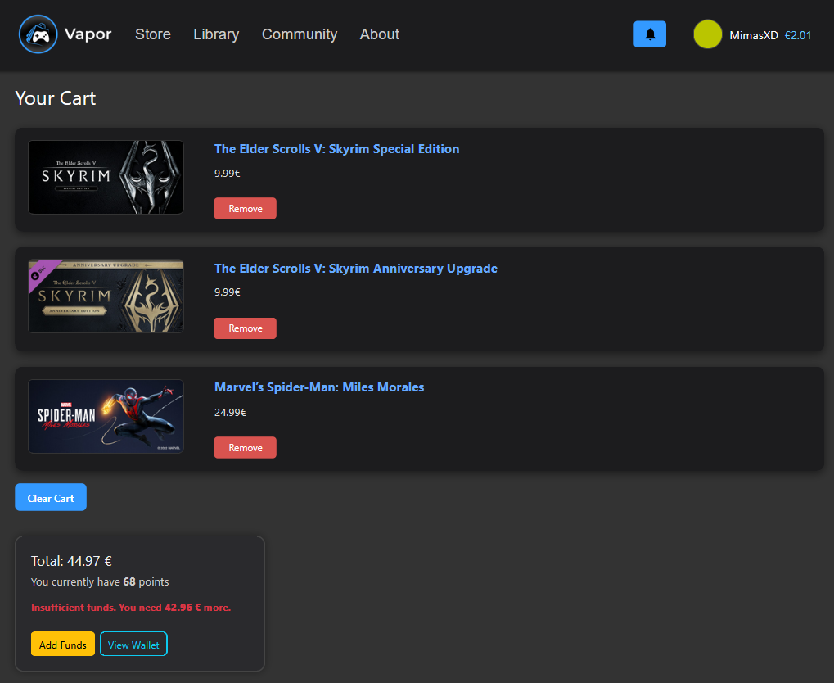

Figure 50. Cart Page (For Stripe Checkout Session)

Upon clicking the **“Add Funds”** button, a modal window appears (see **Figure 50**), informing the user that their current wallet balance is insufficient and prompting them to confirm whether they wish to proceed to Stripe for payment processing. This mechanism ensures that the user is aware of the remaining required amount before being redirected externally.

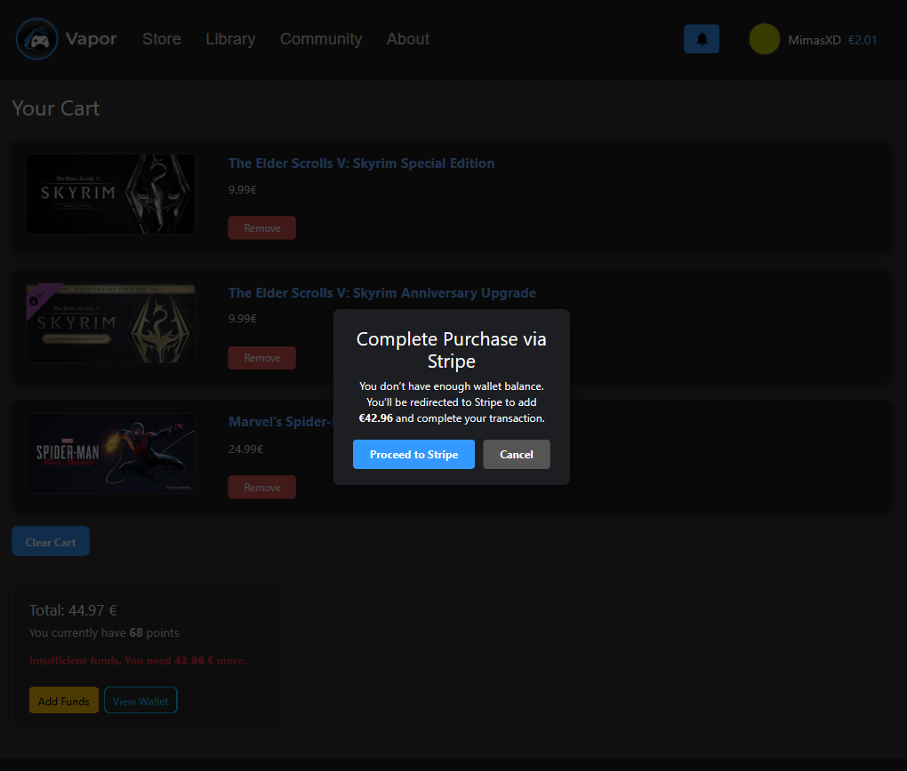

Figure 51. Cart Page (Stripe Modal)

If the user confirms by clicking **“Proceed to Stripe”**, they are taken to a Stripe Checkout session (as shown in **Figure 52**) with the exact amount pre-filled - in this case, **€42.96**. Since the application is still in development and not deployed in production, Stripe operates in **Test Mode**. According to Stripe’s official test API guidelines, the card number must be set to **4242 4242 4242 4242**, with a valid expiration date (any future month and year), and the other fields such as **CVC, name, and country** can be arbitrary. The email address field must be formatted correctly, although it does not need to be a real address during testing.

This seamless integration allows users to fund their wallet and complete their purchase in a single flow, ensuring smooth UX and transaction consistency, even when their wallet lacks sufficient funds. After a transaction attempt, the user is redirected back to the application, where a message is displayed indicating whether the transaction was successful or not.

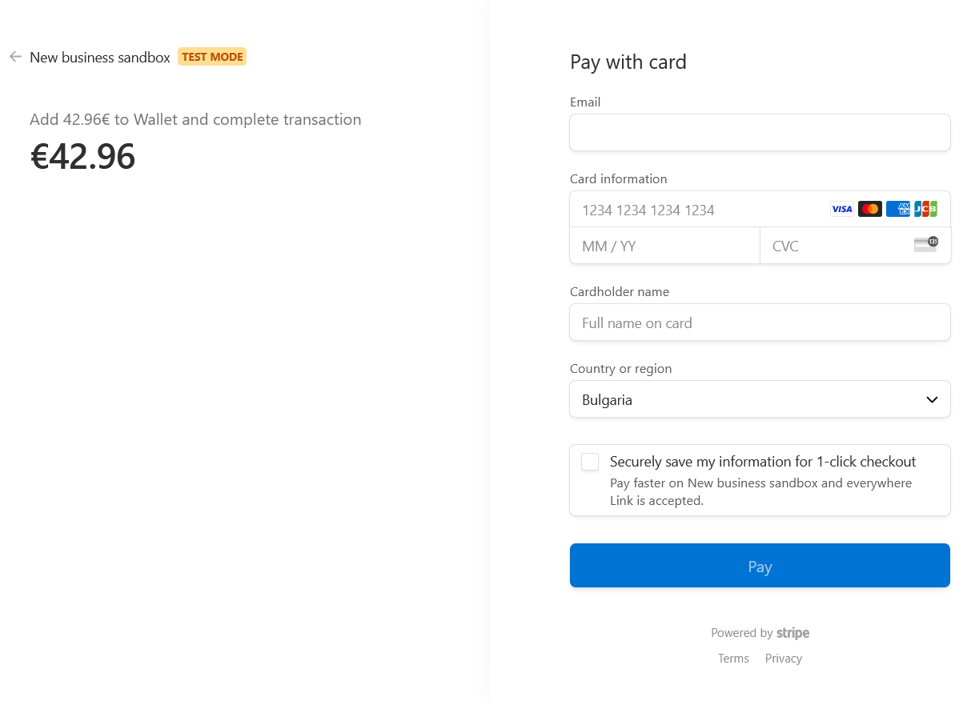

Figure 52. Stripe Checkout Session

As shown in **Figure 53**, a confirmation modal clearly indicates whether the transaction was successful. In this case, a green checkmark and success message are displayed, confirming that the wallet has been topped up and the selected applications have been purchased. Once the user acknowledges the message by clicking “OK,” the cart is automatically cleared, and the purchased items are transferred to the user’s library.

Additionally, the user earns points for every transaction - one point per euro spent. As expected from the previous total, the user now has **120 points**, surpassing the **100-point** threshold required to unlock the discount feature and trigger the email receipt mechanism for eligible purchases.

The email invoice shown in **Figure 54** reflects the completed transaction and lists multiple purchased items, unlike the previous example which included only a single game. It outlines each application's title, individual price, and the total amount paid, providing a comprehensive summary of the order.

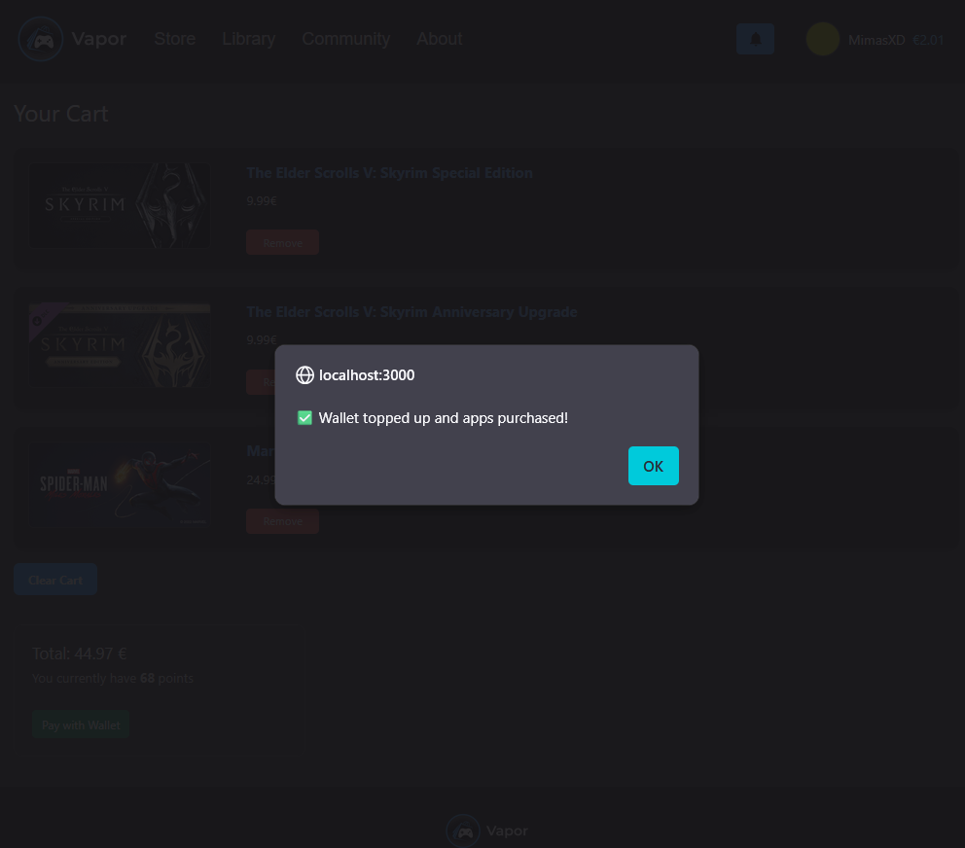

Figure 53. Cart Page (Successful Transaction via Stripe Checkout Session)

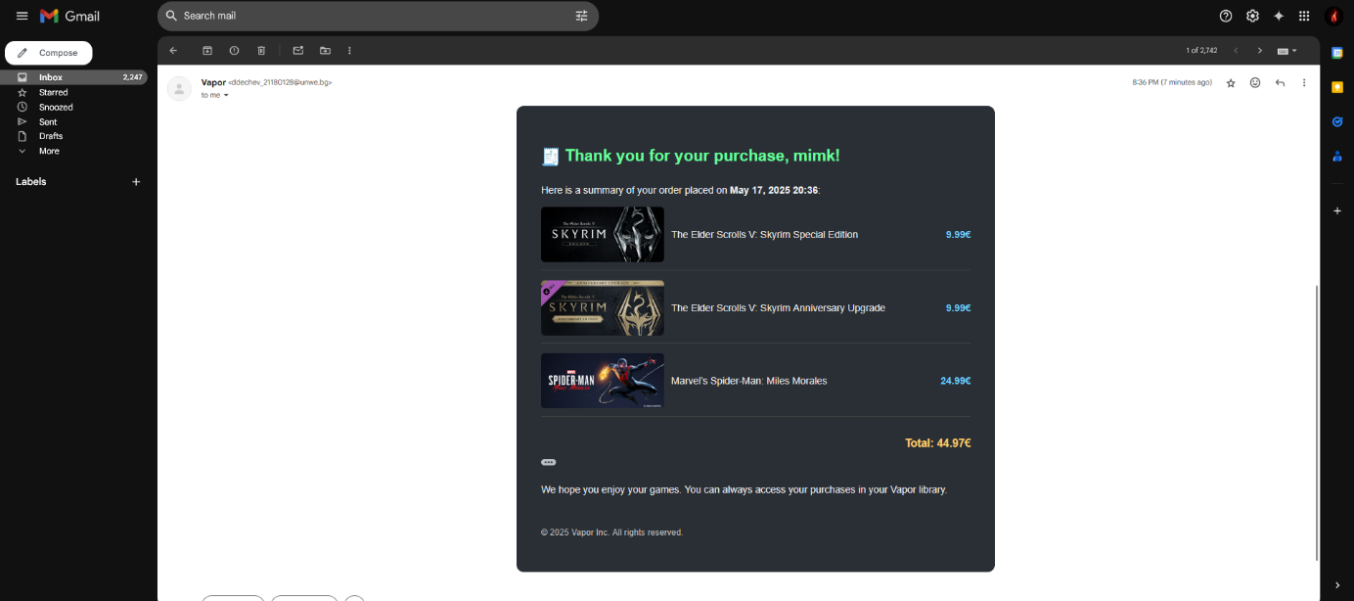

Figure 54. Email Invoice (No Discount, Multiple Items)

Now that we meet the minimum requirement of 100 points, the discount options become available as shown in **Figure 55**. Users can choose to redeem points for a discount: 100 points for 10%, 250 for 25%, and 500 for 50%. Once a discount option is selected, the UI dynamically updates to reflect the adjusted price, while still displaying the original price for reference. Additionally, it recalculates the remaining amount needed to complete the purchase if the wallet balance is insufficient.

As illustrated in **Figure 56**, selecting the 10% discount option reduces the total from €39.59 to €35.63. Users still retain the flexibility to deselect the discount and proceed with a standard purchase if desired. Importantly, when a discount is applied, no new points are earned from that specific transaction. This design choice was intentional - it prevents users from farming points indefinitely and helps maintain profitability within the platform.

Furthermore, the system includes a smart wallet-check feature. For example, if the user has €38 in their wallet and originally needs €39.59, they would not be able to proceed. However, after applying a discount, the required total drops to €35.63, allowing the transaction to succeed using wallet funds alone.

Another convenience feature is cart persistence across sessions: if a guest user adds a game to their cart and later logs in, that item will be preserved and merged with their existing user cart - without duplication.

To ensure consistency in user data (wallet, points, library, etc.) after each transaction - regardless of whether it was completed via wallet or Stripe - a new access and refresh token pair is automatically issued. This eliminates the need for the user to log out and back in to see updated account values.

Finally, a confirmation email is sent after a successful transaction. This receipt includes all purchased items, the applied discount, and the final total. Unlike previous emails that reflected only standard purchases or single titles, this version (see Figure 57) highlights transactions that involve discounts redeemed through points, showing both the original and discounted prices. This provides users with a transparent and detailed summary of their order directly in their inbox.

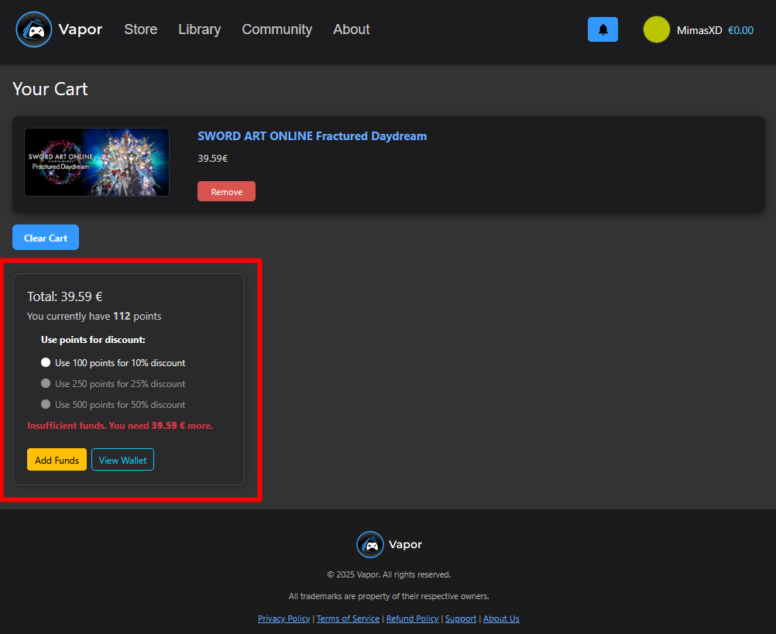

Figure 55. Cart Page (Discount Options)

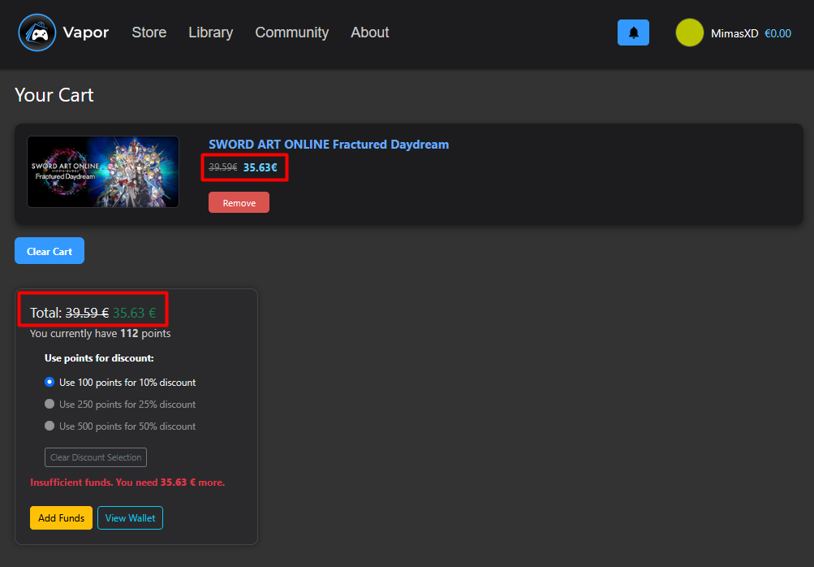

Figure 56. Cart Page (Discount Selected)

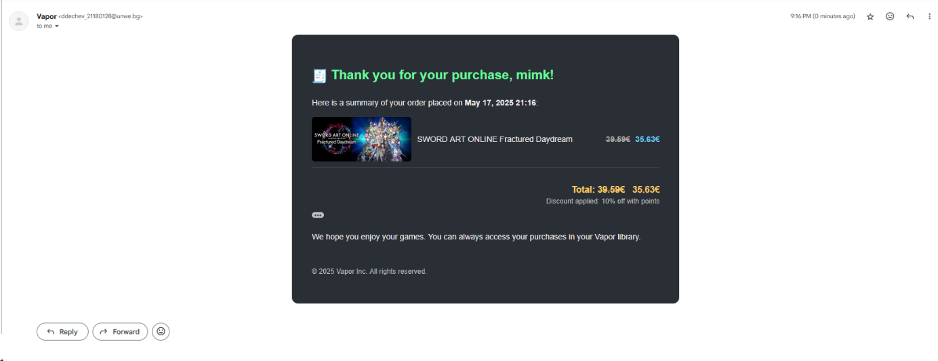

Figure 57. Email Receipt (Discount Applied)

* + 1. Wishlist Page

The Wishlist page provides users with a personalized space to track games they are interested in but have not yet purchased. The functionality closely mimics that of Steam’s wishlist system, offering both visibility and interaction for prioritized game saving.

Users can:

* **View all games** they've added to their wishlist.
* **Change the priority** of items using + / - buttons or by manually entering a value.
* **Remove items** entirely from the wishlist.
* **Click on a game** to view its AppDetails page directly.

Each entry in the wishlist displays the header image, title, current price (or “Free”), and its priority order. Priorities are normalized automatically and handled on the backend to avoid conflicts or duplication.

As shown in **Figure 58**, the interface provides intuitive controls for reordering games, editing priority fields directly, and removing entries.

Behind the scenes, priorities are managed using an integer system. When a new item is added, it receives the next available priority value. On manual changes, the backend reassigns and normalizes all priorities accordingly to maintain integrity (e.g., 1, 2, 3...).

Upon a successful purchase, any wishlist items that match the purchased application IDs are automatically removed from the wishlist, as this implies the user's interest has been fulfilled. This cleanup behavior is done to ensure consistency between the user’s cart, library, and wishlist states. After removal, the remaining wishlist items are automatically reordered to maintain continuous priority values (e.g., 1, 2, 3...). This guarantees that the user’s priority structure remains intact and meaningful even after entries are deleted. (See Figure 59 for a wishlist state before and after a purchase.)

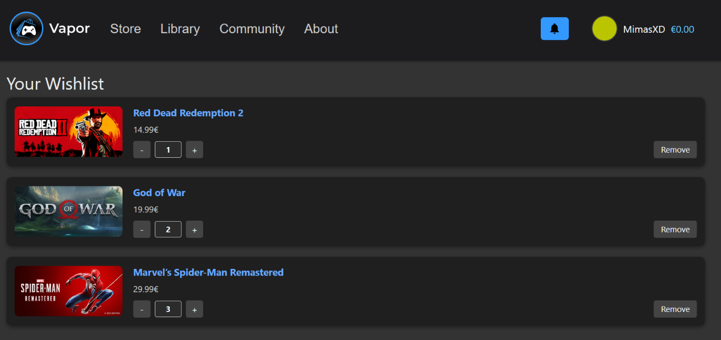

Figure 58. Wishlist Page (Before purchasing an item from the wishlist)

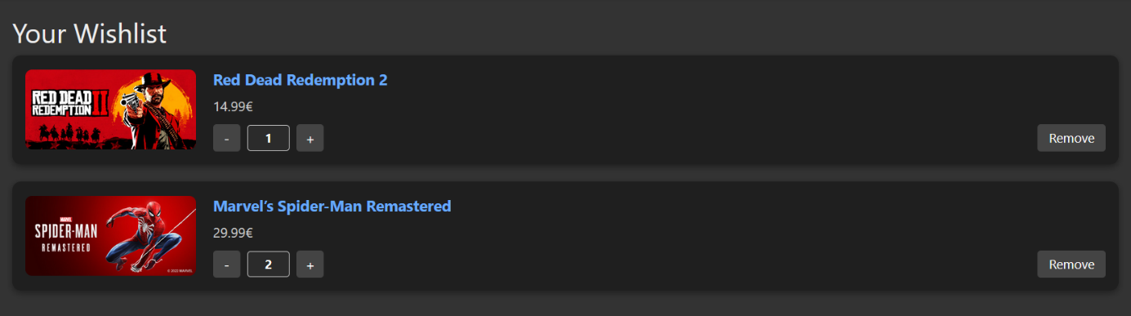

Figure 59. Wishlist Page (After purchasing an item from the wishlist)

* + 1. Wallet Page

The Wallet page (**Figure 60**) allows users to add funds to their Vapor Wallet, which can then be used for purchasing games or other digital content. Several predefined options are available - €5, €10, €25, €50, and €100. Each button opens a Stripe Checkout session for the selected amount.

For instance, clicking the “Add 5€” button triggers the Stripe payment process (**Figure 61**), where the corresponding amount is automatically populated. After completing the payment successfully, the wallet is updated immediately, as shown in **Figure 62**, now reflecting the €5 added to the account.

Access to the Wallet page is made intuitive via the user dropdown menu. As seen in **Figure 63**, clicking on the username at the top right reveals account-related actions, including “View my wallet,” which leads directly to the Wallet page. This design ensures quick and easy navigation.

The wallet balance is consistently visible in both the profile panel and the header, providing users with real-time feedback on their available funds. This functionality mirrors that of modern platforms like Steam, supporting a familiar and reliable user experience.

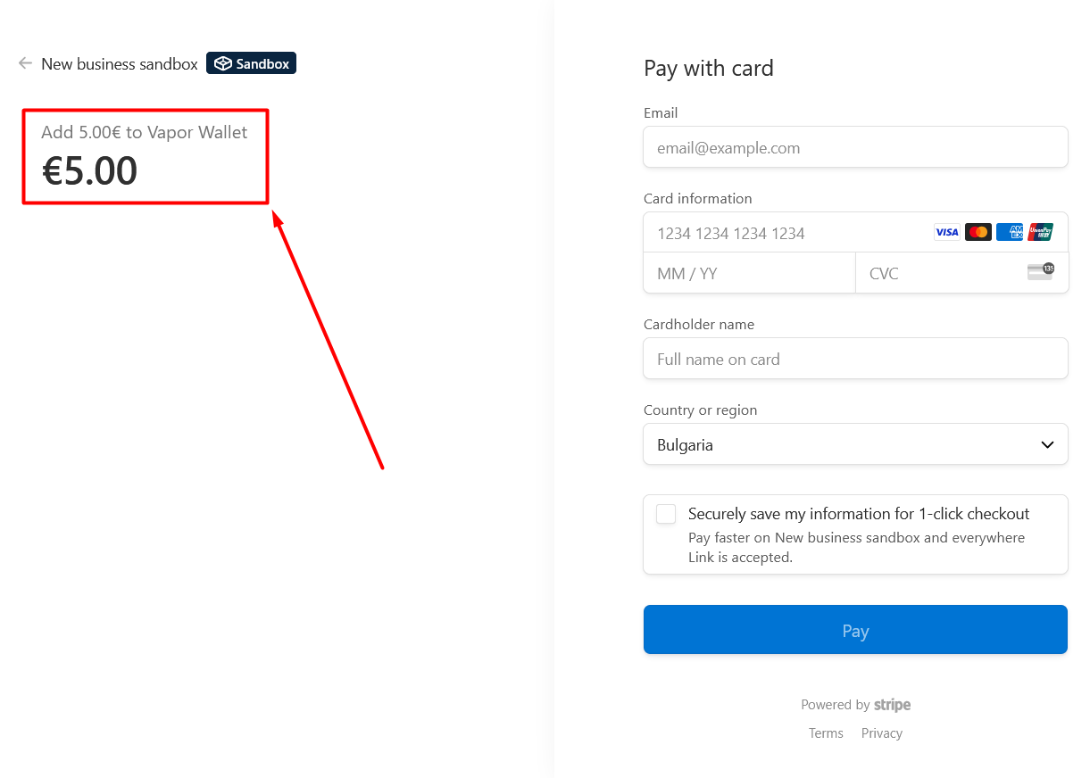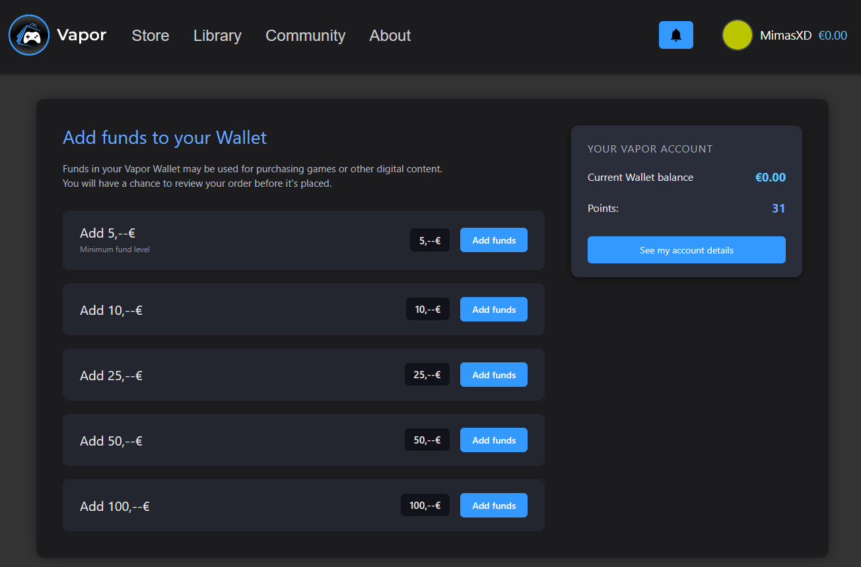

Figure 60. Wallet Page

Figure 61. Stripe Wallet Top-up Session

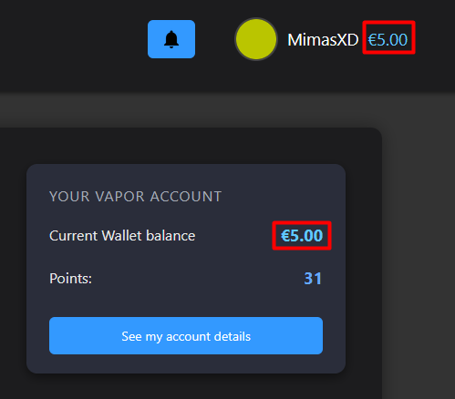

Figure 62. Wallet page (After Stripe Session)

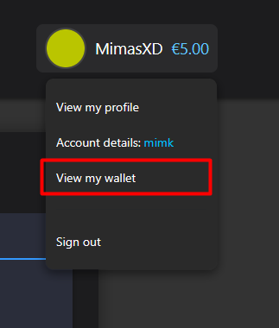

Figure 63. User Dropdown Menu

* + 1. Account Details Page

The Account Details page (**Figure 64**) provides users with a centralized overview of their profile and account management settings. At the top, the user can view their current wallet balance, along with a shortcut to add funds. Beneath that, partially masked contact information is displayed to enhance privacy. The lower portion of the page contains actionable buttons under the Settings section, allowing users to manage their account credentials, view their purchase history, and unlink their Google account if applicable (**Figure 65**).

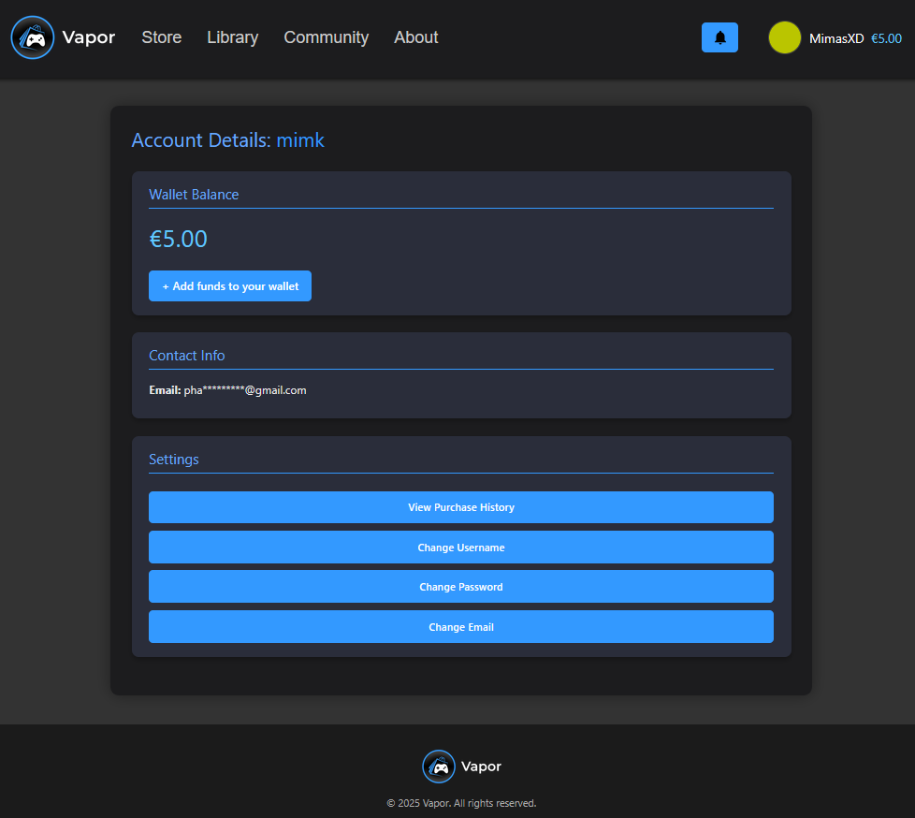This page plays a key role in consolidating all essential account-related operations into one clean interface, mimicking platforms like Steam while introducing custom controls for both standard and OAuth-authenticated users.

Figure 64. Account Details Page (Not Linked with Google)

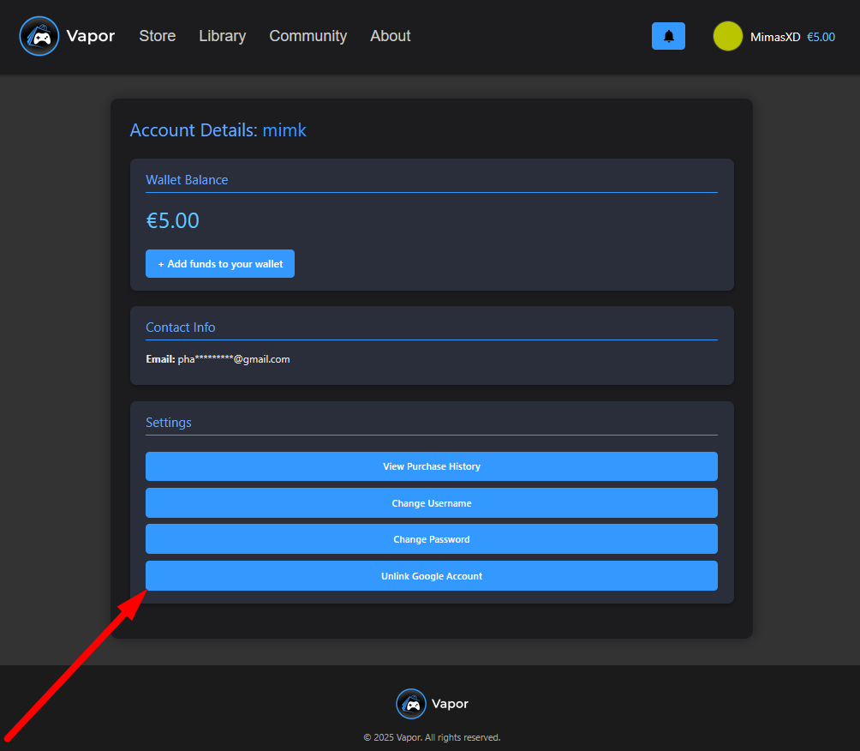

Figure 65. Account Details Page (Linked to Google)

* + 1. Purchase History Page

Clicking the **"View Purchase History"** button from the Account Details page leads to a dedicated page where users can explore their entire transactional record in a tabular format (see **Figure 66**). The table includes six key columns:

* **App**: Shows either the name and thumbnail of the purchased application or "💰 Wallet Top-Up" if it's a fund addition.
* **Date**: Displays the exact date and time the transaction occurred.
* **Payment**: Indicates the method used - either "Wallet", "Stripe Wallet Top-Up", or "Free".
* **Price**: The price paid for the app, with applied discounts already reflected.
* **Wallet Δ**: Represents the change in wallet balance. A positive value for top-ups, and a negative for deductions.
* **Wallet Balance**: Shows the remaining wallet balance **after** the transaction was completed.

This view provides a **comprehensive financial history** for the user, allowing them to verify purchases, track top-ups, and evaluate their spending behavior.

Notably, when a user **adds funds through the Wallet page**, those transactions also appear here as "Stripe Wallet Top-Up" entries. Similarly, when a user makes a purchase using the cart (even if it involves discounts or auto-purchase flows), the full financial details are recorded and reflected in this history log. This ensures full **accounting transparency** for all user-side monetary operations.

* + 1. 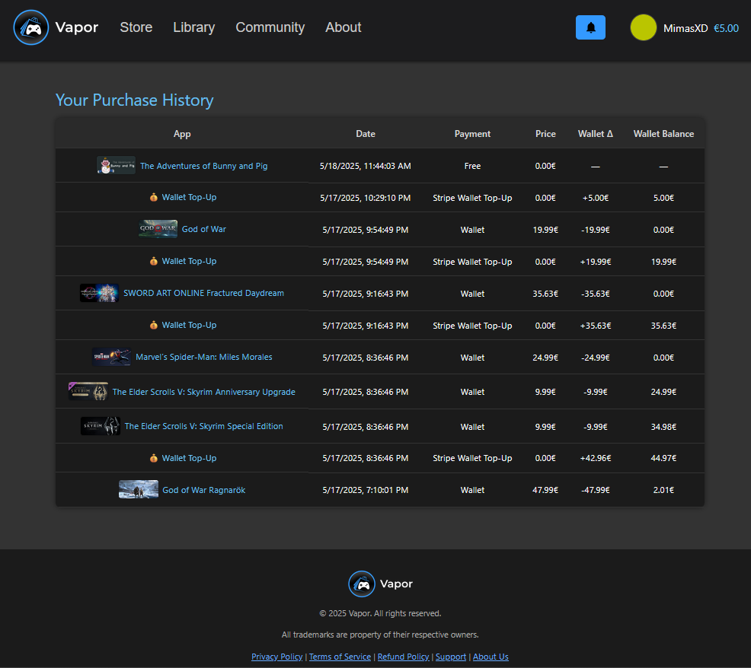Change Username Page

Figure 66. Purchase History Page

Users can update their username by clicking the **"Change Username"** button found in the Account Details page. This action navigates them to a dedicated page where a simple form allows them to input a new desired username.

On form submission, several backend validations are performed:

* The new username must comply with predefined validation rules (length, format, etc.).
* It must be **unique** - duplicate usernames are not allowed.
* If all conditions are met, the username is updated in the database.

Once successfully changed, two key actions occur:

1. **Token Regeneration**: The user’s access and refresh tokens are regenerated using the new username to ensure session consistency.
2. **Email Confirmation**: A confirmation email is sent to the user notifying them of the successful username change (See **Figure 67**).

On the frontend, a **confirmation modal** (**Figure 68**) appears to provide immediate feedback that the operation has completed successfully. After dismissing the modal, the user is redirected back to the Account Details page.

This feature enables identity flexibility while ensuring data integrity and user experience continuity.

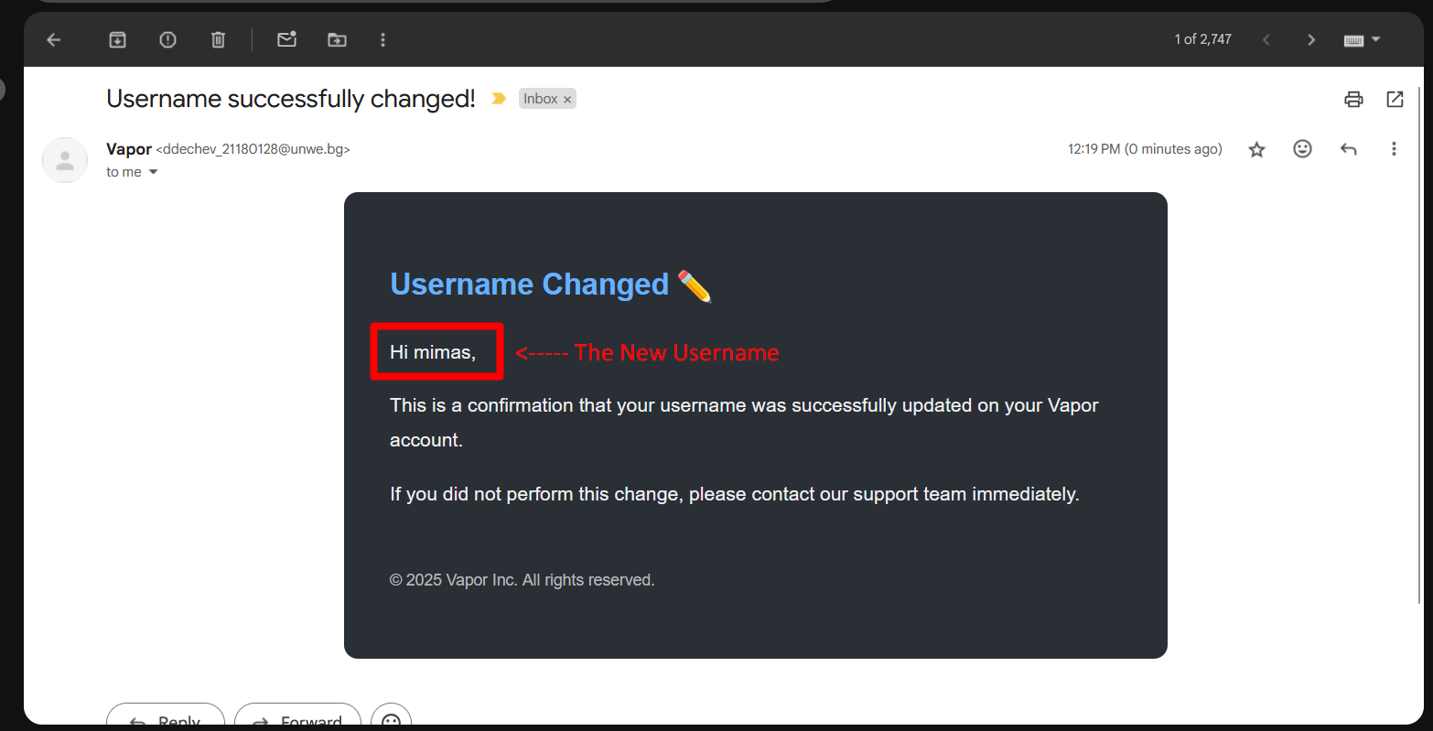

Figure 67. Email Confirmation (Username Changed)

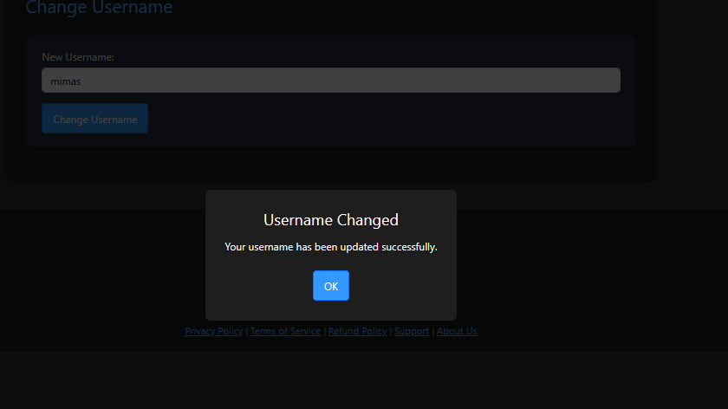

Figure 68. Username Changed Confirmation Modal

* + 1. Change Email Page

The **Change Email** functionality in Vapor offers a secure and user-friendly flow for updating a user’s registered email address, with safety checks and verification steps inspired by modern industry standards.

Upon selecting the **Change Email** option from the Account Details page, users are directed to a form (See **Figure 69**) where they must input and confirm their new email address. The system performs several **frontend and backend validations** before proceeding:

* The two email inputs must match.
* The new email must follow a valid format.
* It cannot be the same as the currently registered email.
* It must not already be in use by another account.

If all checks pass, the backend generates a unique token and stores it in the EmailChangeTokens table with a short expiration time (e.g., 10 minutes). A **confirmation email** is then sent to the current email address of the user, containing a secure link (e.g., confirm-email-change?token=...) which they must click to finalize the update.

**Frontend Flow**

Once the token is generated and the email is sent, the user is shown a modal confirming that a confirmation email has been dispatched (see **Figure 70**). The change will **not take effect until the user clicks the confirmation link button** on the email(see **Figure 71**).

**Handling Token Expiration or Errors**

If the user attempts to use an expired or invalid token (e.g., they waited too long or clicked a broken link), a fallback error is returned (See **Figure 72**).

Additionally, if an email change request is already pending, the system prevents generating another one until the first one expires (See **Figure 73**).

**Successful Change and Notification**

Once the token is validated and the change is applied, the user's email is updated in the database, and the used token is removed. The user also receives a **notification email** at their new address confirming the successful change.

This flow is shown visually in **Figures 73 and 74**:

* **Figure 73**: Confirmation modal shown immediately after submitting the change request.
* **Figure 74**: Notification email received after successfully confirming the change.

This implementation balances user experience with security by requiring confirmation and preventing duplicate or unauthorized updates.

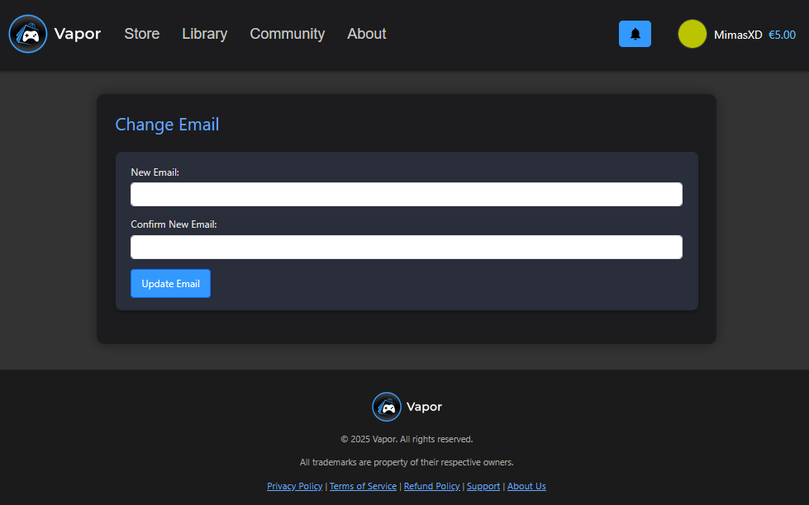

Figure 69. Change Email Page

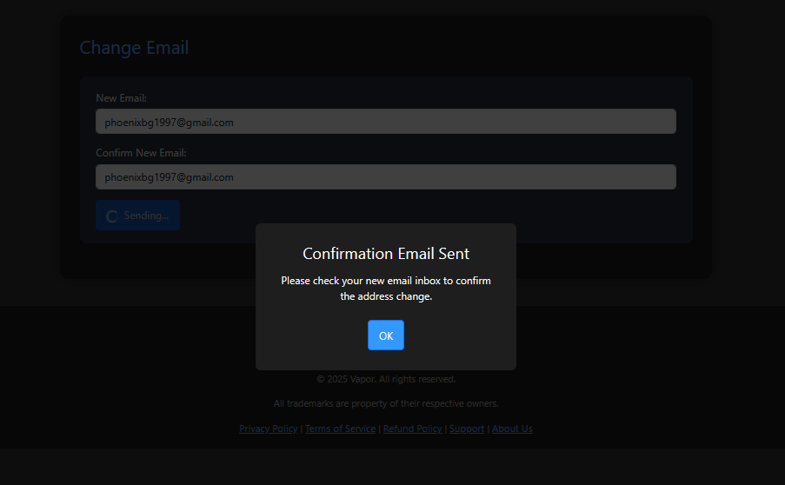

Figure 70. Change Email Confirmation Modal

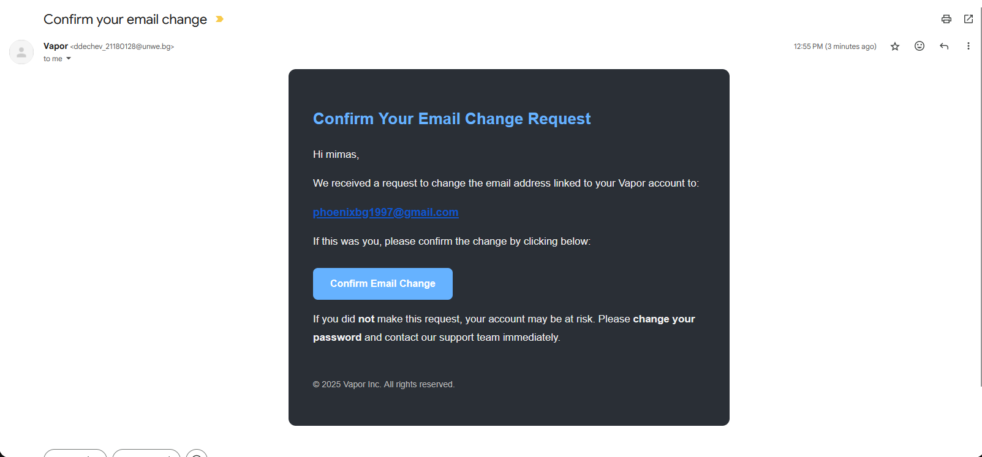

Figure 71. Email Confirmation Request for Change

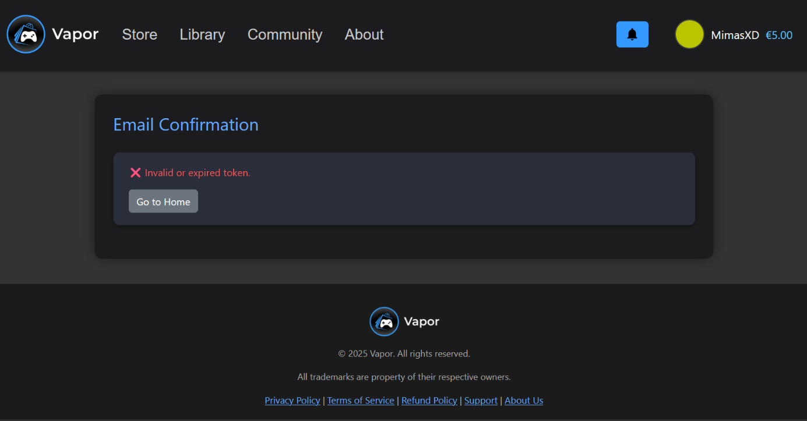

Figure 72. Email Confirmation (Fail due to Expired Token)

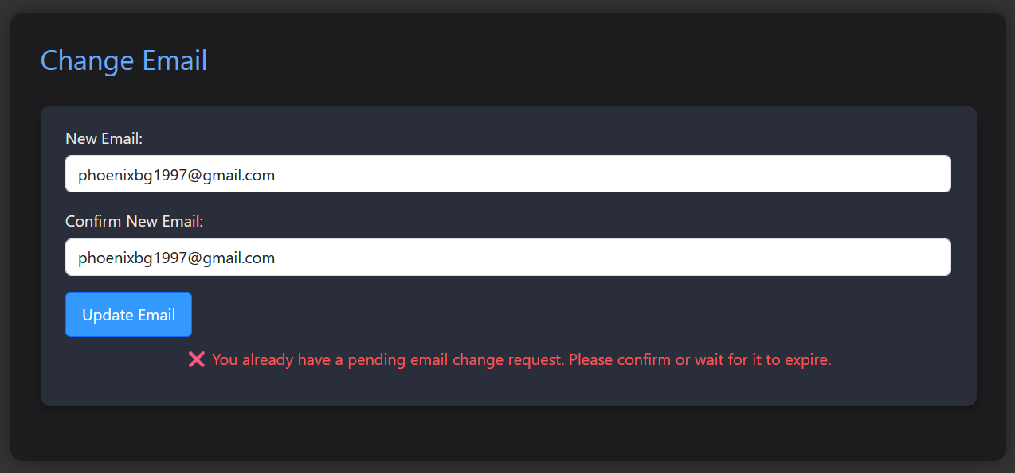

Figure 73. Change Email Page (Valid Email Change Token still Existing)

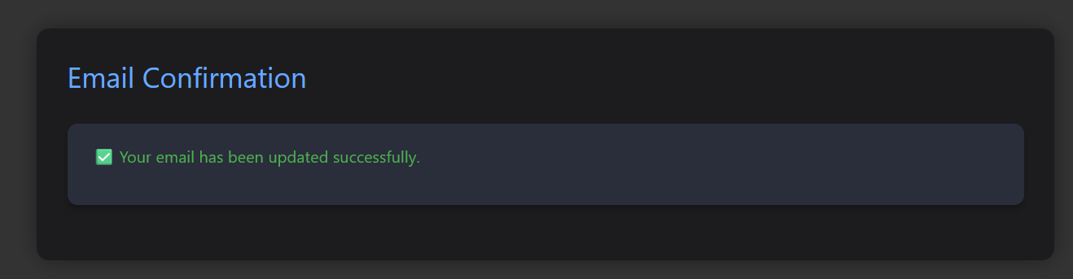

Figure 74. Email Successfully Changed Message

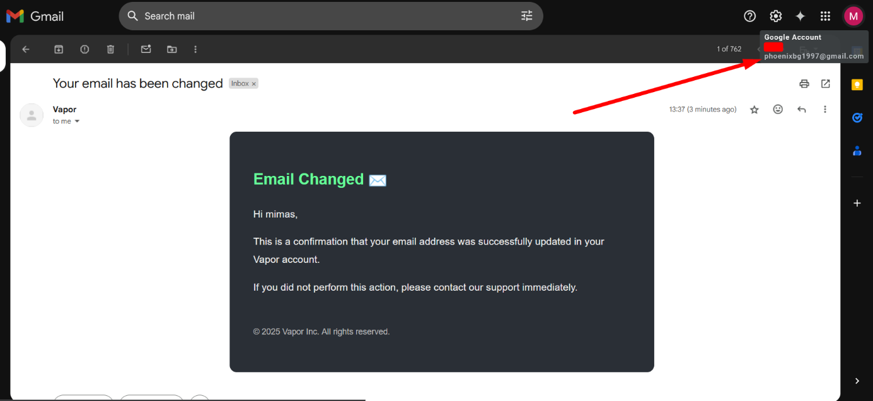

Figure 75. Email Changed (Email Confirmation to the new Email)

* + 1. Change Password Page

The **Change Password** feature allows users to securely update their password while logged into their account. This functionality prioritizes validation, feedback, and security best practices throughout the entire flow.

**User Interface & Workflow**

Upon navigating to the **Change Password** page (See **Figure 76**), the user is presented with a form that contains three fields:

1. **Current Password**
2. **New Password**
3. **Repeat New Password**

The frontend enforces basic validation rules before making a request:

* The new password must differ from the current password.
* The new password and repeat password fields must match.
* All fields are required.

If the validation passes, the data is sent to the backend, where additional checks are performed.

**Backend Validation & Logic**

The backend logic performs the following steps:

1. Verifies the user exists by ID.
2. Validates the provided current password using a password hasher.
3. Checks the new password against internal rules (minimum length, complexity, etc.).
4. If all checks pass, the new password is hashed and stored in the database.

After a successful update, the system sends an **email notification** to the user confirming that their password has been changed (See **Figure 77**). This serves as both a confirmation and a security alert in case the change was unauthorized.

**UI Feedback & Navigation**

Once the password change is successful, the frontend displays a confirmation modal (see **Figure 78**) with a success message. Clicking "OK" closes the modal and redirects the user back to the Account Details page.

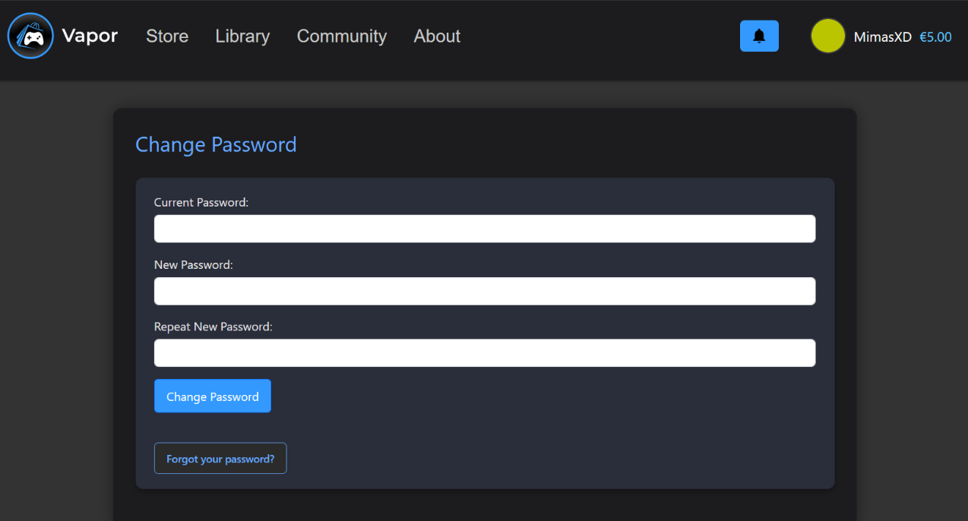

Figure 76. Change Password Page

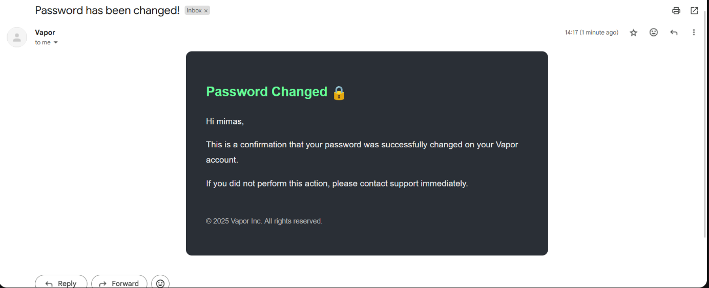

Figure 77. Password Changed Email Confirmation Message

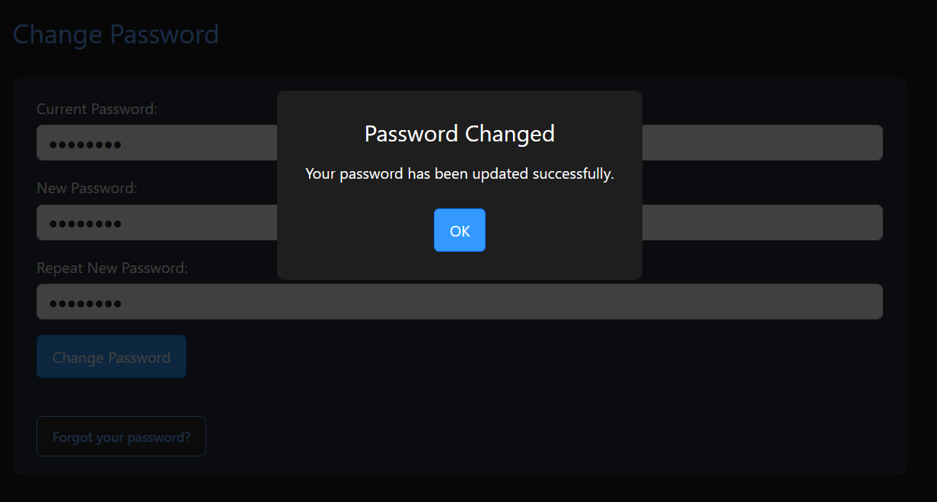

Figure 78. Password Change Confirmation Modal

The **Forgot Password** functionality is accessible from both the **Login** and **Change Password** pages but is fully documented here to avoid redundancy later on. This feature allows users who have forgotten their password to securely reset it via a verified email process.

When a user submits their email address through the **Forgot Password** form (see **Figure 79**), the system generates a secure password reset token and embeds it in a unique link, which is then emailed to the user (see **Figure 80**). The confirmation message is always displayed - regardless of whether the email exists in the database - to prevent email enumeration and maintain user privacy.

Importantly, the system ensures that only **one active reset token** exists per user at any given time. If a token already exists (even if expired), **no new token or email will be generated or sent** during a subsequent request. Instead, the user must first interact with the original email by clicking the link. If the token is invalid or expired, it is deleted upon interaction, and only then will the system allow a new token to be issued. This design prevents spam while preserving security and reinforces intentional, user-driven flow.

After submission, the user is automatically redirected to either the **Change Password** or **Login** page based on their authentication status (see **Figure 81**).

On the backend, the submitted email is checked and, if found, any unused password reset tokens for that user are removed. A new secure token is then created with a **10-minute expiration window**. The reset link, including the token, is embedded into a styled email rendered via a Razor template and sent to the user (see **Figure 82**). All emails in the application - such as verification, account updates, and password changes - are consistently generated using Razor templates to ensure unified design and maintainability.

Clicking the reset link directs the user to a dedicated password reset page (see **Figure 83**), where they are prompted to enter and confirm a new password. The token embedded in the URL is extracted and validated for authenticity and expiration. If the token is valid, the new password is securely hashed and saved in the database. A success message is then shown on the interface (left side of **Figure 84**). If the token is invalid or expired, an error message is displayed instead (right side of **Figure 84**). Following a successful reset, a confirmation email is also sent to the user to acknowledge the change (see **Figure 85**).

To complete the flow, users are automatically logged out and redirected to the login screen after a brief delay, ensuring a clean session transition and enhanced account security.

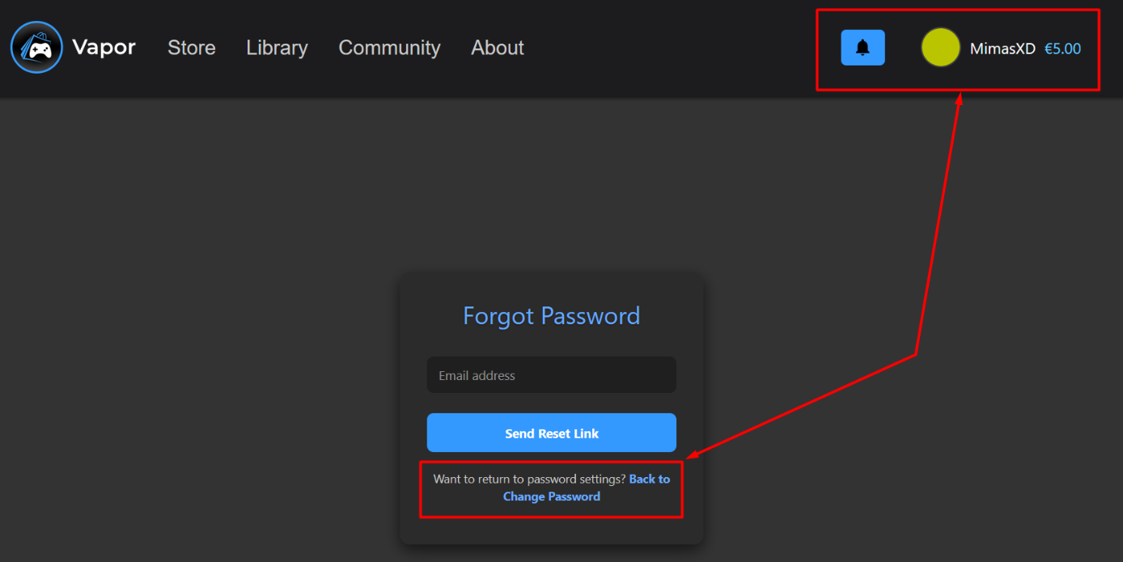

Figure 79. Forgotten Password Page (Authenticated)

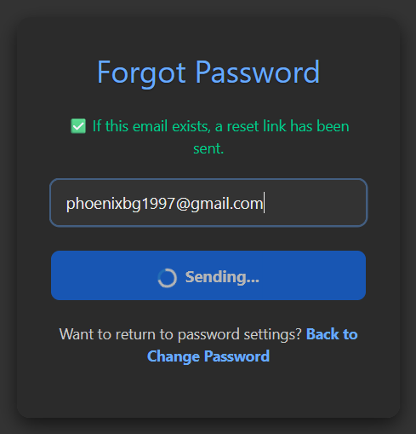

Figure 80. Forgotten Password Page (Message)

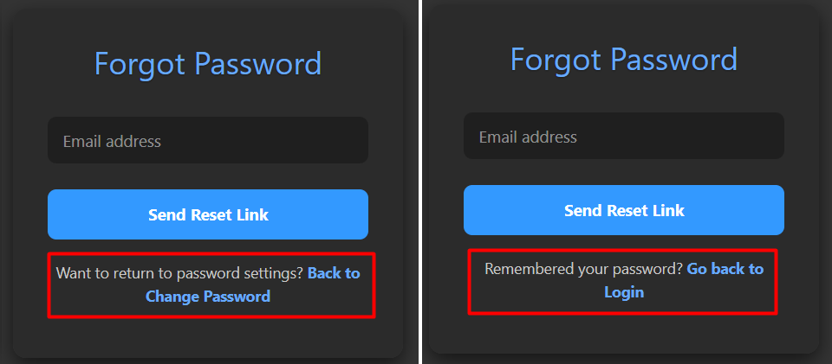

Figure 81. Forgotten Password (Authenticated and Guest states)

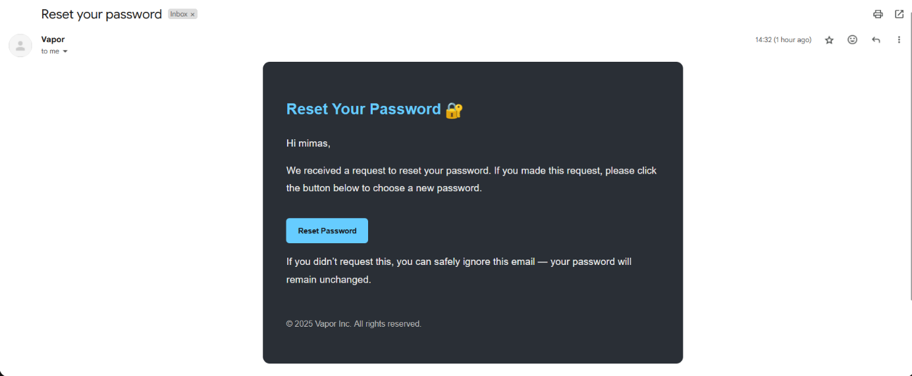

Figure 82. Reset Password Email

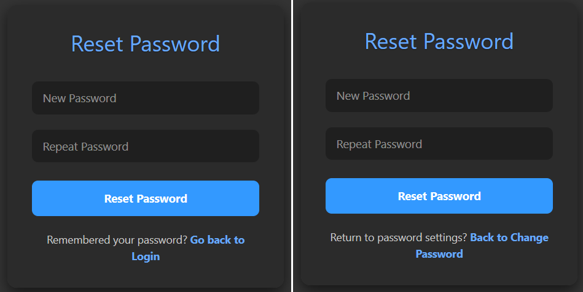

Figure 83. Reset Password Page (Guest and Authenticated states)

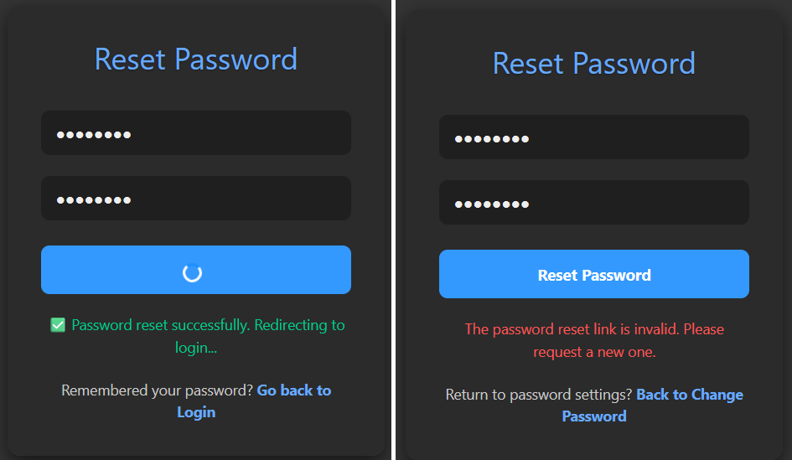

Figure 84. Reset Password Page (On Submission results)

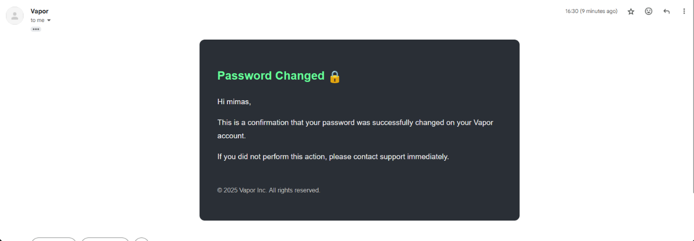

Figure 85. Password Reset Successful (Email Confirmation Message)

* + 1. Google Account Linking & Unlinking Functionality

Users who registered with an email address ending in @gmail.com and used standard credential-based registration have the ability to link their Google account through the login flow. When the same Gmail address is used to authenticate via Google, and it matches an existing user’s email, the system links the Google ID to the existing account, sets the IsGoogleAuthenticated flag to true, and sends a confirmation email (see **Figure 86**).

Once linked, the “Unlink Google Account” button becomes visible in the Account Details section (see **Figure 87**). Linked users are restricted from changing their email address to ensure the integrity of the Google association. If the user chooses to unlink their Google account, they must first have a non-Google password set (see **Figure 88**). Upon successful unlinking, the GoogleId is removed, IsGoogleAuthenticated is set to false, and a confirmation email is sent again (see **Figure 89**).

This functionality is handled dynamically on the frontend based on the user's authentication state and is not a separate page, but a toggleable feature within the broader Account Details interface.

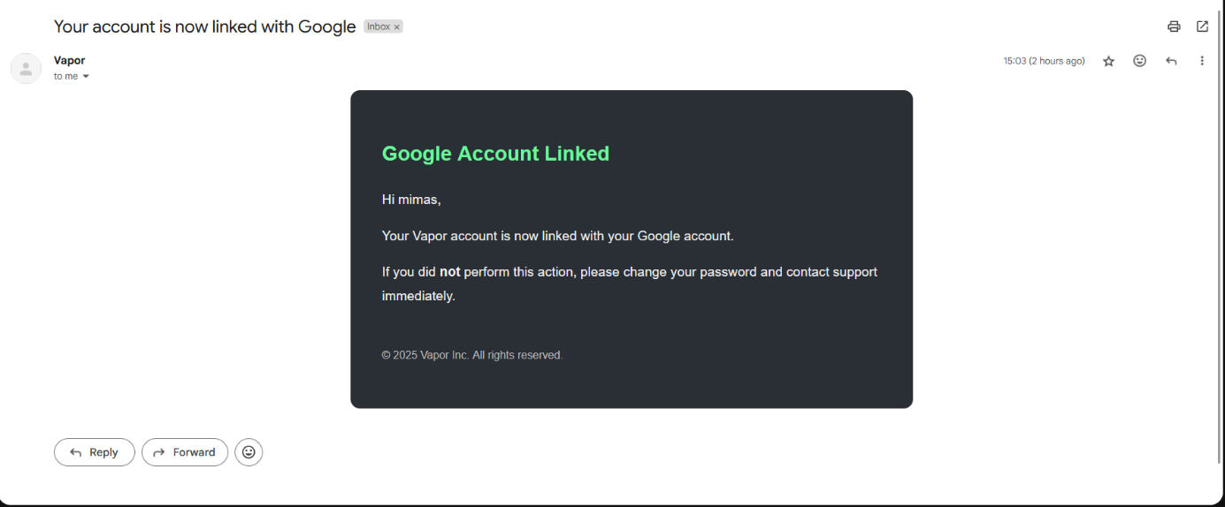

Figure 86. Google Linked Email Confirmation

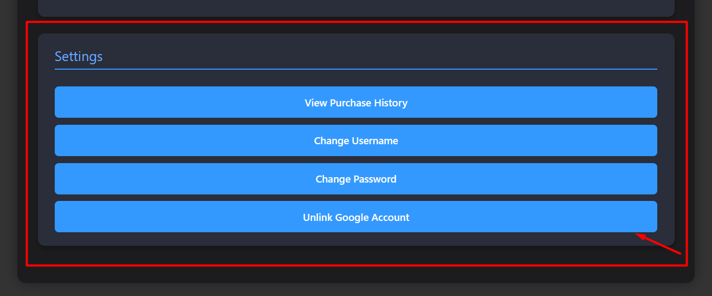

Figure 87. Account Details Page - Unlink Google Account Option

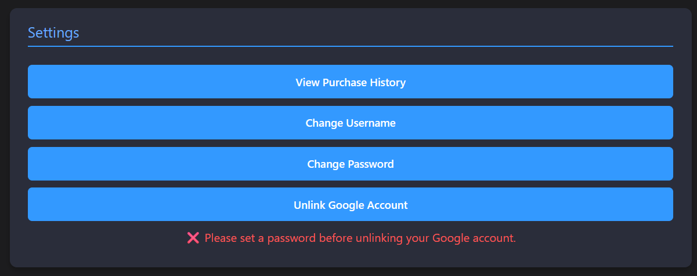

Figure 88. Account Details - Google Unlink Attempt with no password set

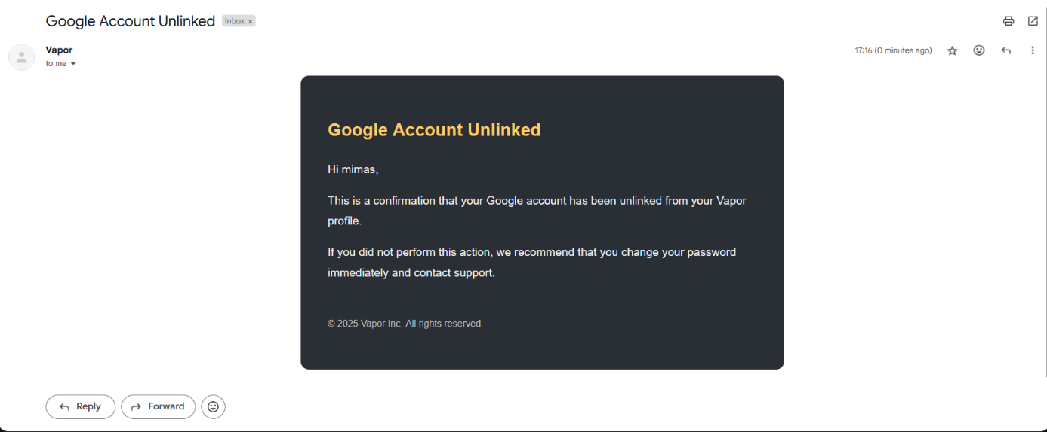

Figure 89. Google Unlink Email Confirmation

* + 1. User Profile Page

The User Profile page provides a public overview of a user's owned games and their respective purchase dates. This page is accessible to all users and guests, allowing anyone to view the profile of any registered user through a dedicated **URL** in the format:  
**https://localhost:3000/profile/{username}.**

For instance, navigating to **https://localhost:3000/profile/mimas** will open the profile of the user with the username **mimas (previously mimk)**. By changing the mimas portion of the **URL**, users can view the profiles of others within the system. This feature will also be utilized later in the Community section for post attribution and interaction.

As seen in **Figure 90**, the profile includes:

* The user’s **display name**, **username**, and **profile picture**.
* A list of **owned base games** (AppTypeId = 1 only), each showing:
  + The game title
  + Header image
  + Purchase date (formatted for readability)

If the currently logged-in user is viewing their **own profile**, an **Edit Profile** button is displayed, enabling them to update their display name or profile picture.

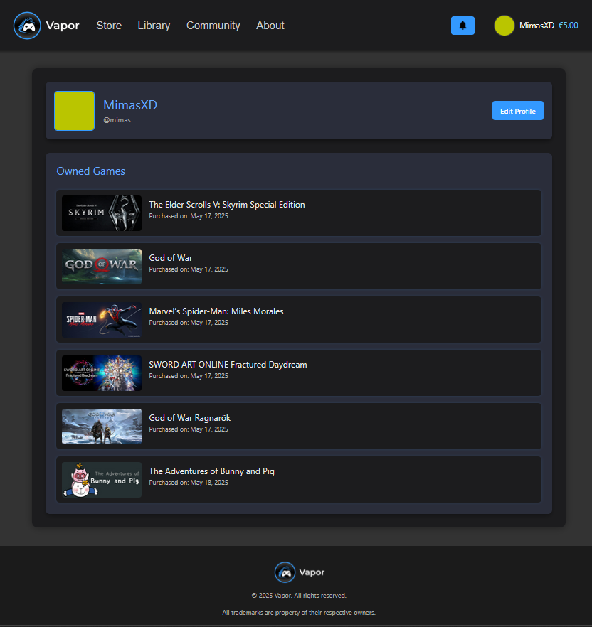

Figure 90. User Profile Page

* + 1. Edit Profile Page

The Edit Profile page allows users to personalize their account by updating their **display name** and **profile picture**. These changes are immediately reflected across the platform, including in **community posts, comments, and likes**, ensuring consistency in identity representation (see **Figure 91**).

When a user changes their display name, it automatically updates all active records where their identity is visible—such as authored posts or comments—except in cases where the comment has been **soft-deleted** (either by the user or the original post owner). In such cases, the name remains preserved in its last known state, maintaining the integrity of historical data while respecting deletion semantics.

The interface displays the user’s current display name and provides a file input for uploading a new profile picture. Once a picture is selected, the user is prompted to crop it before applying the change. This cropping mechanism will be covered in the next section.

After submitting the form:

* The new display name and/or cropped profile image are sent to the server.
* The backend stores the new data and performs targeted updates across community-related tables for non-deleted interactions.
* Upon successful update, the system refreshes the JWT to reflect the new identity values and redirects the user to their profile page with a success message.

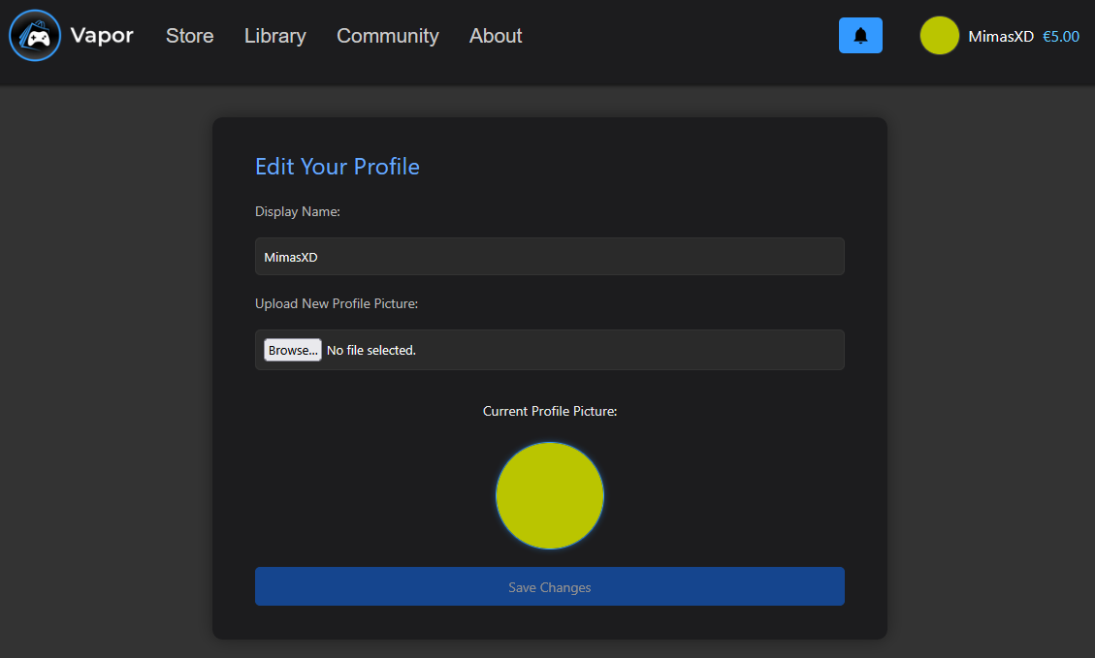

Figure 91. Edit Profile Page

Once a new image is selected for the profile picture, the user is presented with an **interactive cropping interface** (see **Figure 92**). This modal allows the user to **adjust the zoom level and reposition the image** (See **Figure 93**) within a fixed 1:1 (square) aspect ratio. This ensures consistent avatar formatting throughout the platform. The user can either confirm the crop via the “Crop & Upload” button or cancel the operation entirely.

After cropping, the preview of the cropped image is immediately shown in the interface (see **Figure 94**), allowing the user to visualize their new profile picture before saving changes. At this point, they can also modify the display name, and both changes are submitted together upon pressing the **Save Changes** button.

Behind the scenes, the cropped image is processed using a canvas-based cropping utility (getCroppedImg), which returns a Blob. This Blob is uploaded via the backend, and if successful, replaces the user’s current profile picture on the server and in all related parts of the application (e.g., comments, posts, and public profile).

If no display name or image has changed, the **Save Changes** button is disabled to prevent unnecessary requests. Once a change is submitted, the user's access and refresh tokens are regenerated to reflect the updated profile picture in JWT claims, ensuring immediate propagation throughout the UI.

This flow ensures a **secure, smooth, and visually consistent profile update experience**, leveraging client-side cropping for flexibility and server-side processing for file management.

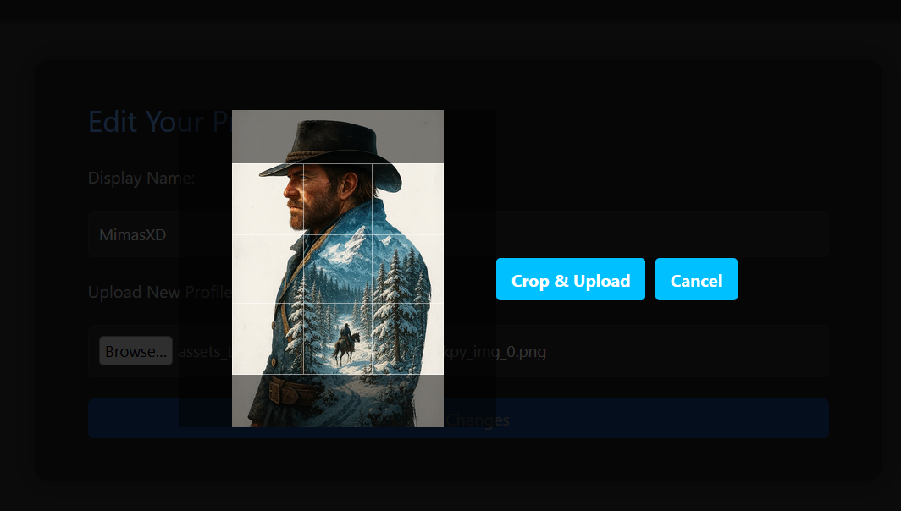

Figure 92. Image Cropper

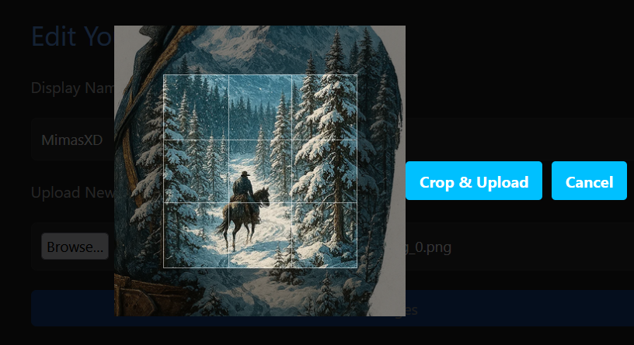

Figure 93. Image Cropper (Zooming/Selecting)

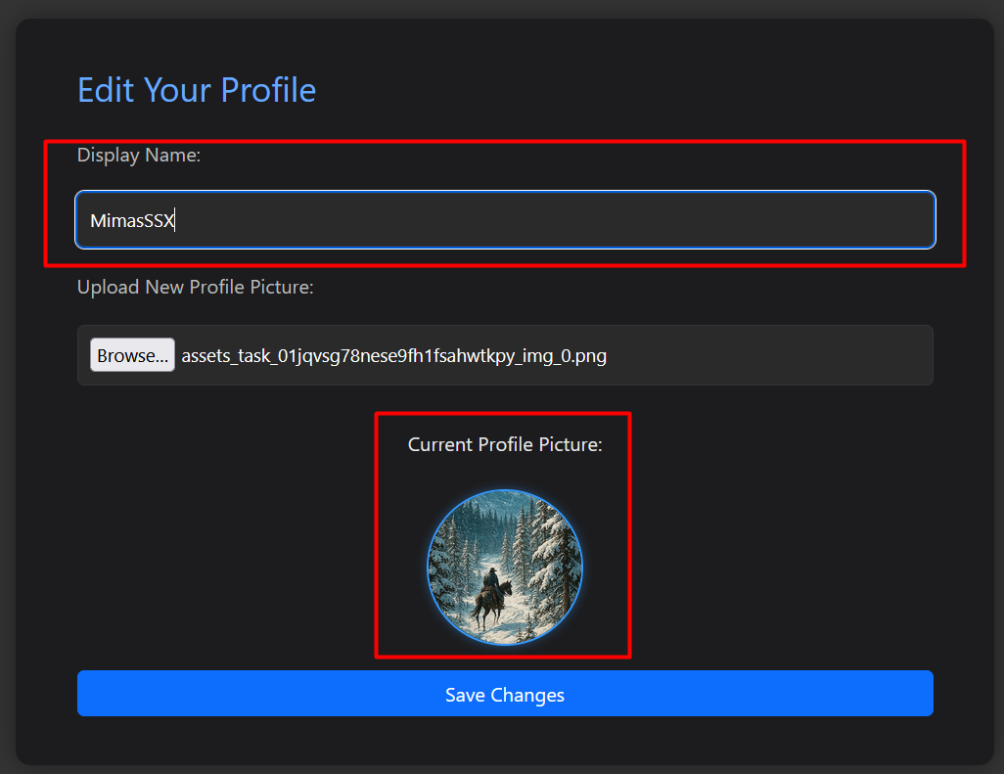

Figure 94. Edit Profile Page (Display Name and Profile Picture modification)

* + 1. Library Page

The **Game Library** page serves as a personalized space where users can view all the games they own. Upon logging in, the page fetches and displays only the base games from the user’s collection, while related content such as DLCs, soundtracks, and artbooks are grouped directly beneath their respective base titles.

Each main game is displayed with its cover image and title (see **Figure 95**), and clicking on it navigates to the corresponding **App Details** page. If the game has related content, these items are displayed in a horizontal list directly under the base game. For each related app, the UI clearly distinguishes between owned and unowned content:

* **Owned items** are shown with a subtle green border.
* **Unowned items** are grayed out and marked with a ❌ Not Owned badge, preventing confusion about ownership status (see **Figure 96**).

All game entries include visual thumbnails, dynamic routing via react-router-dom, and price labels (e.g., “Free” or a specific price in euros), enhancing navigability and transparency.

If the user has no games in their library, a fallback message with a Store redirect link is shown (see **Figure 97**).

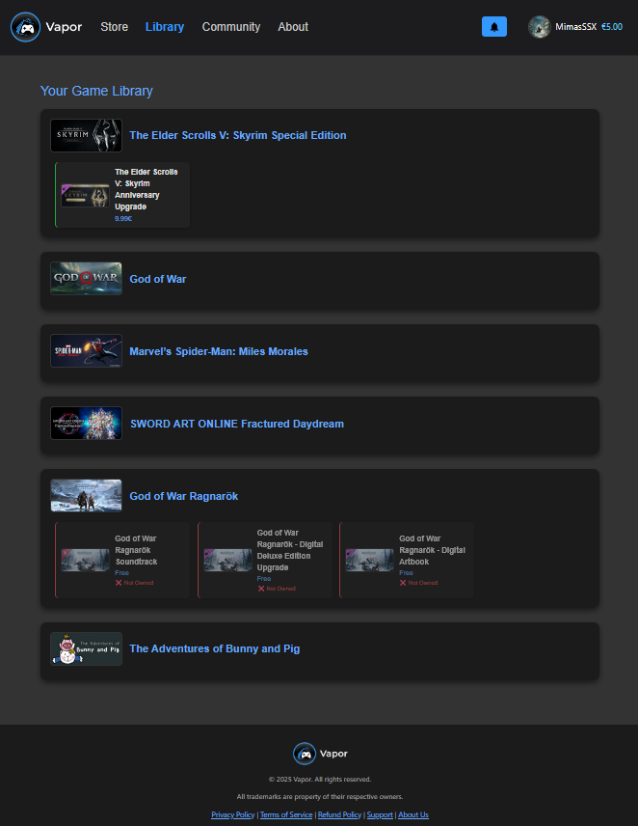

Figure 95. Library Page

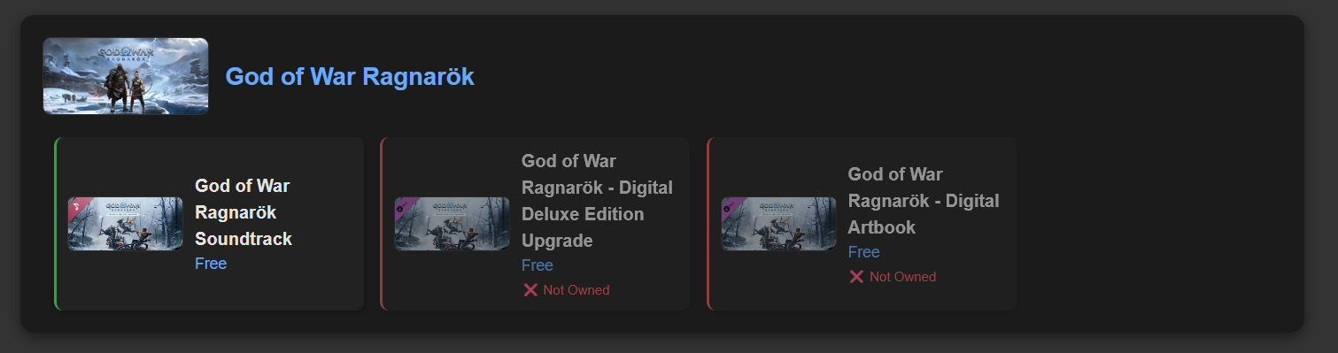

Figure 96. Library Page (Owned/Not Owned Related Apps)

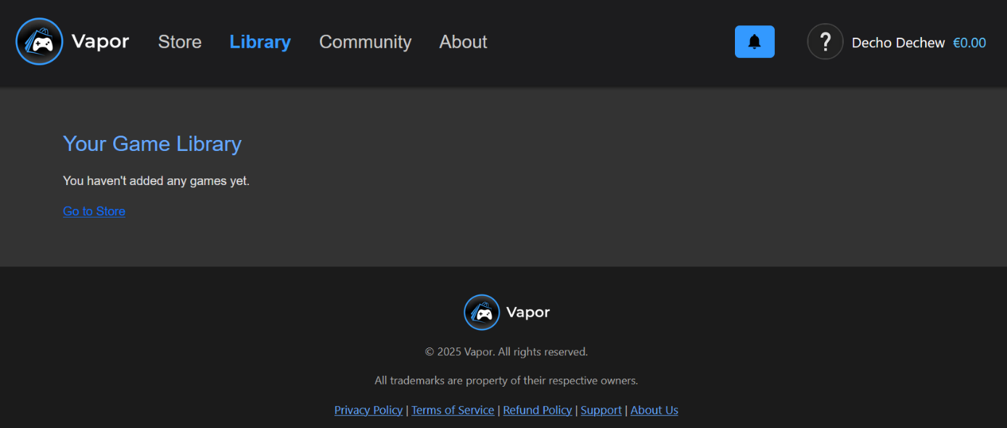

Figure 97. Library Page (Empty)

* + 1. About Page

The About page (**Figure 98**) provides users with a clear overview of what Vapor is and how its Point System operates. It serves as an informative section accessible to all users from the navigation bar.

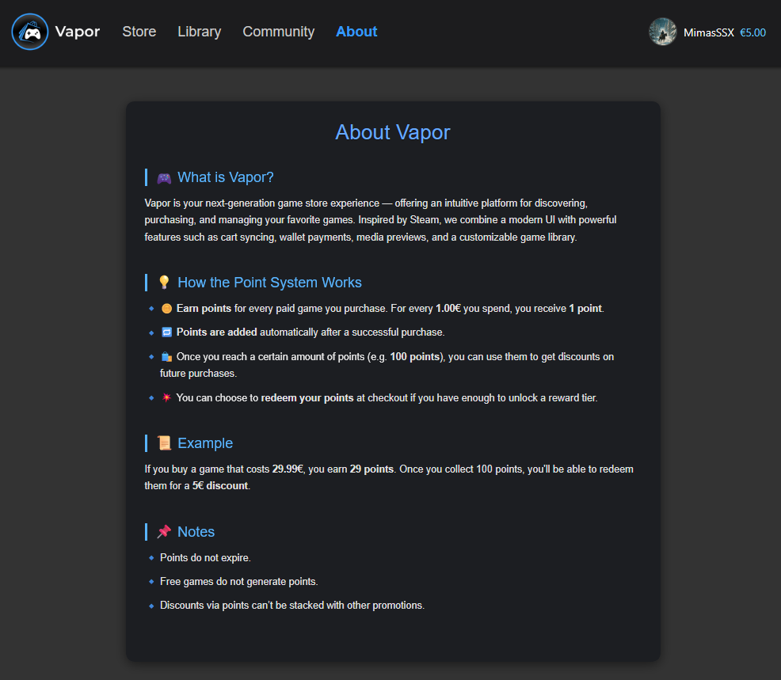

Figure 98. About Page

* + 1. Admin Panel Page

This is the Admin Panel page (**Figure 99**), accessible only to users with the “Admin” role. It can be reached via the user dropdown menu, as shown in **Figure 100**. The interface provides quick access to multiple system tables via tab-based navigation.

Since all administrative tables follow the same structural and functional layout, I will focus on the Users Table as an example.

In this table, admins can perform standard management actions:

* Click the ✏️ Edit icon to update any field inline.
* All updates are validated on the backend to ensure data integrity.
* Admins can also delete users via the 🗑️ Delete icon if necessary (See **Figure 101**).

Other tabs will not be discussed in detail here, as they follow the same editable and exportable logic.

Once the ✏️ icon is clicked, the selected row enters edit mode (**Figure 102**). Changes to any field can be canceled with the ❌ icon or saved via the ✅ confirmation icon. If the administrator edits their own record, the system automatically regenerates their access and refresh tokens to maintain session consistency and reflect updated credentials.

Deletion requests prompt a confirmation dialog to prevent accidental removals (**Figure 103**). However, users are prevented from deleting their own account through the admin interface; any such attempt results in a clear message notifying them of this restriction (**Figure 104**).

These safeguards ensure secure and stable admin operations while maintaining a user-friendly interface across all entities.

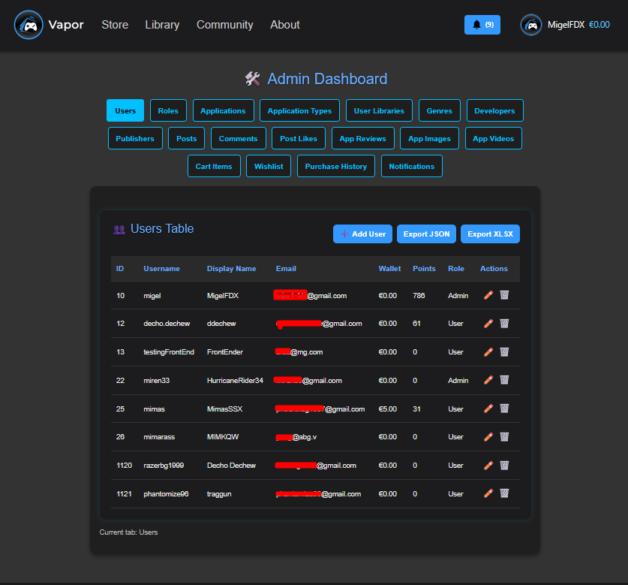

Figure 99. Admin Panel Page (Users Table)

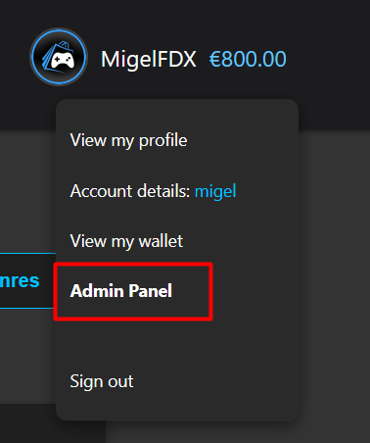

Figure 100. User Dropdown (Admin Authentication)

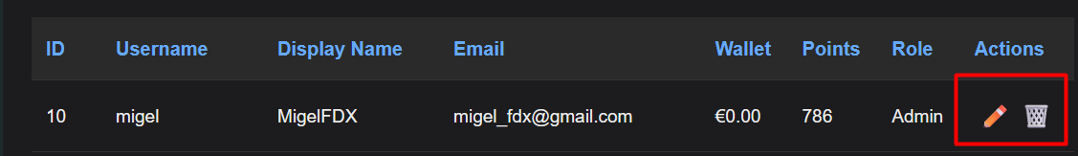

Figure 101. Admin Panel (Action Buttons)

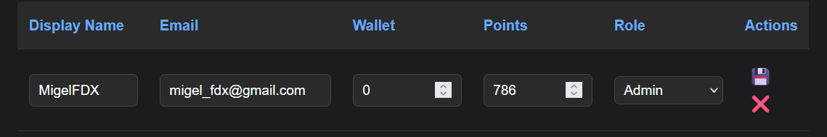

Figure 102. Admin Panel (Edit Mode)

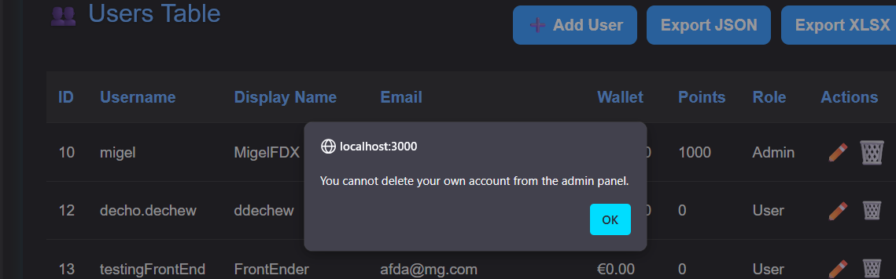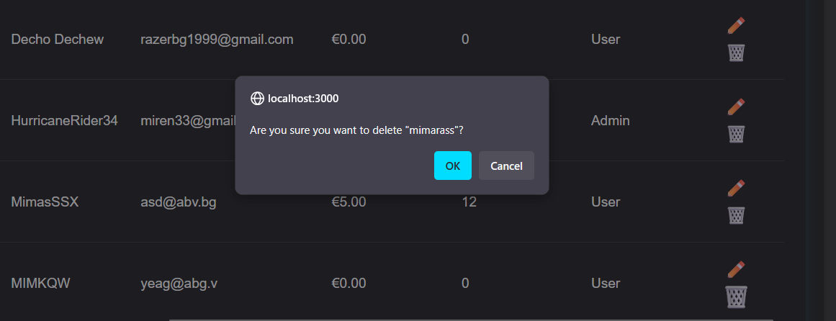

Figure 103. Admin Panel - Attempting to Delete a User

Figure 104. Admin Panel - Attempt to Delete my own Account

In addition to editing and deleting users, administrators can also create new user accounts via the **“+ Add User” modal** (**Figure 105**). Clicking this button opens a popup form that collects essential user information such as username, display name, email, temporary password, wallet balance, point balance, and user role.

The modal interface is designed to be intuitive and efficient. Each field includes validation to ensure correct formatting (e.g., email and numeric fields), and roles are populated dynamically from the system’s current role list. Upon submission, the entered data is sent to the backend, where it undergoes additional validation and is securely stored. If the operation succeeds, the new user is immediately reflected in the Users Table without requiring a full page reload (**Figure 106**).

This functionality allows for rapid administrative onboarding while maintaining consistency with the overall structure of the admin interface.

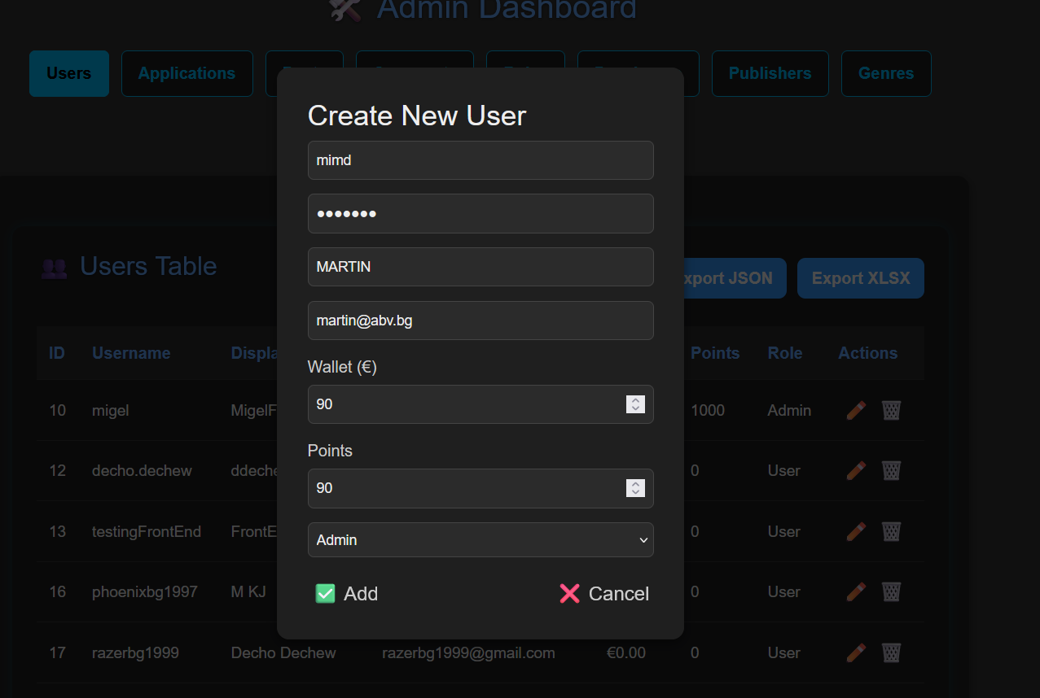

Figure 105. Admin Panel - Add Modal

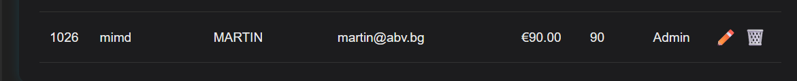

Figure 106. Admin Panel - Successfully added User

To facilitate administrative reporting and data backup, the Users Table also includes two export options: **Export JSON** and **Export XLSX** (**Figure 107**). These buttons allow the current user dataset to be downloaded in either structured JSON format or spreadsheet-compatible Excel format, respectively.

The **Export JSON** button generates a downloadable .json file containing all user data currently displayed in the table (**Figure 108**). This format is ideal for developers or system auditors who require structured data for integration or inspection.

The **Export XLSX** button triggers a backend call that returns a ready-to-download Excel file (**Figure 109**). This feature is especially useful for administrative staff or business analysts who prefer to work with tabular data in spreadsheet software such as Microsoft Excel or Google Sheets.

These export tools ensure flexibility in how administrators manage and process user data outside of the application.

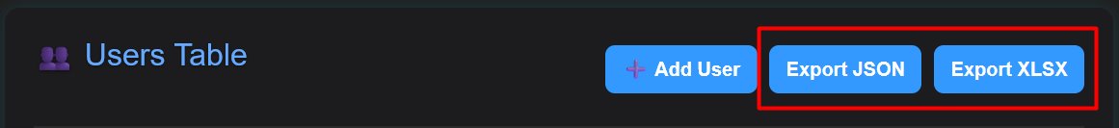

Figure 107. Admin Page (Users Table - Export Buttons)

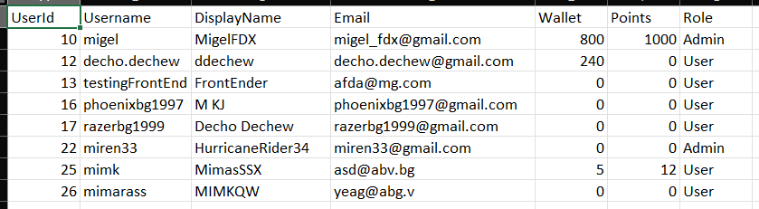

Figure 108. Admin Panel - XLSX Clicked (Result file)

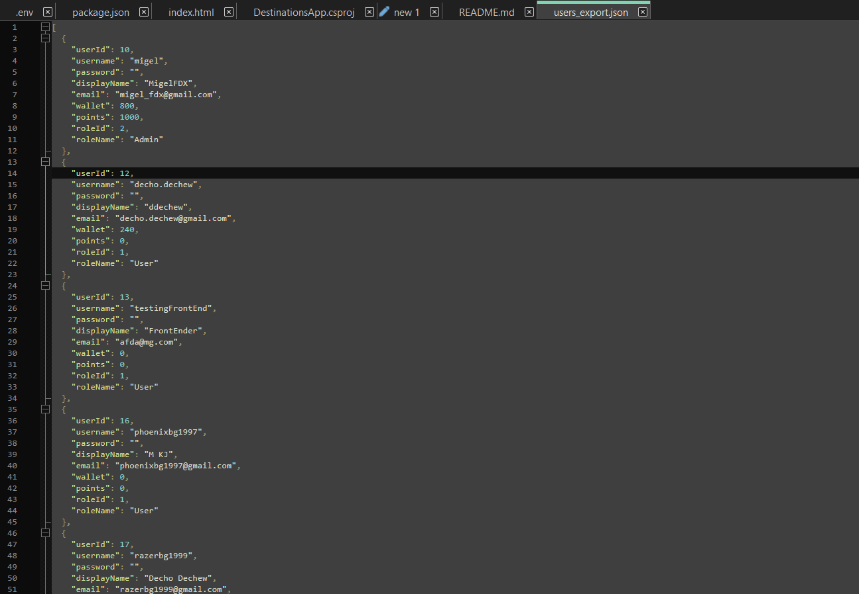

Figure 109. Admin Panel - JSON Clicked (Result file)

* + 1. Community Page

The **Community Page** serves as a central hub for user-generated content within Vapor, allowing users to interact, share opinions, and engage with posts related to games they own. Users can create posts, like others' content, and comment within threaded discussions - fostering a more connected and expressive gaming ecosystem.

Upon visiting the page, users are presented with a scrollable feed of community posts (**Figure 111**). Each post displays the author's name, content, creation time, and associated game, along with buttons for liking, commenting, and, when applicable, deleting. Guest users can browse but are not permitted to interact.

If logged in and owning at least one game, users are presented with a **Create Post** button, which redirects them to a dedicated post creation form.

Each post supports:

* **Likes** with live counters and access to a modal showing all users who liked it
* **Commenting**, with support for editing and soft-deletion
* **Real-time updates**, ensuring the UI reflects all interaction changes (e.g., new likes or comments)
* **Post ownership controls**, enabling creators to delete their own posts

All post and comment actions are validated server-side and UI feedback is provided to ensure clarity and responsiveness. Additional modals such as **LikersModal** and **CommentsModal** are loaded dynamically when needed, and the system supports direct linking to specific posts via query parameters (e.g., ?postId=123).

In the next sections, we will break down each core component of the Community system, starting with the **PostCard** element.

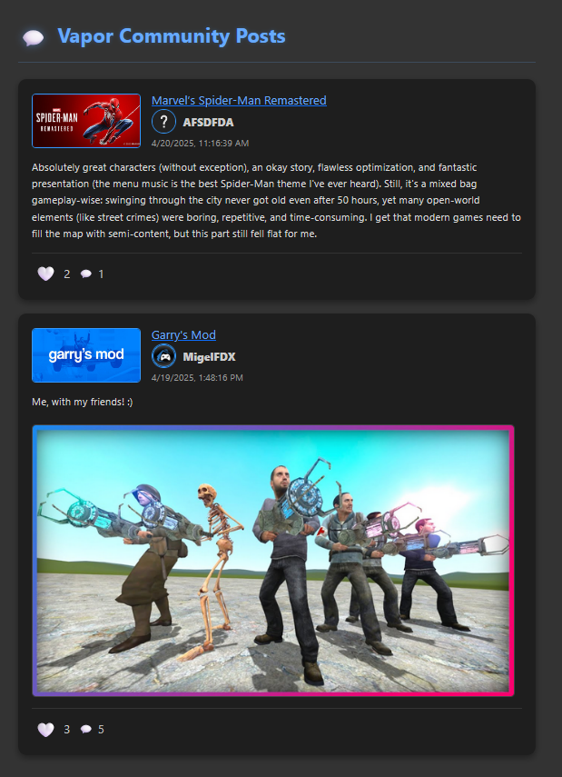

Figure 110. Community Page

* **Main Components of Community Page**
  + - 1. PostCard

Each post in the Community feed is rendered using the PostCard components (see **Figure 111**). It encapsulates all essential post details, interactions, and contextual behavior.

The component includes the following sections:

1. **Header Section**

* **Game Info:** Shows the game associated with the post (name + header image). Clicking redirects to the AppDetails page.
* **User Info:**
  + If the post belongs to an active user, their **display name**, **username**, and **profile picture** are shown, linking to their profile.
  + If the post is from a deleted user, their name is still displayed but no profile link is rendered (soft deletion logic).
  + **Timestamp:** Displays when the post was created using a locale-friendly format.

1. **Content Section**

* **Text Body:** Displays the actual content of the post written by the user.
* **Image Preview (Optional):** If the post includes an image, it is shown below the text with responsive styling (**Figure 112**).

1. **Footer Section**

Includes interactive controls for post engagement:

* **Like Button:**
  + Users can like or unlike a post. If the post has not been liked by the current user, a white heart (🤍) is displayed. Clicking it will toggle the like, changing the icon to a filled red heart (❤️) to indicate it has been liked. Clicking the red heart again will unlike the post and revert it back to white. This behavior ensures intuitive and immediate visual feedback for like status.
  + The like count is shown only when greater than zero.
  + Clicking the like icon or count opens the **LikersModal**, displaying all users who liked the post.
* **Comment Button:**
  + Opens the **CommentsModal** for viewing and submitting replies.
  + Guests are redirected to the login page upon interaction.
* **Delete Button:**
  + Visible only to the post owner.
  + Triggers a confirmation prompt before removing the post via the backend.

All buttons prevent propagation of click events to avoid accidental triggering of parent elements (e.g., post focus highlighting). Additionally, optimistic UI updates are used to reflect interactions immediately while backend synchronization ensures consistency.

In the next sections, we’ll explore the **LikersModal** and **CommentsModal** components in detail.

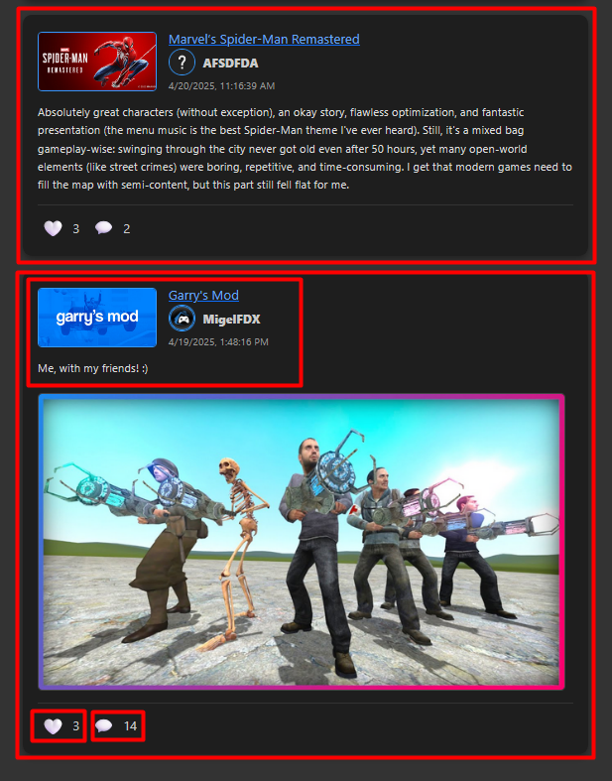

Figure 111. Community Page - Post Cards (Without an image and with an image)

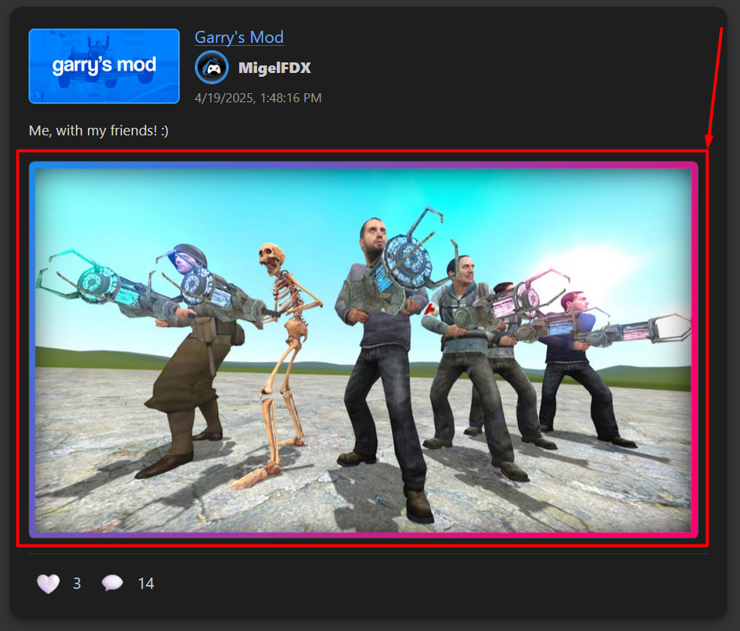

Figure 112. Community Page (PostCard with an Image)

* + - 1. Likers Modal Component

When users click on the like count or heart icon under a post, the LikersModal component is displayed (see **Figure 113**). This modal shows a list of all users who have liked that specific post.

1. **Modal Structure**

* The modal is overlaid on the screen using a backdrop to darken the background, drawing attention to the content.
* Clicking outside the modal (on the backdrop) closes it, while clicks inside the modal content are ignored (stopPropagation()).

1. **Likers List**

Each liker is shown with:

* + - Their profile picture (or a default fallback image).
    - Their display name, used consistently throughout the app.
    - A link to their public profile page, allowing viewers to explore other users directly from their likes.

1. **Access Control**

* Guests cannot open this modal (as enforced in the PostCard component).
* Users who try to interact with the like button while not logged in are redirected to the login page.

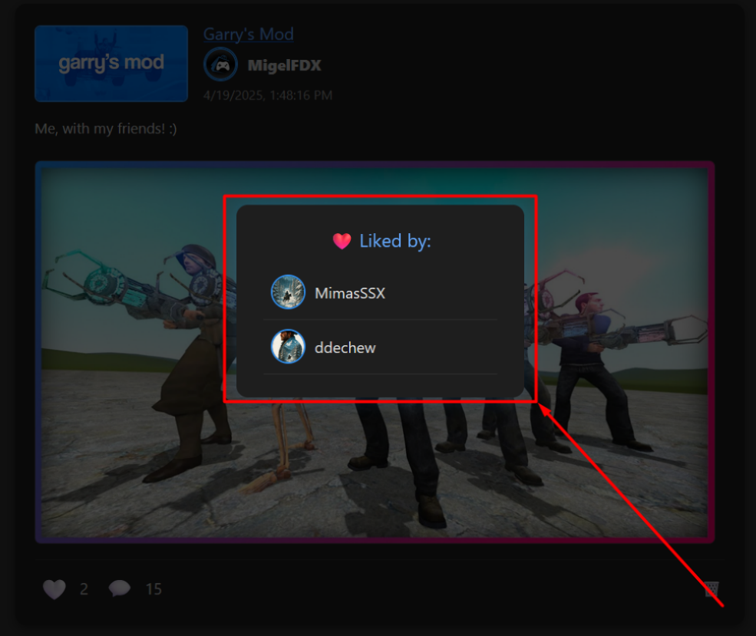

Figure 113. Community Page (Likers Modal)

* + - 1. Comments Modal Component

Clicking the **💬** comment icon on any post opens the Comments Modal, which displays all comments associated with that post. Users can read, write, edit, or delete comments depending on their permissions (see **Figure 114**).

Each comment entry includes:

* The commenter's display name, avatar, and timestamp.
* The actual comment text, with a subtle "(edited)" label if it has been modified after creation.
* A **[deleted]** label is shown for comments that have been soft-deleted either by the user or the post owner. These are anonymized, and their avatars are replaced with a default placeholder.

1. **Commenting & Editing**

* Logged-in users can leave a comment in the input area at the bottom (See **Figure 114**). If the comment box is empty or contains only whitespace, the button is disabled.
* Users can edit their own comments by clicking the **✏️ icon**, which turns the comment into a textarea with Save/Cancel buttons. Backend validation ensures no empty or unchanged text is accepted (See **Figure 115**).
* While editing, a loading state is shown to prevent multiple submissions.

1. **Deleting Comments**

* Comment authors can delete their own comments, which results in a soft deletion - the comment text becomes "Comment deleted by user" and the display name is set to [deleted].
* Post owners can delete any comment under their own post. In this case, the text becomes "Comment deleted by post owner".
* These deletions preserve the thread's structure while masking sensitive content, a common practice in modern communities.

1. **Guest Access**

* Guests cannot comment or interact with comments. A redirection to the **Log in** page is initiated instead.

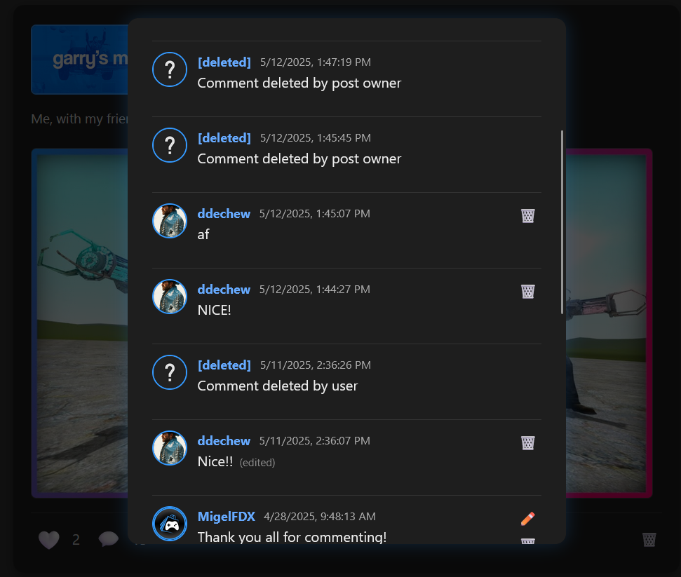

Figure 114. Comments Modal (Post Owner)

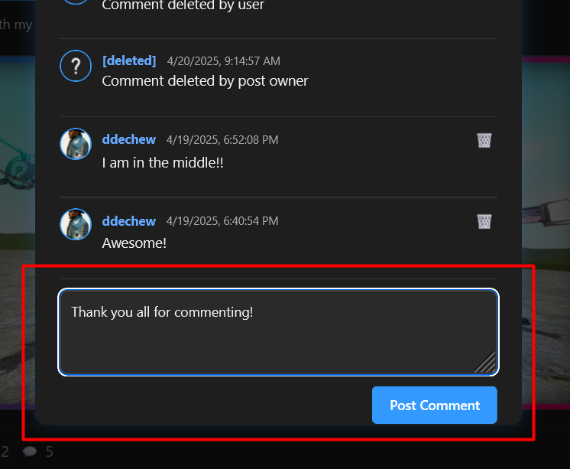

Figure 115. Community Page - Comments Modal (Textbox and Button)

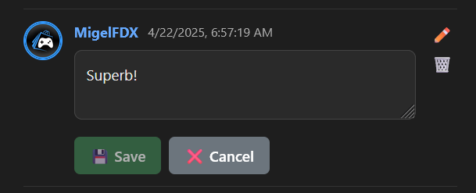

Figure 116. Comments Modal (Edit Mode)

* + 1. Create Post Page

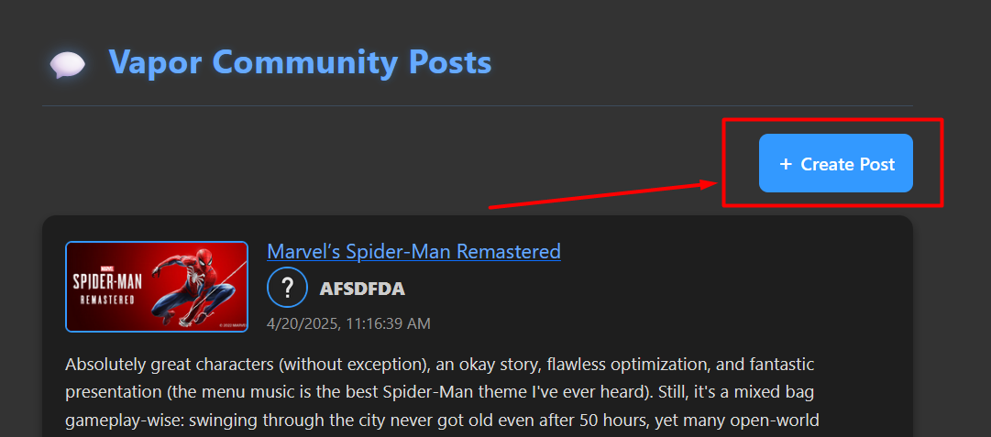Users who are logged in and own at least one game will see a + Create Post button on the top-right of the Community Page (see **Figure 117**). Clicking this button navigates the user to the Create a Post page, where they can express their thoughts or share visual content related to a game they own.

Figure 117. Community Page - Create Post Button

On the Create Post page (**Figure 118**), users are prompted to:

1. **Select a Game** **-** The dropdown displays only the games the user owns. This is enforced at the backend to ensure that users can only post about games in their library.
2. **Write a Message** **-** A text area is provided for entering the main post content.
3. **Upload an Optional Image** **-** An image can optionally be uploaded to visually complement the post. Once an image is selected, a live preview appears below the form (see **Figure 119**).

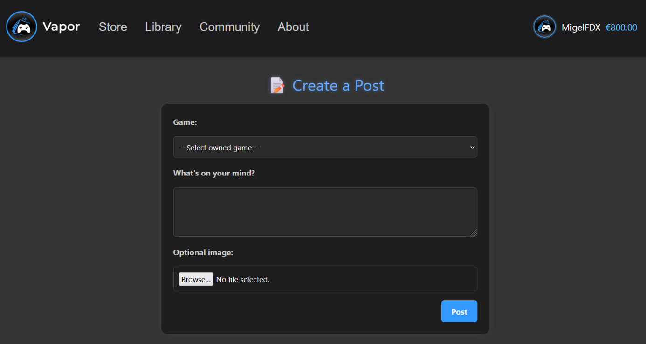

Figure 118. Create Post Page

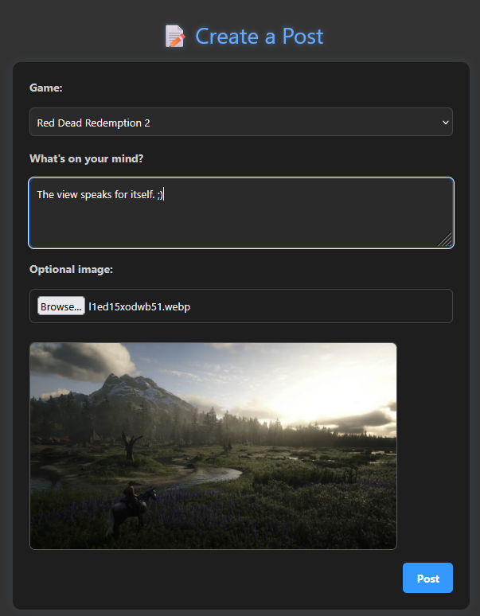

Figure 119. Create Post Page (Filled)

Once the form is completed, clicking the **Post** button will trigger the submission. If an image was selected, it is first uploaded and then referenced in the post payload.

* If everything is valid, the post is created and the user is redirected back to the **Community Page**, where the newly created post now appears among all others.
* If the image fails to upload or the submission is invalid (e.g., no game selected), appropriate error messages are displayed.
* This flow ensures that posts are:
* Authenticated (only logged-in users can create them)
* Contextual (only tied to owned games)
* Customizable (with or without an image)

See the result of a successful submission displayed on the Community feed in **Figure 115**.

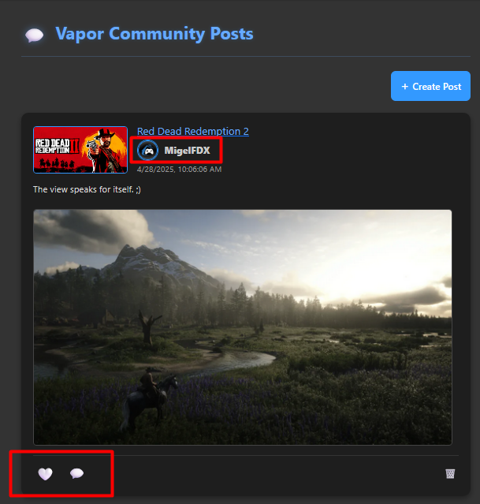

Figure 120. Community Page (Updated after successful post creation)

* + 1. Registration Page

The **Registration Page (Figure 121)** allows new users to create a Vapor account by entering a username, display name, email, and password. The interface provides real-time validation feedback and ensures that all required fields are filled correctly (**Figure 122**).

Once the form is submitted:

* The backend performs **validation checks** on:
  + Username format and uniqueness
  + Email format and uniqueness
  + Password complexity and match
* If the validation passes:
  + The user is saved into the database with a default profile picture and user role.
  + A **verification token** is generated and sent to the user’s email.
  + The system displays a success message and redirects to the Login page after a short delay (**Figure 123**).

This structured process prevents unauthorized access, duplicate accounts, and invalid input - while setting the stage for a secure login and user onboarding experience.

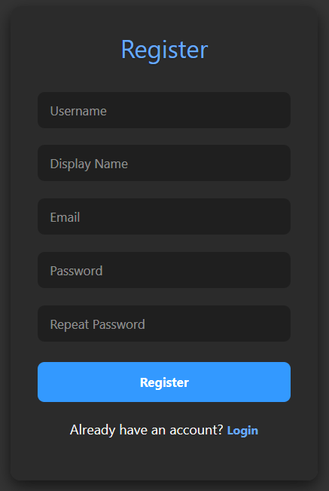

Figure 121. Registration Page

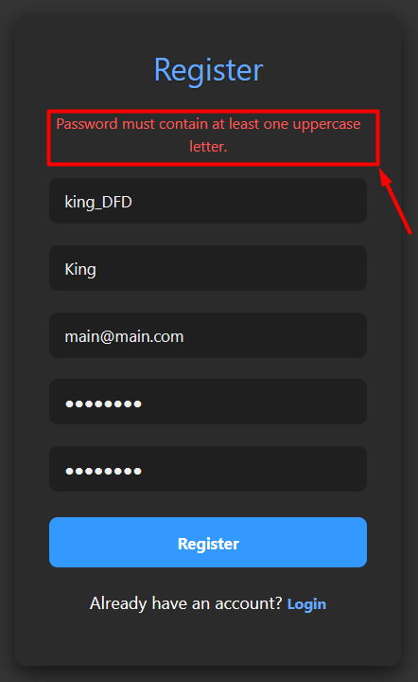

Figure 122. Register Page (Error Message Output)

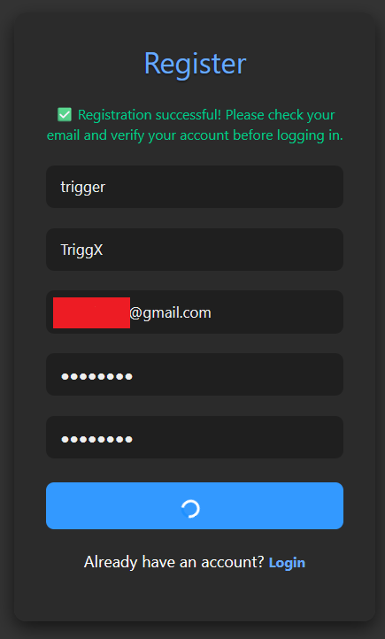

Figure 123. Register Page (Successful Registration)

* + 1. Login Page

Upon visiting the login page (see **Figure 121**), users are presented with two authentication options:

* **Standard Login** using a username and password
* **Google Authentication** via the "Sign in with Google" button

This dual approach offers flexibility and convenience, especially for users who prefer social logins.

1. **What is Google Authentication and Why Use It?**

**Google Authentication** is part of the **OAuth 2.0** family of protocols, which enables third-party applications to securely access user account information without needing to store their passwords. Since its public release by Google in the late 2000s, it has become one of the **most widely adopted authentication providers globally**, used by millions of websites and applications - from small startups to enterprise platforms.

* **Security**: Google's infrastructure includes advanced security features.
* **User Trust**: Users are more likely to sign in with providers they recognize and trust.
* **Reduced Friction**: No need to create a new password or remember credentials for every service.

By integrating **Google Sign-In**, the Vapor platform inherits these benefits, offering users a faster and safer login experience.

1. **Google Authentication Flow**

When the user selects **"Sign in with Google"**, a secure OAuth flow is initiated that redirects them to a Google account selection screen (see **Figure 122**). This step allows the user to choose an existing Gmail account or use another email.

* If the selected Google account matches an existing user in the system (based on email), it will link the Google ID and mark the user as IsGoogleAuthenticated.
* If there is no existing match, a new account is created automatically. A unique username is generated (based on the email), and the account is instantly marked as verified.

After successful login via Google, an **email confirmation** is sent (see **Figure 123**) to inform the user that their account has been verified and is ready to use. This confirmation email is automatically sent, and **no further action is required from the user.**

This behavior enhances user experience by removing the need for manual email confirmation when using trusted Google logins.

Once authenticated, the system issues a **JWT access token** and a **refresh token**, which are stored and used for secure navigation across the app.

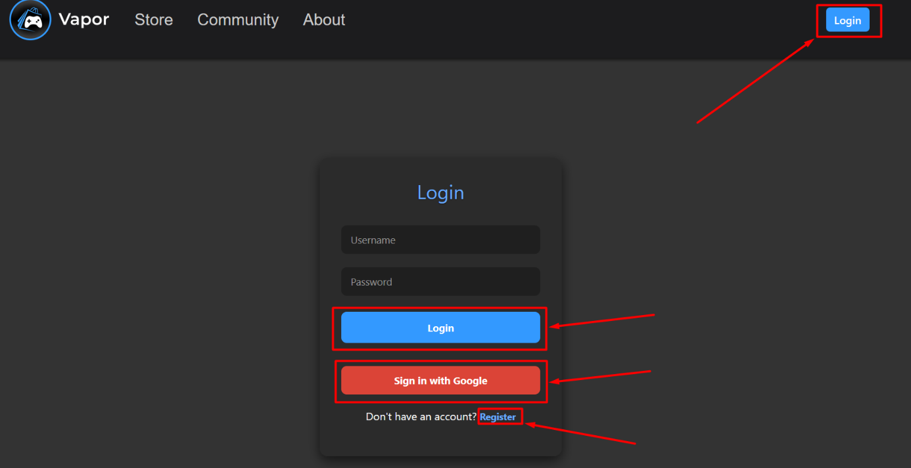

Figure 124. Login Page

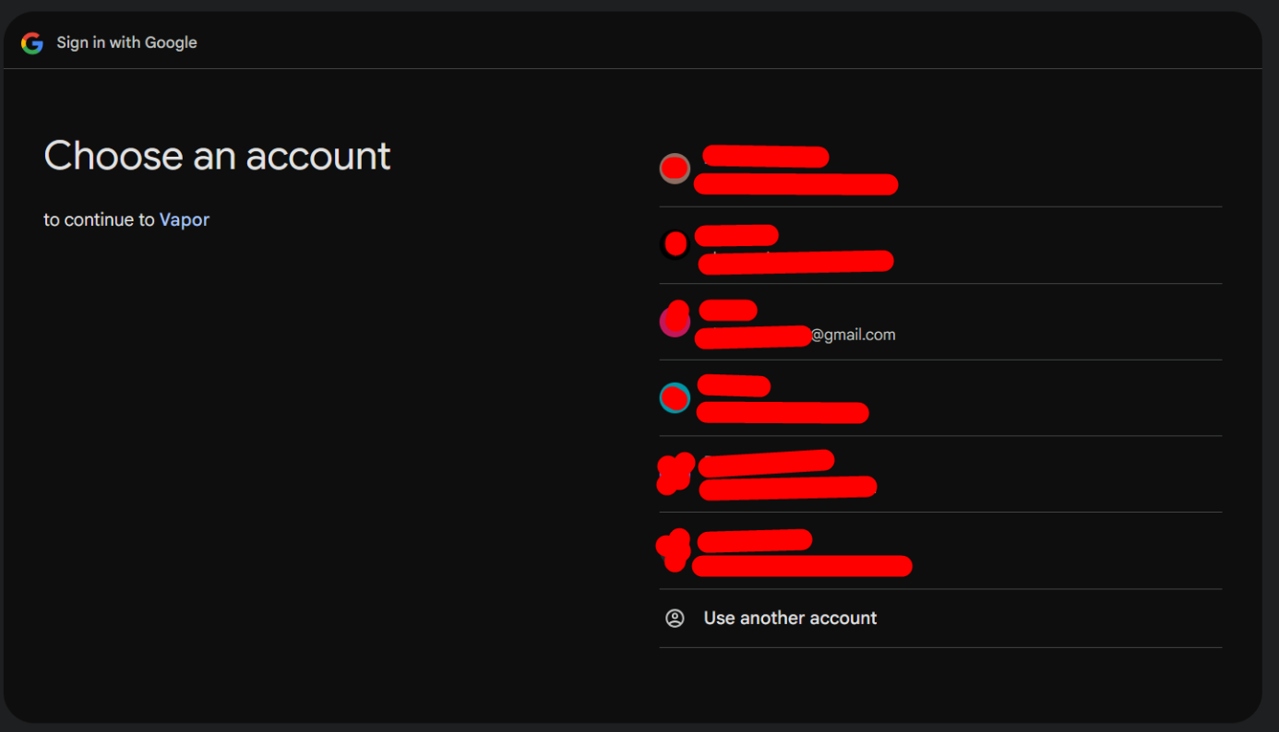

Figure 125. Google OAuth

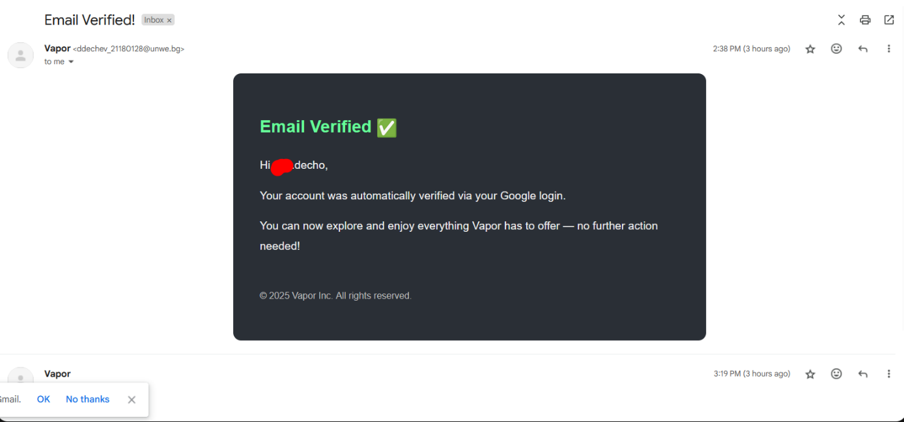

Figure 126. Google Email Verification Message (First time Sign-in)

1. **Email Verification in Standard Login**

When a user attempts to log in through the standard form, the system performs a crucial verification step: checking if the user's email has been confirmed.

If the email is not verified, the login process is halted, and the user is redirected to the Email Verification page. This page explains the issue and offers an option to resend the verification email (**Figure 124**).

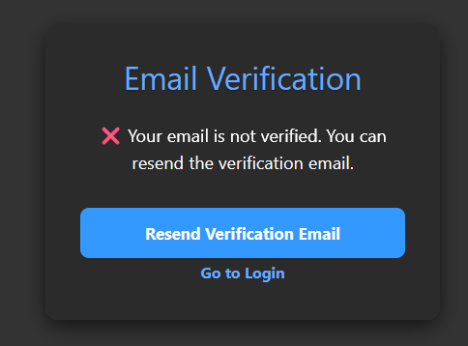

Figure 127. Standard Login (Email Not Verified)

* **Resubmission Behavior**

If the user tries to request a new verification email too soon - while their current token is still active - the system prevents it and displays a message (See **Figure 125**)

This mechanism ensures that token generation is not abused, and prevents email spam or user confusion.

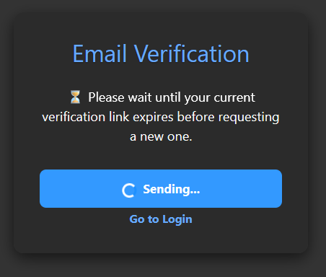

Figure 128. Login (Send Email Verification while there is an Active token)

* **Email Resend After Expiration**

Once the original verification token expires, the user can resend a new email from the same screen (See **Figure 126**).

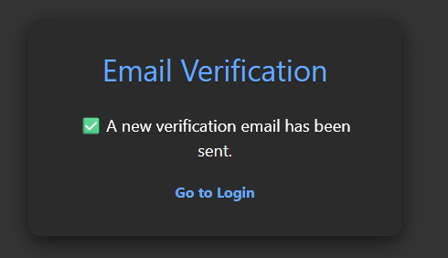

Figure 129. Login (New Verification Email Sent)

* **Email Verification Flow: Success, Expiration & Account Deletion**

Once a user receives the verification email (**Figure 127**), it presents them with **two distinct actions**:

* **Verify Email** - confirms their email and activates their account.
* **Delete Account** - allows them to instantly remove the account if it was created unintentionally or by someone else.

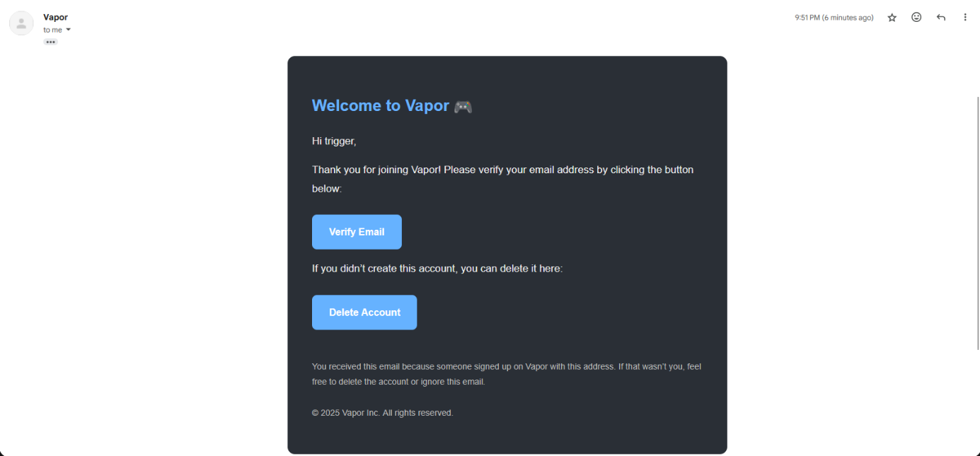

Figure 130. Verification Email

**Case 1: Successful Email Verification**

* Clicking **“Verify Email”** takes the user to /verify-email?token=XYZ.

The system checks the token:

* If it’s **valid and not expired**, the email is marked as verified.
* All verification tokens tied to that user are deleted.
* A confirmation email (**Figure 128**) is sent stating.
* The app then displays a success screen (**Figure 129**).

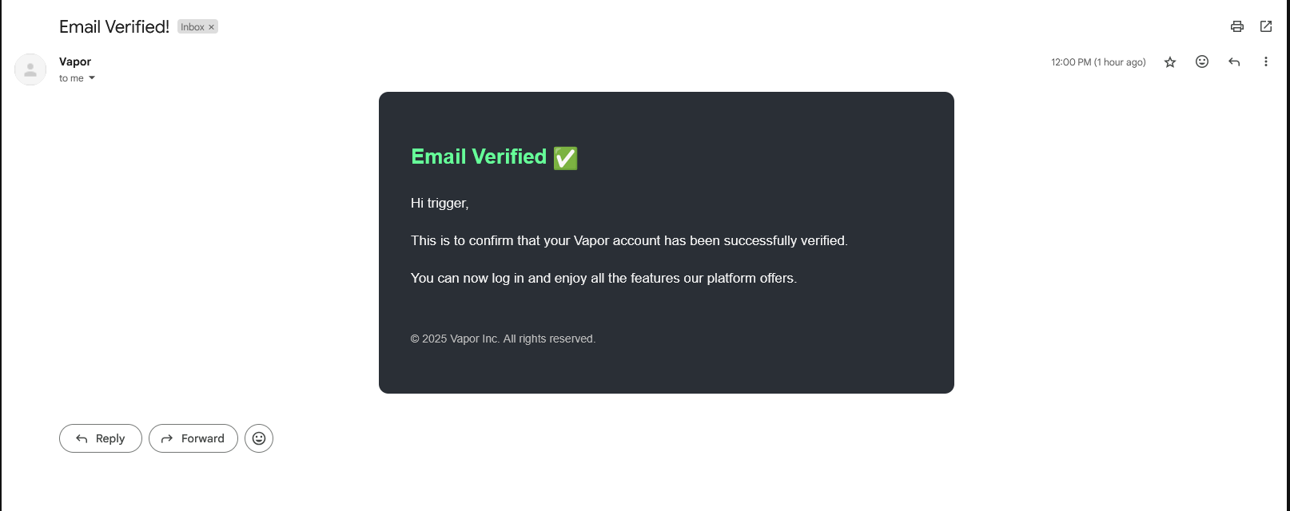

Figure 131. Email Verified Confirmation

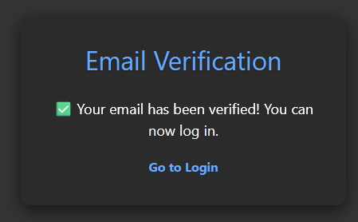

Figure 132. Email Verified Message

**Case 2: Expired Verification Link**

When a user clicks on the **Verify Email** button in their email **after the token has expired** (i.e., more than 10 minutes have passed), the system detects this during backend validation and responds accordingly.

As shown in **Figure 128**, the user is taken to a special screen informing them that the token has expired.

They are then presented with a **"Resend Verification Email"** button, which allows them to trigger a new verification link to their registered email address.

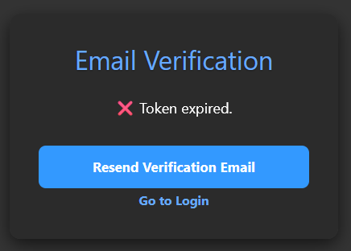

Figure 133. Email Verification Expired Link

**Case 3: Delete Account via Email**

If the user clicks the “Delete Account” button in the verification email:

* They are redirected to /delete-account?token=XYZ.
* The system validates the token and, if valid, proceeds to permanently delete the user account from the database.
* A confirmation email is sent to the address previously linked to the account (**Figure 131**).
* The app displays a success screen indicating that the account has been removed (**Figure 132**).

This deletion flow is especially useful in cases of:

* Mistaken sign-ups with someone else’s email
* Users who no longer wish to use the platform
* Quick action against malicious or accidental registrations

**Handling Invalid or Reused Tokens**

If the token:

* Is missing
* Has expired
* Has already been used

…the system rejects the deletion request and shows an appropriate error (**Figure 133**).

This behavior ensures:

* Tokens cannot be reused maliciously
* System integrity and deletion transparency

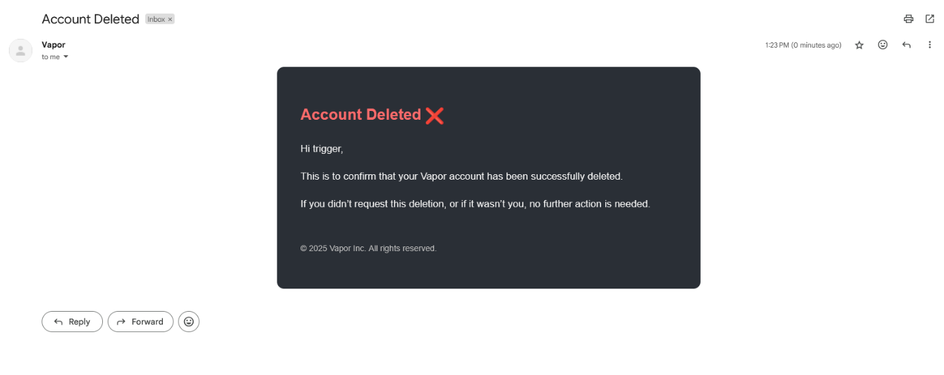

Figure 134. Account Deleted Email

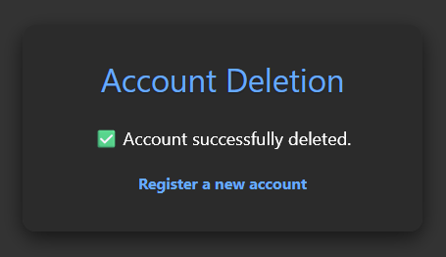

Figure 135. Account Deleted Success Message

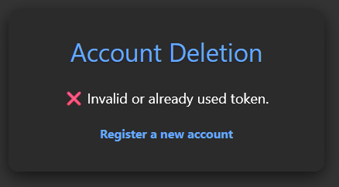

Figure 136. Account Deletion Failed

* + 1. Footer

The **Footer** component (**Figure 137**) is a simple, responsive section displayed at the bottom of all pages. It contains:

* The **Vapor logo**, which navigates to the home page when clicked.
* Basic copyright and ownership notices.
* A set of **quick navigation links** to important legal and informational pages, including Privacy Policy, Terms of Service, Refund Policy, Support, and About Us.

The links are implemented as buttons with smooth scroll-to-top behavior for improved UX.

Figure 137. Footer Component

* + 1. Privacy Policy Page

The **Privacy Policy** page (**Figure 138**) outlines how Vapor collects, uses, and safeguards user data. It is a static informational page structured into clearly labeled sections, covering:

* What personal and technical data is collected.
* How that data is used to operate the platform.
* The platform’s stance on **data sharing** (limited only to trusted partners).
* User rights and choices (e.g., account deletion, data updates).
* Notification practices for future policy changes.
* Contact information for privacy-related inquiries.

This page enhances transparency and supports legal compliance regarding user data handling.

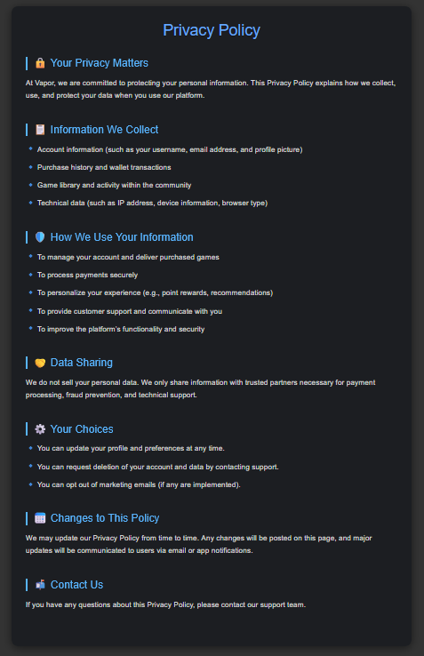

Figure 138. Footer - Privacy Policy Page

* + 1. Terms of Service Page

The Terms of Service page (**Figure 139**) defines the legal agreement between the user and the Vapor platform. It is a structured document that establishes:

* **User agreement and acceptance**: Use of the platform implies acceptance of these terms.
* **Usage rules**: Includes account responsibility, legal compliance, and behavior expectations.
* **Purchase terms**: Clarifies that purchases are final and subject to pricing changes and promotional terms.
* **Prohibited actions**: Lists activities like unauthorized game sharing or service disruption that are not allowed.
* **Service updates**: States Vapor’s right to modify or discontinue services at any time.
* **Policy changes**: Outlines how users will be informed of future changes to these terms.
* **Support contact**: Provides a section for reaching out in case of questions or disputes.

This page ensures both legal protection for the platform and clarity for users regarding their rights and responsibilities.

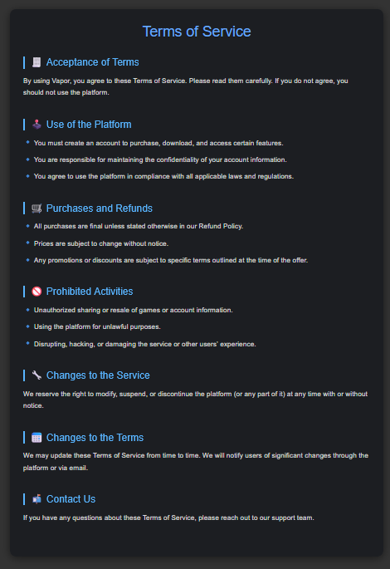

Figure 139. Footer - Terms of Service Page

* + 1. Refund Policy Page

The Refund Policy page (**Figure 140**) outlines Vapor’s commitment to fair and transparent purchase practices. It serves as a user-friendly guide for understanding refund conditions and procedures, including:

* **Eligibility window**: Refunds are accepted within 14 days of purchase, provided the game has been played less than 2 hours.
* **Exceptions**: DLCs, gifts, and wallet transactions may have special rules or be non-refundable.
* **Excluded cases**: Heavily used games, non-refundable promotional items, and redeemed virtual goods are not eligible.
* **Request process**: Users can submit refund requests via their purchase history with a short explanation.
* **Review & discretion**: Vapor’s support team evaluates each request, typically responding within 7 business days. Abuse of the system may lead to consequences.

This page ensures customers are informed of their rights while helping maintain a balanced and fair refund system.

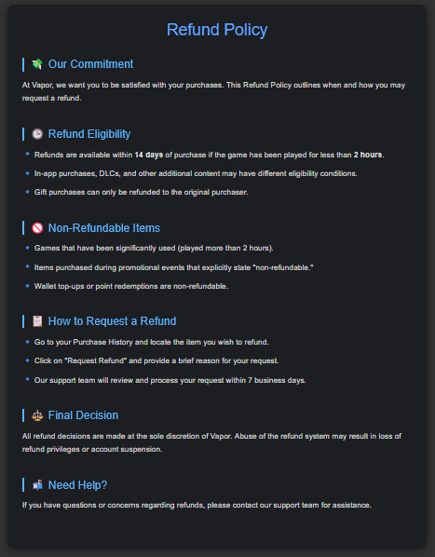

Figure 140. Footer - Refund Policy Page

* + 1. Support Page

The **Support** page (Figure XX) offers users a centralized space for resolving issues and accessing help. It is structured to guide users through:

* **Common issues** such as login problems, payment inquiries, and community concerns
* **Contact methods**, including email support and the upcoming in-app ticketing system
* **Expected response time**, generally within 24–48 hours
* **Helpful guidelines** encouraging users to include details (like screenshots or error messages) for faster resolutions

This page ensures users feel supported throughout their experience and sets clear expectations for resolving technical or account-related problems.

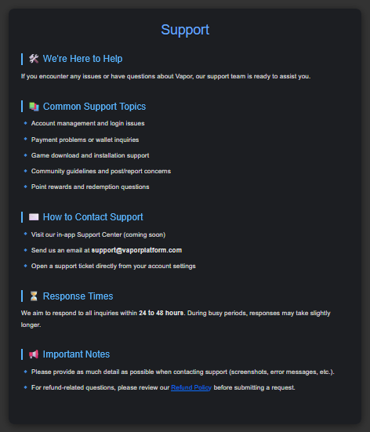

Figure 141. Footer - Support Page

* 1. Data Flow Diagrams
     1. Full Overview DFD

This Data Flow Diagram (**Figure 142**) provides a comprehensive overview of the core functional and security processes within the Vapor application. It visualizes how users interact with different subsystems and how various backend tables support these interactions.

Users can register through the Register Process, which stores their credentials in the Users table. After registration, accounts go through the Email Verification Process. If the user registered using standard credentials, a verification email is sent and stored in the EmailVerifications table. However, users signing in via Google OAuth are automatically marked as verified and bypass this step.

During login, the system checks the IsEmailVerified flag for standard logins and ensures the account is valid before granting access.

Once logged in, users can:

* Search for games through the Game Search Process, interacting with the Apps table.
* Add games to the cart via the Add to Cart Process, which writes to the CartItems table.
* Proceed to checkout using the Checkout Process, integrating wallet payments, Stripe, and discount logic via the PaymentTokens table.
* View their library using the Library Update Process, pulling data from the Library table.
* Edit profile data through the Profile Update Process, modifying the Users table.

The Community Post Process enables users to engage socially by posting, commenting, and liking through the Posts, PostComments, and PostLikes tables.

Administrators can view and manage key data entities via the Admin Management Process, ensuring operational oversight.

Some flows, have been intentionally excluded from the diagram to preserve clarity and avoid visual overload.

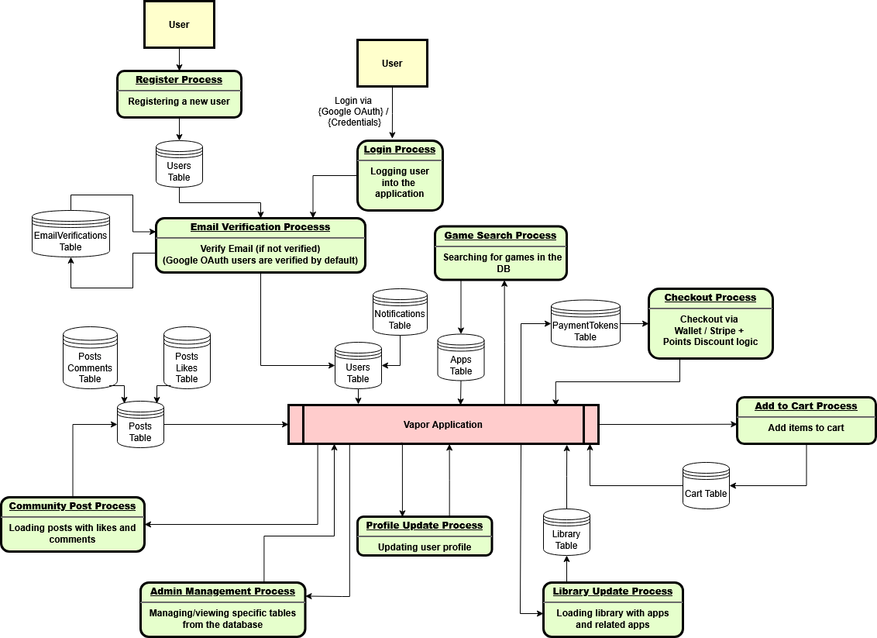

Figure 142. Full Overview Data Flow Diagram

* + 1. Register Process DFD

The registration process begins when a user submits their input through the interface. This data is passed to the Register Process, which collects and forwards it to the Validation Process. The validation phase performs critical backend checks - ensuring that the username is unique, the email is valid and not already in use, and that the password meets security standards.

If all validations succeed, two actions occur:

* A new user record is saved in the Users Table.
* A unique verification token is generated and stored in the EmailVerifications Table to trigger the email verification process.

This ensures that only properly verified users can continue to access the platform, enforcing security and data integrity from the moment of registration (**Figure 143**).

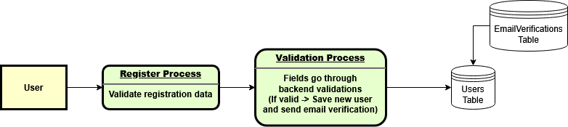

Figure 143. Register Process DFD

* + 1. Login Process DFD

The login process begins when a user submits their credentials - either a traditional username and password, or by using Google OAuth (**Figure 144**). The submitted data is passed through a Validation Process, which verifies if such a user exists in the system.

Once the user is identified, the system proceeds to an Email Verification stage:

* For users logging in via Google, email verification is automatically assumed to be complete.
* For users logging in via credentials, the system checks if their email has been verified.
  + If the email is not verified, the login is interrupted, and the user is redirected to the verification screen.
  + If the email is verified, the process continues and access is granted.

To keep the diagram concise and readable, the flow is presented in a straightforward linear format - though in practice, some of the checks (like verification status) may trigger redirects or token generation depending on the result.

This layered design ensures only verified users can log in, preserving account security while offering a smooth experience for Google-authenticated users.

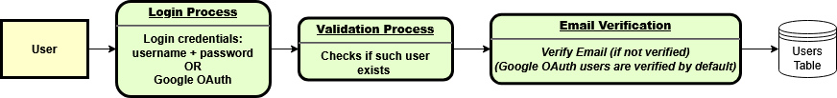

Figure 144. Login Process DFD

* + 1. Email Verification Process DFD

The Email Verification Process (**Figure 145**) handles user account confirmation through secure, time-limited tokens. When a user clicks the email verification link received during registration, the system validates the associated token and follows one of three conditional flows based on its status.

* **Valid Token:**

If the token is valid and unexpired, the user is marked as verified in the **Users** table. All existing verification tokens linked to the account are then deleted from the EmailVerifications table to prevent reuse.

* **Expired Token:**

If the token is expired, the user is shown an option to resend a new verification email. This prevents abuse while still allowing recovery from missed or delayed email interactions.

* **Invalid Token:**

If the token is malformed or already used, the system displays a corresponding error message, alerting the user that verification could not proceed.

* **Account Deletion (Optional):**

If the user chooses the “Delete Account” option from the verification email, the account is permanently removed from the database and a confirmation email is sent.

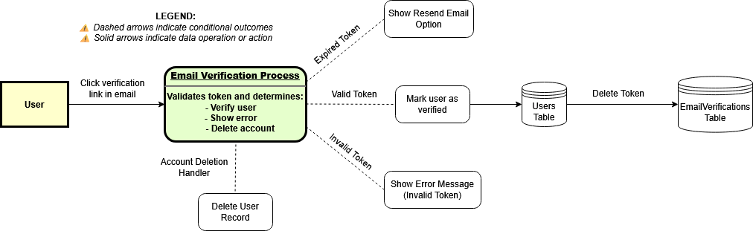This process reinforces both security and user control, ensuring that only verified users gain access while still giving individuals the ability to self-manage unintended or fraudulent registrations.

Figure 145. Email Verification Process DFD

* + 1. Forgotten Password Process DFD

The Forgotten Password process (**Figure 146**) illustrates the secure recovery procedure users follow when they cannot access their Vapor account.

1. **Reset Request Process**

The process begins when the user submits a password reset form with their registered email. This step initiates the backend verification process to determine whether a reset can proceed.

1. **Token Validation & Generation Process**

The backend first checks if the submitted email belongs to an existing user.

* + If the user exists and no active reset token is currently valid, a new token is generated and stored in the PasswordResetTokens Table.
  + If an active token already exists, the request is blocked to prevent abuse and potential spam.

1. **Reset Link Email Dispatch**

If a new token is created, an automated email containing a secure password reset link is sent to the user's email. This link contains the token needed for validation.

1. **Token Verification Process**

When the user clicks the reset link, the system verifies the token's validity and expiration:

* + The page is always shown, regardless of token validity.
  + The token is not validated at this stage. It is only validated when the user submits the new password.

1. **Password Change Handler**

Once the user enters and submits their new password:

* + The backend checks the token's validity and expiration at that moment.
  + If the token is valid, the password is hashed and updated in the Users Table, and the token is deleted from the PasswordResetTokens Table.
  + If the token is invalid or expired, an error message is displayed and the token is removed if it exists.

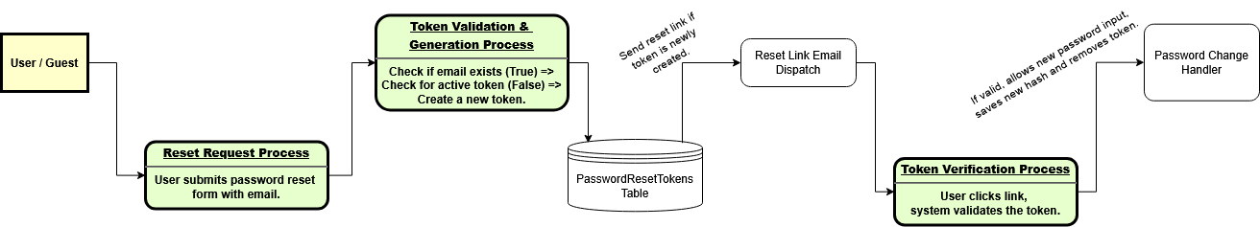Due to the high complexity of the password recovery functionality - including conditional behaviors around token validity, expiration, and secure submission handling - a complete diagram capturing every interaction and edge case has not been included. Instead, this section focuses on the core functional flow to maintain clarity and avoid overcomplicating the visual representation.

Figure 146. Forgotten Password Process DFD

* + 1. Game Search Process DFD

In the game search process (**Figure 147**), users submit search parameters such as game name, genre, or price filters (e.g., free or paid apps). The system processes this input and queries the Apps table to retrieve matching results from the database.

The search results are then returned and presented to the user for browsing and selection within the search results page.

Additionally, the search functionality includes real-time suggestions — as the user types each letter into the search bar, the system dynamically performs database queries to fetch and display matching suggestions instantly. This enhances user experience by enabling quicker and more intuitive searching.



Figure 147. Game Search Process DFD

* + 1. Add to Cart Process DFD

In the add to cart process (**Figure 148**), users select an application they intend to purchase. Before the item is added, the system performs validation checks - verifying whether the user already owns the application and, in the case of related content (e.g., DLCs), confirming that the required base application has been purchased.

If the validation passes, the selected app is stored in the cart (via the Cart table). The updated cart contents are then displayed to the user, allowing them to review or modify their selection prior to checkout.

Guest users can also build a cart. Upon logging in or registering, their guest cart items are automatically merged into the authenticated user's cart, ensuring a seamless shopping experience.

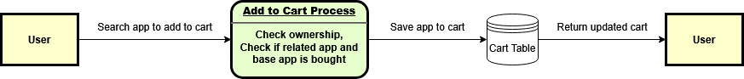

Figure 148. Add to Cart Process DFD

* + 1. Checkout Process DFD

The Checkout Process (**Figure 149**) begins when the user proceeds to checkout from their cart. The system first checks the User Table to evaluate the user's wallet balance:

* **If the balance is sufficient:**

The required amount is deducted directly from the wallet. The purchased applications are then added to the Library Table, and the purchase is logged in the PurchaseHistory.

* **If the wallet balance is insufficient:**

The system initiates a Stripe Checkout Session. This session is created through the Stripe API, and the necessary details are stored in the PaymentTokens Table.

Once the user completes the Stripe transaction:

* + The system confirms the payment using the Session ID.
  + The corresponding wallet amount is credited to the user.
  + The Stripe-related PaymentToken is deleted after successful confirmation.
  + The user can then complete the purchase using their now-sufficient wallet balance.

This process is designed to support both direct wallet purchases and dynamic top-up with auto-purchase, depending on the user’s current balance and the payment method selected. All operations are securely recorded and reflected in the Users, Library, and PurchaseTokens tables accordingly.

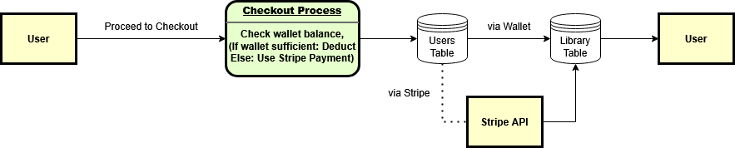

Figure 149. Checkout Process DFD

* + 1. Library Update Process DFD

After a successful transaction - whether via wallet or Stripe - the Library Update Process (**Figure 150**) is triggered automatically. The system records the purchased applications in the Library Table, effectively granting the user access to those titles. This process ensures the user's game collection reflects the most recent changes.

Once updated, the user's library is reloaded and returned to the frontend, allowing them to immediately browse, launch, or interact with their newly acquired games. The system also ensures that related apps (e.g., DLCs, music, etc.) are displayed in a structured and consistent manner under the main game entry.



Figure 150. Library Update Process DFD

* + 1. Community Post Process DFD

The Community Post Process (**Figure 151**) enables users to interact with each other by creating posts, liking posts, and commenting on them. Each type of interaction is stored in a dedicated table:

* Posts are saved in the Posts Table.
* Likes are recorded in the Posts Likes Table.
* Comments are stored in the Posts Comments Table.

Whenever a user likes or comments on another user's post, the system automatically generates a corresponding entry in the Notifications Table. This ensures the original post creator is notified of new activity on their content, enhancing community engagement.

When a user visits the community page, the system retrieves all posts along with their associated likes and comments. These are presented in a unified view, enabling seamless browsing, interaction, and real-time feedback through notifications.

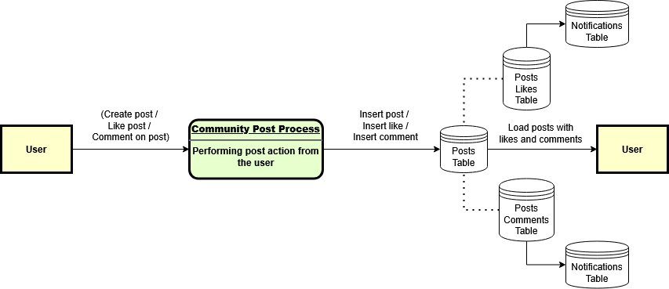

Figure 151. Community Post Process DFD

* + 1. Profile Update Process DFD

The Profile Update Process (**Figure 152**) allows users to modify their display name, profile picture, or both. Once the user submits the changes, the system updates the corresponding fields in the Users Table.

If the display name is changed, the system performs an additional step: it updates all associated entries in both the Posts Table and Posts Comments Table. This ensures that previously created posts and comments continue to reflect the user’s current identity. Only records that haven’t been soft-deleted by the user or the original poster are updated to preserve historical accuracy where needed.

Upon successful completion:

* The updated profile is returned to the user.
* The application refreshes the UI with the new data.
* New access and refresh tokens are generated to reflect the updated identity.
* The user is automatically redirected to their profile page.

This ensures that identity consistency is maintained across the platform while also improving user experience and session integrity.

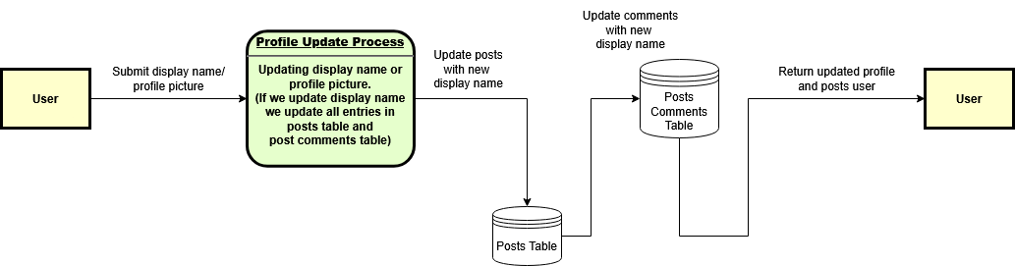

Figure 152. Profile Update Process DFD

* + 1. Admin Management Process DFD

The Admin Management Process (**Figure 153**) provides administrative users with access to critical system tables within the platform. Admins can navigate through the admin panel to view, edit, or delete records depending on their assigned privileges.

Not all tables are editable - some are read-only and are included for reporting, monitoring, or audit purposes. The system enforces permission-based control to ensure only authorized actions are allowed per table or data type.

This flexible and centralized control flow ensures the integrity of application data while empowering authorized personnel to maintain, debug, or supervise the platform in a controlled environment.

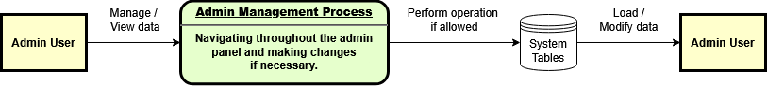

Figure 153. Admin Management Process DFD

1. Data model - sources and data models
   1. Overview of the Database

The Vapor application utilizes a relational database model implemented in Microsoft SQL Server. All objects are defined under a dedicated schema named 21180128, which was a requirement.

The database structure is designed to support the core business processes of the system, including:

* User authentication and account management
* Profile updates and personalization
* Application catalog browsing and filtering
* Shopping cart operations and checkout processing
* Digital library access for owned applications
* Community features such as posts, likes, and comments

Data within the system originates from four primary sources:

* **User Input:** Captured during activities such as registration, login, profile changes, cart interactions, community participation, and purchases.
* **Administrative Actions:** Performed by system administrators with permissions to manage designated tables (e.g., editing or deleting application-related records).
* **System-Generated Data:** Automatically created by internal operations, such as wallet deductions, purchase logs, and points awarded based on user activity.
* **Third-Party Integrations:** Primarily interactions with external services like the Stripe API, used for secure payment processing and wallet top-ups.

To maintain data consistency and security:

* Referential integrity is enforced through primary and foreign key constraints.
* Cascade deletion rules are applied where applicable to ensure orphaned records are prevented.
* A service log table (21180128_log**)** is maintained, capturing insertion and update operations via triggers to provide an auditable change history across critical tables.

Two visual representations of the database are provided for reference:

* PowerDesigner Diagram (**Figure 154**)
* SQL Server Management Studio Diagram (**Figure 155**)

While both diagrams convey the same relational model, each offers unique visualization strengths. The PowerDesigner diagram provides a high-level structural overview, whereas the SQL Server Management Studio diagram includes schema-qualified table names for more detailed inspection.

**Note:** Due to the large dimensions and resolution of the database diagrams, the embedded images may not be clearly visible within this document. To ensure proper inspection, both diagrams are also provided as external files in the following folders:

* **PowerDesigner** – Contains the original .pdm model and a high-resolution exported image.
* **MSSQL** – Contains full screenshots of the SQL Server Management Studio schema layout and the database script.

If the embedded hyperlinks are non-functional or inaccessible due to software constraints, the diagrams can be accessed manually by navigating to their respective folders in the submitted project directory.

[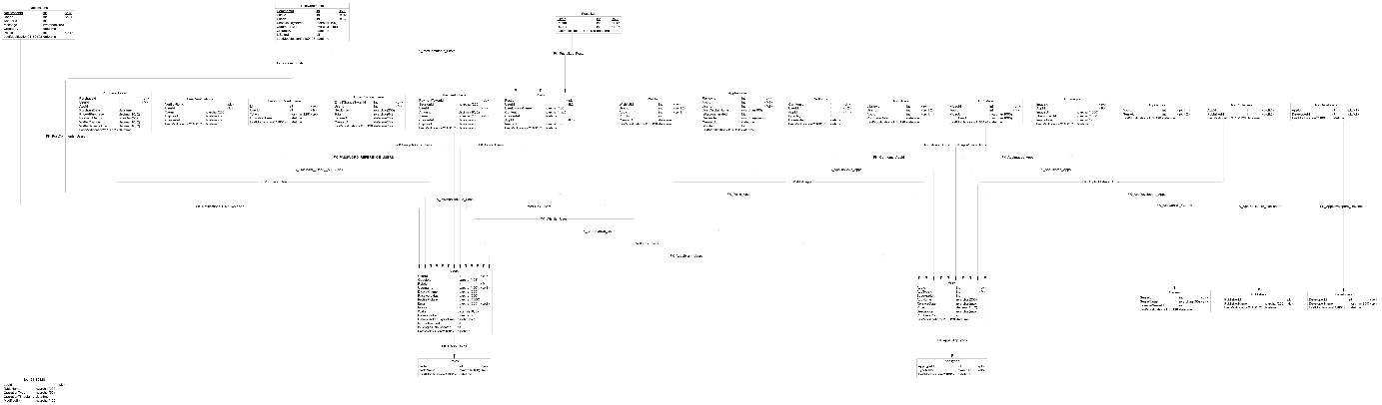](PowerDesigner/VaporDB_PhysicalDiagram.jpg)

Figure 154. Vapor Database Schema (PowerDesigner)

[](MSSQL/VaporDB_Diagram.png)

Figure 155. Vapor Database Schema (MSSQL)

* 1. Table-by-Table Explanation
     1. Roles Table

The roles table defines the different types of user roles within the application, enabling role-based access control. Each role is uniquely identified by RoleId and has an associated RoleName (e.g., User, Admin). The table enforces a unique constraint on the RoleName to prevent duplicate role definitions. Additionally, the LastModification21180128 column automatically updates on insert or update operations through dedicated triggers, maintaining an audit trail of role modifications. The roles table serves as a reference table and is linked to the Users table to assign permissions accordingly.

* + 1. Publishers Table

The publishers table stores information about the publishers responsible for the applications listed in the Vapor platform. Each publisher is uniquely identified by PublisherId and has an associated PublisherName, which must be unique across all records. The LastModification21180128 column tracks the last change made to the publisher record and is automatically updated through triggers during insert and update operations. This table is primarily referenced in many-to-many relationship with applications through the AppPublishers linking table.

* + 1. AppPublishers Table

The AppPublishers table establishes a many-to-many relationship between applications and publishers within the Vapor system. Each record links an AppId (application) to a PublisherId (publisher), allowing an application to have multiple publishers and a publisher to be associated with multiple applications. The table uses a composite primary key consisting of both AppId and PublisherId to ensure uniqueness of each association. Cascade deletion is enforced, this means if either application or publisher is deleted, the corresponding associations in the AppPublishers table are automatically removed. The LastModification21180128 column is automatically updated via triggers during insert and update events, providing audatibility of relationship changes

* + 1. Developers Table

The developers table stores information about game or application developers within the platform. Each developer is uniquely identified by a DeveloperId and has a unique DeveloperName. A unique constraint on the DeveloperName ensures no duplicate records exist. The LastModification21180128 column captures the timestamp of the last update and is automatically maintained through insert and update triggers. This table is used in a many-to-many relationship with applications via the AppDevelopers linking table. Deletion of a developer cascades to remove any related associations in AppDevelopers.

* + 1. AppDevelopers Table

The AppDevelopers table establishes many-to-many relationship between applications and developers. Each record links one developer to one application through the composite primary key of AppId and DeveloperId. The table includes a LastModification21180128 column, which logs the timestamp of the latest change using triggers. Cascade delete is enabled for both referenced tables, ensuring related links are removed when a developer or app is deleted.

* + 1. Genres Table

The genres table stores the different game genres available on the platform. Each Genre is uniquely identified by a GenreId and includes a GenreName and optional ExternalGenreId for reference. The external genre id column stores the value of the API that we used to get all the data for our platform (Steam). A LastModification21180128 column tracks the latest change, maintained by triggers. Genres are linked to apps through a many-to-many relationship managed by the AppGenres table.

* + 1. AppGenres Table

The AppGenres table defines the many-to-many relationship between apps and genres. It consists of two foreign keys (AppId and GenreId), both forming a composite primary key, just like on AppDevelopers and AppPublishers. Each record represents an association between an app and a genre. The LastModification21180128 column logs the most recent change, maintained by triggers. Cascade deletes are enabled, so removing an app or genre also removes related entries.

* + 1. AppImages Table

The AppImages table stores images (the file path towards the image itself) related to applications, including full-size and thumbnail urls. Each image is identified by an imageId and linked to a specific app through AppId. The ImageType column indicates the image category (e.g., header, screenshot). The LastModification21180128 field is updated via triggers on insert or update. Cascade delete ensures associated images are removed when an app is deleted.

* + 1. AppVideos Table

The AppVideos table stores video trailers associated with applications. Each entry is uniquely identified by a VideoId and linked to an app via AppId. It includes both the video url and a corresponding thumbnail. Insert and update triggers maintain the LastModification21180128 timestamp. Cascade delete ensures video entries are removed when an associated app is deleted.

* + 1. AppLibrary Table

The AppLibrary table records which apps are owned by which users. Each row is uniquely identified by a LibraryId and represents the ownership of a specific AppId by a specific UserId. It includes a PurchaseDate field and a LastModification21180128 timestamp, updated via triggers. A unique index on the combination of UserId and AppId prevents duplicate entries (or composite key with other words). Cascade delete ensures entries are removed if either the user or app is deleted.

* + 1. AppTypes Table

The AppTypes table stores the different types of applications in the platform, such as games/demos/music and dlcs. Each type is uniquely identified by an AppTypeId and labeled with a TypeName. The LastModification21180128 column tracks the last update timestamp, maintained through insert and update triggers. A unique constraint on TypeName ensures that no two types share the same name.

* + 1. CartItems Table

The CartItems table holds data about which apps users intend to purchase. Each record is uniquely identified by a CartItemId and includes references to both the user (UserId) and the app (AppId) being added. Additional fields include Quantity, DateAdded and a LastModification21180128 timestamp, which is updated automatically via triggers. Cascade delete is enabled on AppId to ensure cart entries are removed if the corresponding app is deleted.

* + 1. log_21180128 Table

The log_21180128 table records data manipulation activities (insert or update) for audit purposes. Each entry is uniquely identified by a LogId and stores the affected table’s name, the type of operation (insert or update), a timestamp (OperationTimestamp) and the user who performed the change (ModifiedBy). The table is populated via triggers defined on individual tables throughout the schema.

* + 1. PostLikes Table

The PostLikes table tracks which users have liked specific posts. Each entry is identified by a LikeId and references a post (PostId) and a user (UserId). The LastModification21180128 column stores the timestamp of the most recent change, automatically managed via triggers. If a user is deleted, the UserId rows are deleted from PostLikes table.

* + 1. PostComments Table

The PostComments table stores user components associated with posts. Each comment is identified by a CommentId and references a post (PostId) and a user (UserId). Additional fields include the commenter’s UserDisplayName, CommentText and CreatedAt timestamp. The LastModification21180128 field tracks the last update time and is automatically maintained via triggers. If the user is deleted, their UserId is set to null to preserve the comment history.

* + 1. Posts Table

The posts table stores user-generated posts associated with a specific app. Each post is uniquely identified by PostId and includes references to both the user (UserId) and the app (AppId). Additional fields include UserDisplayName, Content, CreatedAt and ImageUrl. The LastModification21180128 column is updated via triggers on insert or update, the same as all tables. If the user is deleted, the UserId is set to null to preserve the post content.

* + 1. Users Table

The Users table contains information about registered users. Each user is uniquely identified by UserId. Fields Include Username, DisplayName, Email, PasswordHash, ProfilePicture and RoleId. The table also tracks authentication data with RefreshToken and its expiration. Fields like Points, Wallet and LastModification21180128 are maintained, the latter updated via triggers. A unique constraint on Username and Email ensures no duplicates. Deletion cascades affect dependent tables such as AppLibrary, CartItems, PostComments and PostLikes.

* + 1. Apps Table

The Apps table stores data about all applications listed on the platform. Each app is uniquely identified by AppId. Fields include AppName, ReleaseDate, Price, Description and PurchaseCount. The AppTypeId links to the app category and BaseAppId is used to associate related content like DLCs / Music. The LastModification21180128 timestamp is updated via triggers. Deleting an app cascades to related entries in tables such as AppGenres, AppDevelopers, AppPublishers and AppLibrary.

* + 1. Wishlist Table

The Wishlist table stores entries representing user-desired applications. Each record is uniquely identified by WishlistId and references both a user (UserId) and an application (AppId). The Priority field allows users to assign importance to wishlist items, while CreatedAt captures the time the entry was added.

The LastModification21180128 column tracks the last update timestamp and is automatically maintained via triggers. A unique constraint prevents duplicate wishlist entries for the same user-app pair.

Cascade delete rules are enforced via foreign keys: if a user or app is removed, related wishlist entries are automatically deleted. Additionally, insert and update triggers log changes to the log_21180128 service table to maintain audit trails.

* + 1. PurchaseHistory Table

The PurchaseHistory table records transaction history for all user purchases, including standard application purchases and wallet top-ups. Each entry is uniquely identified by PurchaseId and references a user via UserId. The AppId field is nullable to support non-app-related purchases, such as wallet recharges.

Additional columns include PurchaseDate, PriceAtPurchase, and PaymentMethod, along with WalletChange and WalletBalanceAfter to reflect financial adjustments. The LastModification21180128 field is automatically maintained via update triggers.

A cascade delete is enforced through the UserId foreign key - removing a user clears their purchase history. Insert and update triggers ensure audit trail consistency by writing changes to the log_21180128 table.

* + 1. PaymentTokens Table

The PaymentTokens table manages session-based records related to Stripe payment attempts. Each record is uniquely identified by PaymentTokenId and references the user via UserId. The SessionId and unique Token fields are used to track and validate the payment session. Amount reflects the wallet top-up value, while CreatedAt and ExpiresAt define the session's validity window.

The LastModification21180128 column is updated via a backend trigger during data changes. A foreign key constraint ensures referential integrity with the Users table and enforces cascade deletion. Insert and update triggers log all operations in the log_21180128 table for auditing purposes. This table is critical in ensuring secure, single-use payment flows and avoiding duplicate or expired session processing.

* + 1. PasswordResetTokens Table

The PasswordResetTokens table manages temporary tokens issued for password reset operations. Each token entry is identified by a unique Id and is associated with a specific user via UserId. The Token field stores the reset identifier, while ExpirationTime determines the validity window of the reset request.

The LastModification21180128 field is maintained via triggers and reflects the last update timestamp. A unique constraint on Token prevents duplicates. If the user is deleted, associated reset tokens are removed automatically via cascade deletion.

Insert and update operations are logged through triggers into the log_21180128 table, providing traceability for all reset attempts. This table plays a critical role in securing the password recovery process and ensuring that reset requests are time-bound and user-specific.

* + 1. Notifications Table

The Notifications table manages system-generated alerts that inform users of community-related interactions, such as likes or comments on their posts. Each notification is uniquely identified by NotificationId and linked to a receiver via UserId. The SenderId indicates who triggered the action, and the Message field holds the notification content. If applicable, a PostId reference is stored to associate the notification with a specific community post.

The CreatedAt field tracks when the notification was generated, and LastModification21180128 is automatically updated via triggers. If the post is deleted, the PostId is set to NULL. If the recipient is removed, cascade deletion ensures cleanup. Insertions and updates are logged in the log_21180128 table to maintain an audit trail.

This table enhances user engagement by delivering timely feedback about community interactions directly in the application.

* + 1. EmailVerifications Table

The EmailVerifications table is responsible for managing verification tokens used to activate user accounts after registration. Each record is uniquely identified by VerificationId and references a user through UserId. The Token is a unique identifier used for verification, while CreatedAt and ExpiresAt define the token’s lifespan. If a token is expired, the user must request a new one.

The LastModification21180128 field is automatically updated using triggers on update events. The table maintains referential integrity via a foreign key to the Users table, with cascade delete ensuring that all related verification entries are removed if the user is deleted.

Insert and update operations are logged in the log_21180128 audit table. This structure enables secure and traceable email verification, forming a critical step in the user onboarding process.

* + 1. EmailChangeTokens Table

The EmailChangeTokens table manages email change requests initiated by users. Each entry is uniquely identified by EmailChangeTokenId and includes a reference to the user via UserId, the NewEmail address being requested, and a unique Token used for confirmation. The ExpiresAt field defines how long the token is valid, and CreatedAt captures the creation timestamp.

The LastModification21180128 column is maintained automatically through triggers upon any update, ensuring consistent audit tracking. If the associated user is deleted, the email change request is also removed, thanks to the cascade delete constraint on UserId.

Insertions and updates to this table are logged in the log_21180128 audit table, preserving a trail of all changes. This table plays a key role in allowing secure, user-initiated email updates without exposing sensitive account functionality.

* + 1. AppReviews Table

The AppReviews table stores user-submitted reviews for applications. Each review is uniquely identified by ReviewId and references both an AppId and optionally a UserId. If the user account is deleted, the UserId is set to null while preserving the review. Each review includes the reviewer’s UserDisplayName, a boolean IsRecommended flag (indicating whether the user recommends the app), the actual ReviewText, and a CreatedAt timestamp.

The IsEdited field tracks whether the review has been modified after creation, and the LastModification21180128 column is automatically updated through triggers.

All insertions and updates are recorded in the audit table log_21180128, providing a complete history of review activity. Cascade deletion is enabled for the associated app to remove all reviews when an app is deleted. This structure enables transparent and moderated community feedback within the Vapor platform.

1. Implementations technologies and decisions
   1. Technologies Used

The Vapor application was developed using a modern full-stack architecture, combining the following technologies:

* Backend: ASP.NET Core Web API
* Frontend: React
* Database: Microsoft SQL Server
* Database Modeling: PowerDesigner 16
* Authentication:
  + Custom JWT-based authentication for login and session management.
  + Google OAuth for third-party login.
* Payments: Stripe API
* External APIs
  + YouTube API to fetch trailers dynamically.
  + Steam API to fill in the database with applications.
  1. Key Design Decisions
* RESTful API Architecture
* The System is split into independent backend and frontend layers connected via HTTPS. Each controller in the backend handles a specific responsibility. (Apps, Auth, Cart, etc.)
* JWT Token Authentication with Refresh Tokens
  + Tokens are used for stateless user session management. Refresh token support was added to preserve long-term sessions securely.
* Trigger-Based Logging System
  + All insert and update operations are logged in a log_21180128 table via database triggers to track changes to critical data.
* Cascade Delete and Set Null Rules
  + Relationships were carefully configured to prevent orphan data. For example, deleting a developer removes their AppDevelopers links (on delete cascade) or the deletion of user and posts.
* Points System for Discounts
  + A custom rule allows users to earn points based on purchases, which can later be redeemed for discounts at checkout. This required wallet/points integration.
* Admin Role Support
  + Admin users can view and manage certain database tables via protected API endpoints.

1. Testing

|  |  |  |  |  |
| --- | --- | --- | --- | --- |
| **Test Case ID** | **Prerequisites** | **Title/Description** | **Steps** | **Expected Result** |
| **GENERAL** | | | | |
| GEN_01 | User not logged in | Guest tries to like/comment | Open Community => Click ❤️ or 💬 | Redirected to login page |
| GEN_02 | User not logged in | Guest tries to create post | Redirect via URL | Redirected to login page |
| GEN_03 | User not logged in | Guest tries to add to wishlist/cart | Click 💖 or 🛒 | Redirected to login page |
| GEN_04 | User not logged in | Guest tries to view profile settings | Redirect via URL | Redirected to login |
| GEN_05 | User not logged in | Guest tries to checkout | Add app to cart => Click Checkout | Redirected to login page |
| GEN_06 | Expired token | Try to verify email with expired token | Click expired link | Message: "Token expired" + option to resend |
| GEN_07 | Expired token | Try to reset password with expired token | Use expired password link | Message: "Token expired" + no password reset allowed |
| GEN_08 | Unauthorized user | Normal user accesses Admin Panel | Enter /admin in browser | Access denied / redirected to home |
| GEN_09 | Session expired | Use app after long idle time | Leave tab idle >1 hour => click action | Token is refreshed or logout triggered |
| GEN_10 | Invalid URLs | Navigate to non-existent route | Enter /fakepage | 404 error or fallback message |
| **Test Case ID** | **Prerequisites** | **Title/Description** | **Steps** | **Expected Result** |
| **REGISTRATION** | | | | |
| REG_01 | None | Load registration page | 1. Navigate to /register | The registration page loads with all required input fields visible. |
| REG_02 | None | Submit empty form | 1. Click "Register" with no fields filled | Error messages are shown for all required fields. |
| REG_03 | None | Mismatched passwords | 1. Fill all fields with valid values 2. Enter different values in Password and Repeat Password 3. Click "Register" | Error: "Passwords do not match!" |
| REG_04 | None | Invalid username (too short) | 1. Enter username: abc 2. Fill valid data in other fields 3. Click "Register" | Error: "Username must be between 4 and 20 characters long." |
| REG_05 | None | Invalid username (too long) | 1. Enter username: qwertyuiopasdfghjklzx 2. Fill valid data in other fields 3. Click "Register" | Error: "Username must be between 4 and 20 characters long." |
| REG_06 | None | Invalid username (consecutive dots) | 1. Enter username: abcd.. 2. Fill valid data in other fields 3. Click "Register" | Error: "Username cannot have consecutive dots or start/end with a dot." |
| REG_07 | None | Invalid username (invalid characters) | 1. Enter username: user@name 2. Fill valid data in other fields 3. Click "Register" | Error: "Username can only contain letters, numbers, underscores (_), and dots (.)." |
| REG_08 | None | Username already exists | 1. Enter a username already in use 2. Fill valid data in other fields 3. Click "Register" | Error: "Username already exists" |
| REG_09 | None | Email already in use | 1. Enter email already used by another account 2. Fill valid data in other fields 3. Click "Register" | Error: "Email is already in use" |
| REG_10 | None | Invalid password (too short) | 1. Enter password: Abc1! 2. Fill valid data in other fields 3. Click "Register" | Error: "Password must be at least 8 characters long." |
| REG_11 | None | Invalid password (no uppercase) | 1. Enter password: password123! 2. Fill valid data in other fields 3. Click "Register" | Error: "Password must contain at least one uppercase letter." |
| REG_12 | None | Invalid password (no number) | 1. Enter password: Password! 2. Fill valid data in other fields 3. Click "Register" | Error: "Password must contain at least one number." |
| REG_13 | None | Invalid password (no special char) | 1. Enter password: Password123 2. Fill valid data in other fields 3. Click "Register" | Error: "Password must contain at least one special character (!@#$%^&* etc.)." |
| REG_14 | None | Valid password and successful register | 1. Enter valid and unique credentials including password StrongPass123! 2. Click "Register" | Message: "Registration successful! Please check your email..." |
| REG_15 | None | Invalid email format | 1. Enter email: user@invalid or user.com 2. Fill valid data in other fields 3. Click "Register" | Error: "Invalid Email Address!" |
| REG_16 | None | Invalid display name (too short) | 1. Enter display name: ab 2. Fill valid data in other fields 3. Click "Register" | Error: "Display name must be between 3 and 30 characters long." |
| REG_17 | None | Invalid display name (too long) | 1. Enter display name with 31+ characters 2. Fill valid data in other fields 3. Click "Register" | Error: "Display name must be between 3 and 30 characters long." |
| REG_18 | None | Invalid display name (no letters) | 1. Enter display name: 12345_._ 2. Fill valid data in other fields 3. Click "Register" | Error: "Display name must contain at least one letter." |
| REG_19 | None | Invalid display name (disallowed symbols) | 1. Enter display name: John@Doe! 2. Fill valid data in other fields 3. Click "Register" | Error: "Display name can only contain letters, numbers, spaces, dots, dashes, and underscores." |
| REG_20 | None | Valid registration flow | 1. Enter all valid data 2. Click "Register" 3. Wait for response | Success message: "✅ Registration successful! Please check your email and verify your account before logging in." |
| **Test Case ID** | **Prerequisites** | **Title/Description** | **Steps** | **Expected Result** |
| **LOGIN** | | | | |
| LOGIN_01 | None | Load login page | 1. Navigate to /login | Login page loads with username and password fields visible |
| LOGIN_02 | None | Submit empty login form | 1. Click "Login" with both fields empty | Client-side validation prevents submit |
| LOGIN_03 | Unregistered user | Invalid username | 1. Enter username: notexist123 2. Enter any password 3. Click "Login" | Error: "Invalid username or password" |
| LOGIN_04 | Registered user | Incorrect password | 1. Enter valid username 2. Enter incorrect password 3. Click "Login" | Error: "Login failed." |
| LOGIN_05 | Unverified user | Email not verified | 1. Enter valid credentials for unverified user 2. Click "Login" | Redirect not performed; encoded message like unverified:email… |
| LOGIN_06 | Verified user | Successful login | 1. Enter valid username and password 2. Click "Login" | User is logged in and redirected to home page |
| LOGIN_07 | None | Google OAuth login | 1. Click "Sign in with Google" button | Redirect to Google, login flow completes, user is authenticated |
| LOGIN_08 | An existing account created via standard registration exists for the same email used with Google | Login via Google for already registered user | 1. Click “Sign in with Google” 2. Choose Google account matching an existing Vapor account 3. Complete Google sign-in process | User account is linked to Google (GoogleId stored), IsGoogleAuthenticated is set to true, email notification is sent, and user is logged in successfully with access and refresh tokens |
| LOGIN_09 | No matching user exists in DB for Google email | First-time Google Login (New User) | 1. Click “Sign in with Google” 2. Select a Google account that does not exist in Vapor DB | A new user is created with generated username, IsGoogleAuthenticated = true, IsEmailVerified = true. User is logged in and confirmation email is sent. |
| LOGIN_10 | User previously unlinked Google | Login after Unlinking Google | 1. Use Google to login with previously unlinked account | Login fails or returns new user (depending on desired logic). If original account existed without GoogleId, either new account is created or fallback message is shown. |
| LOGIN_11 | Google OAuth returns invalid data (e.g., missing email or ID) | Handle Google login with incomplete claims | Simulate a Google login attempt where Google does not return valid email or googleId | Login is aborted and returns null, user is not logged in. |
| LOGIN_12 | Valid user attempts normal login with incorrect password | Standard login with incorrect credentials | 1. Enter valid username 2. Enter wrong password 3. Click Login | Login fails, appropriate error is displayed (e.g., “Invalid username or password”). |
| LOGIN_13 | Google user tries to log in with password | Google-authenticated user has no valid password | 1. Enter username of Google-authenticated account 2. Enter any password 3. Click Login | Login fails due to incorrect password (PasswordHash was “GOOGLE_AUTH”); error is returned. |
| LOGIN_14 | Google login for existing verified user | Prevent duplicate account creation | 1. Login with Google using email already linked to a verified Vapor account 2. GoogleId is set and login proceeds | Existing account is linked to Google and used — no duplicate account is created. |
| LOGIN_15 | Standard login for user already logged in with Google | Login as normal | 1. User has linked Google 2. Log in with correct username/password | Login succeeds normally, user is authenticated regardless of Google linkage. |
| **Test Case ID** | **Prerequisites** | **Title/Description** | **Steps** | **Expected Result** |
| **CART** | | | | |
| CART_01 | User logged in | Add app to cart | 1. Click 'Add to Cart' on a base app 2. Verify app appears in cart list | App is added to the user's cart and stored in DB |
| CART_02 | User logged in | Add DLC without base game | 1. Click 'Add to Cart' on DLC 2. Base game is neither owned nor in cart | Error is shown: 'You must own or have added to the cart the base game...' |
| CART_03 | User logged in, app already in cart | Add app that is already in cart | 1. Click 'Add to Cart' on an app already in cart | A client-side protection exists, but if the user manages to bypass it, nothing happens and a message is shown; duplicate is not added |
| CART_04 | User logged in | Remove app from cart | 1. Click 'Remove' on a cart item | App is removed from the cart and DB |
| CART_05 | User logged in | Clear cart | 1. Click 'Clear Cart' button | All items are removed from cart and DB |
| CART_06 | Guest user added apps to cart, then logs in | Merge guest cart after login | 1. Add apps to guest cart 2. Login to account 3. Cart is merged | Apps from guest cart are added to user’s DB cart (no duplicates) |
| CART_07 | User has 250 points and selected discount | Apply discount using points | 1. Select 250-point discount tier 2. Proceed to payment | 25% discount applied to total |
| CART_08 | User wallet balance sufficient | Purchase using wallet only | 1. Click 'Pay with Wallet' | Wallet balance reduced and apps added to library |
| CART_09 | User wallet insufficient | Redirect to Stripe for top-up | 1. Click 'Add Funds' 2. Complete Stripe payment | Stripe top-up completed, app purchase confirmed |
| **Test Case ID** | **Prerequisites** | **Title/Description** | **Steps** | **Expected Result** |
| **PROFILE MANAGEMENT** | | | | |
| USR_01 | Logged-in user | Load Account Details page | 1. Navigate to /account 2. Observe displayed information | User's wallet, email, and profile settings are visible. |
| USR_02 | Logged-in user | Change Display Name (valid) | 1. Navigate to Change Display Name 2. Enter valid name (e.g., John_Smith) 3. Submit | Display name is updated, reflected in posts and comments. |
| USR_03 | Logged-in user | Change Display Name (invalid characters) | 1. Navigate to Change Display Name 2. Enter invalid name (e.g., @badname) 3. Submit | Error: 'Display name can only contain letters, numbers, spaces, dots, dashes, and underscores.' |
| USR_04 | Logged-in user | Upload Profile Picture | 1. Navigate to Upload Picture 2. Choose image file and submit | Old profile picture (if custom) is deleted, new one appears. |
| USR_05 | Logged-in user | Change Email (valid, not in use) | 1. Navigate to Change Email 2. Enter new valid email 3. Confirm email via received link | Email is updated and visible in profile. |
| USR_06 | Logged-in user | Change Email (already in use) | 1. Enter an email already linked to another user 2. Submit | Error: 'Email change is not allowed.' |
| USR_07 | Logged-in user with Gmail & linked | Unlink Google account | 1. Click 'Unlink Google Account' button 2. Confirm | Account is unlinked from Google and password fallback is required. |
| USR_08 | Logged-in user | Change Password (valid) | 1. Navigate to Change Password 2. Enter correct current password 3. Enter strong new password 4. Confirm and submit | Password is updated and user receives confirmation email. |
| USR_09 | Logged-in user | Change Password (incorrect current password) | 1. Enter incorrect current password 2. Enter any new password 3. Submit | Error: 'Current password is incorrect.' |
| USR_10 | Logged-in user | Change Username (valid) | 1. Enter new unique username 2. Submit | Username is updated and reflected in AuthContext. |
| USR_11 | Logged-in user | Change Username (already in use) | 1. Enter username already used by another user 2. Submit | Error: 'Username is already taken.' |
| **Test Case ID** | **Prerequisites** | **Title/Description** | **Steps** | **Expected Result** |
| **EMAIL VERIFICATION** | | | | |
| EMAIL_01 | User registered with unverified email | Attempt login with unverified email | 1. Enter valid credentials for unverified account2. Click "Login" | Redirect not performed; message like unverified:email is returned |
| EMAIL_02 | User accesses verification link with valid token | Verify email with valid token | 1. Open email verification link with valid token 2. Wait for result | Message: ✅ Your email has been verified! You can now log in. |
| EMAIL_03 | User accesses expired verification link | Verify email with expired token | 1. Open expired email verification link 2. Observe result | Message indicates token expired and provides option to resend verification email |
| EMAIL_04 | User with expired or unverified token | Resend verification email by token | 1. Trigger resend using expired token 2. New email is sent | New email sent; token replaced |
| EMAIL_05 | User with expired verification | Resend verification email by email address | 1. Navigate to verification page using base64 encoded email 2. Click resend | Verification email sent again if current token is expired |
| EMAIL_06 | User clicks verification link and then chooses to delete | Delete account via verification link | 1. Visit /delete-account?token=... Link 2. Wait for result | Account is deleted and user sees confirmation message |
| **Test Case ID** | **Prerequisites** | **Title/Description** | **Steps** | **Expected Result** |
| **COMMUNITY** | | | | |
| POST_01 | User is logged in and owns at least one game | Create a post without image | 1. Navigate to Create Post 2. Select an owned game 3. Enter post text 4. Submit | Post is created and visible in Community feed |
| POST_02 | User is logged in and owns at least one game | Create a post with image | 1. Navigate to Create Post 2. Select a game 3. Enter post text 4. Upload image 5. Submit | Post with image appears in Community feed |
| POST_03 | User is logged in and on Community page | Like a post | 1. Click ❤️ on a post 2. Check likes count | Like count increases, user added to likers list |
| POST_04 | User previously liked a post | Unlike a post | 1. Click ❤️ again on the post | Like is removed, count decreases |
| POST_05 | User is logged in | Post a comment on a post | 1. Click 💬 on a post 2. Enter comment text 3. Submit comment | Comment appears in modal and comment count increases |
| POST_06 | User has commented on a post | Edit own comment | 1. Open comments 2. Click ✏️ on own comment 3. Change text and save | Comment is updated and marked as (edited) |
| POST_07 | User has commented on a post | Delete own comment | 1. Click 🗑️ on own comment 2. Confirm | Comment content replaced with 'Comment deleted by user' |
| POST_08 | User is post owner, other user commented | Delete another's comment as post owner | 1. Click 🗑️ on other’s comment 2. Confirm | Comment replaced with 'Comment deleted by post owner' |
| POST_09 | User is logged in and owns the post | Delete own post | 1. Click 🗑️ on post 2. Confirm | Post is removed from feed |
| POST_10 | Guest (not logged in) | Try to like, comment, or post | 1. Try to interact with post 2. Try to access create post page | User is redirected to login |
| **Test Case ID** | **Prerequisites** | **Title/Description** | **Steps** | **Expected Result** |
| **WALLET AND POINTS** | | | | |
| WALLET_01 | Logged in | Add 25€ via Stripe | Click add 25€ | Stripe modal opens |
| WALLET_02 | Enough points | Redeem 25% | Use 250 points | 25% off |
| WALLET_03 | Discount used | Try earning points | Buy with discount | No points added |
| WALLET_04 | Auto-calculation | Wallet + Stripe | Wallet 10€, game 20€ | Stripe charges 10€ |
| WALLET_05 | Session expired | Use old token | Try expired token | Error or blocked |
| **Test Case ID** | **Prerequisites** | **Title/Description** | **Steps** | **Expected Result** |
| **ADMIN PANEL** | | | | |
| ADMIN_01 | Admin logged in | Edit table data | Click ✏️ => update | Save succeeds |
| ADMIN_02 | Admin logged in | Delete user | Click 🗑️ | Confirm, record deleted |
| ADMIN_03 | Admin logged in | Export JSON/XLSX | Click export | File downloads |
| ADMIN_04 | Admin logged in | Admin deletes self | Click delete on own account | Blocked with message |
| ADMIN_05 | Admin logged in | Add new record | Use Add record modal and submit all fields | Record appears in list |
| **Test Case ID** | **Prerequisites** | **Title/Description** | **Steps** | **Expected Result** |
| **LIBRARY, WISHLIST & REVIEWS** | | | | |
| LIB_01 | User owns game | View Library | Go to Library page | Game is shown |
| LIB_02 | Related apps | Own base, not DLC | DLC grayed with ❌ | Ownership distinction shown |
| WISH_01 | User logged in | Add to Wishlist | Click "💖 Add to Wishlist" | Game added and priority set |
| WISH_02 | User logged in | Purchase game | Game in wishlist => buy | Purchased => wishlist updates and priority normalized |
| REV_01 | User logged in | Leave review | Owns game => leave positive/negative review | Review appears |
| REV_02 | User logged in | Edit review | Click Edit and change recommendation or text content | Review edited and "Edited" label is shown |